Tamesha Williams  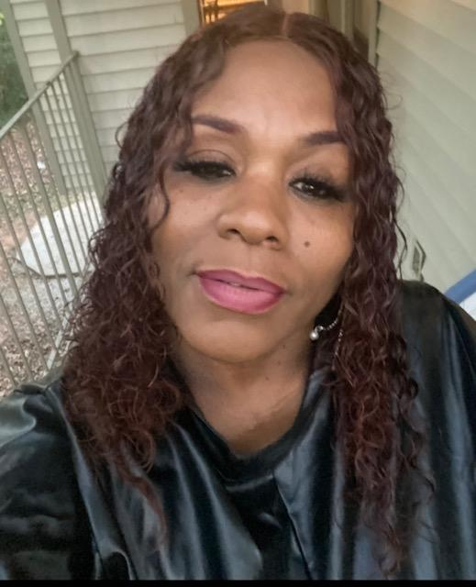  Profile  Energetic, motivated, and fully credential LPN dedicated to driving top quality patient care. Looking for a facility that is committed to patient care and community. I have 14 years’ experience working as LPN and 12 years in the nursing field, working as a CNA. I’m seeking a position, working in the field in a doctor’s office, hospital, or skilled nursing facility where I can share my enthusiasm, professionalism and dedication to caring for patients.  Contact  PHONE:  678-531-2452  EMAIL:  tannis.williams@ymail.com  License:  Licensed Practical Nursing (LPN)  Licensed Number : LN 64578 |  | EDUCATION  Fedrick Douglass High School  August 1986 – May 1990  [Graduated With 3.0 GPA With awards. Also ran track with many awards. Graduated With High School Diploma.  WORK EXPERIENCE  WellStar Cobb Hospital (CNA)  1996–2008  - Turning or moving patients  - Gathering medical supplies  - Bathing Patients  - Grooming Patients by brushing their hair, teeth, shaving them, etc.  William Breman Jewish home (LPN)  2008–2022  - Patients’ assessment and safety  - Provide Injections  - Monitor Vital signs  - Diabetes maintenance  - Document medical histories  - Monitor and reporting labs to physicians  - Manage IV, G- tube and catheter  - Advocate for patients and families  Gupton College (Funeral Assistant)  2022–Present  Skills  - Telephone Rep  - Customer Service  - Filing  - Makeup artists

