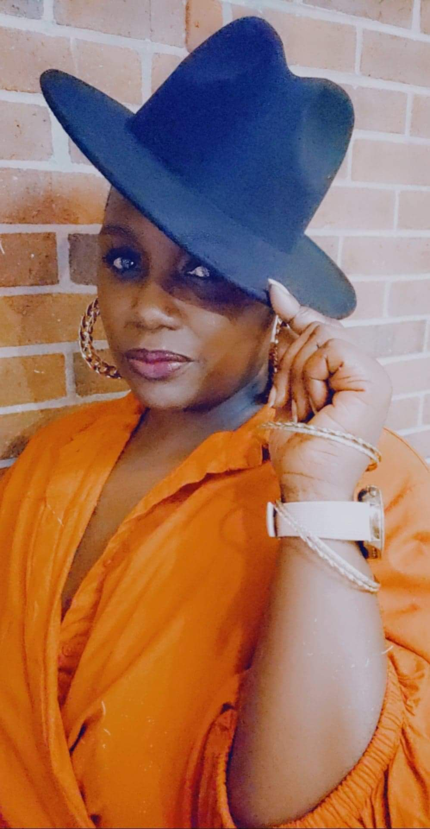 |  | tanya matthews  Actress/songwriter/singer
Profile  Greetings. My name is Tanya. I am an actress, singer and songwriter. I have done two stage plays and one movie so far and seeking to do more. Professionally I have worked in the medical field for 20+ years. I am an ordained Elder and Minister. I love to serve my community.  PHONE:  757-634-5262  757-386-2654  WEBSITE:  facebook.com/tanya.matthews3  IG: @eagleseye76  EMAIL:  Matthewst76@gmail.com |  | Don’t Let It Be Too Late- Kingdom Business Productions LLC  April 2022-Present  Playing an emotional role of a wife and mother Gina in this dynamic stage play.  Different Shades of Lipstick- Kingdom Business Productions LLC  September 2022-June 2022  Played a professional receptionist in a hospital setting in this riveting stage play  Days Ferry Production- Background Actor  July 2018  Played a background actor in the movie Jacqueline and Jilly written, directed and produced by Victoria Rowell

