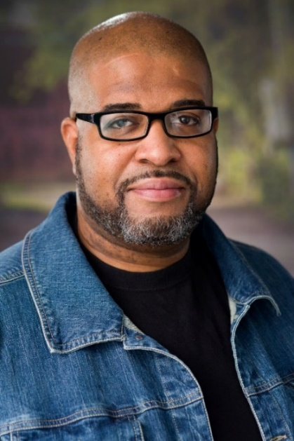
Kenneth Sanders
Phone: 832-930-7093
Address: P.O. Box 15462 Houston, TX 77220
Email:
blackclarkkententerprises@yahoo.com
Education:
BFA in Vocal Performance – Prairie View A&M University
Acting Class - Blinn College
Bio: Eye Color – Brown Height – 6’1” Hair Color – Black Weight – 280lbs.
Experience:
Love’s Complicated – Mathias
Break of Dawn – Security Guard
Trapped – Church Member
Black Santa – Police Officer
Everybody Hates Christmas – Police Officer
B.A.S.H. – Captain Nelson
Dark Summer – Jim
Temptations – Pastor Davis
BARS – Police Officer

Make it Out – Detective Lynch
All Eyez on Me – Marvin
Serial Season: American Santa – Heist Clan Member
The Hoodlum of the Opera – CSI Investigator
Really Mom? - Michael
To Feel Loved - Dr. Wright
Barbershop Talk – Skit and Discussion Panel
Unspoken Revealed 2 – Sex Trafficking Play
Unspoken Revealed – Sex Trafficking Play
Opera in the Heights – Chorus and minor roles
Houston Ebony Opera Guild – Chorus and minor roles
Once on this Island – Tonton
Special Skills:
Singing (Baritone)
Dr. Science – Serving as a children’s ministry teacher

