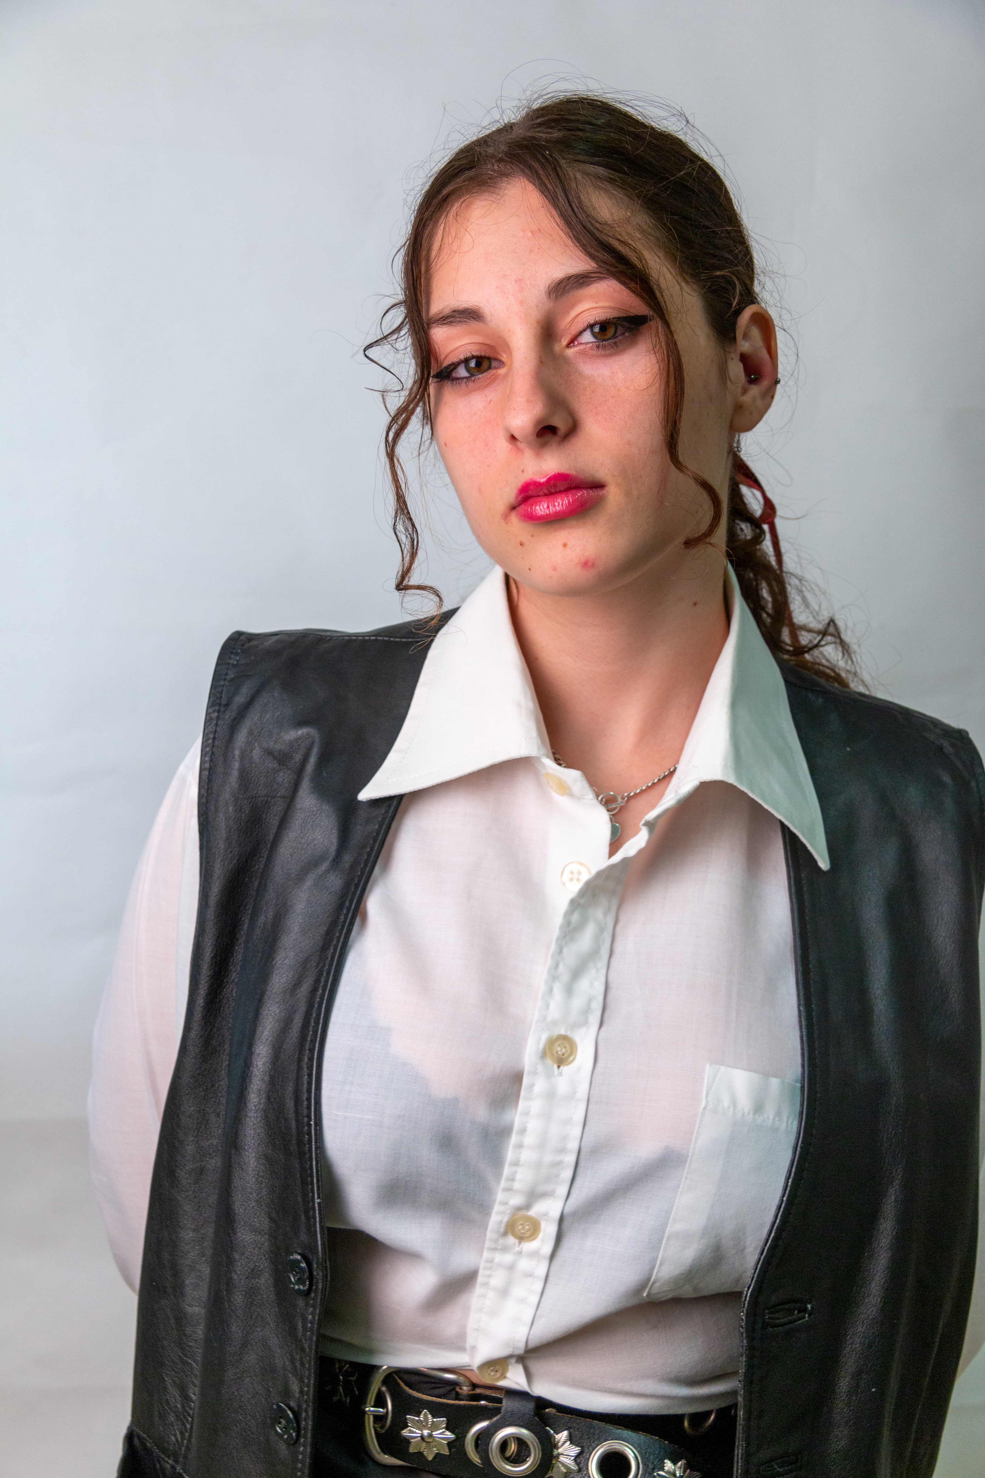BRISELDA KUMANAKU
h: Fier,Albania
e: kbriselda333@gmail.com / bnk220@aubg.com m:+357887383014

Profile
I am a second year college student with a passion for programming, astronomy and acting. My greatest achievement is that I was one of the 11 Albanian national winners of an internship during the “Ponder” program in November 2021 and the thing I am most proud of is that volunteered to help the elderly and middle-aged people at my community to learn how to use public services online, as part of the “E-Governance Youth for Community” program. I study Computer Science at American University in Bulgaria (AUBG).

Achievements
- “Ponder” ICTSlab Internship winner 11/2021
- “Gratitude Student” of Fier December of ’16, ’17,’19,
- Won second place at Francophonie recitation competition 03/2019
- Founder of AUBG Astronomy September 2023

Experience

- Bakery employee at Back Door Donuts Summer 2023
- Salad maker at MV Salads Summer 2023
- Sales Associate at Soft as a Grape Summer 2023
- Salesperson at “Aroma” Gelateri café/ice cream shop/ bakery in Fier Summer2022
- Student Volunteer at Epoka e Re Fier September 2021- currently
- Student assistant at American University in Bulgaria September 2022- currently
- AUBG Sustainability Club member September 2022 – currently
- AUBG Movie Club member September 2022 – May 2023
- Journalist for PCWorld.al 3 month internship 2022
- Red Cross Fier volunteer 2021-2022
- Volunteered at IHRFFA(International Humans Rights Film Festival) September 2021
- Advocating training December 2021
- E-Governance Youth for Community (training) November 2021
- E-Governance Youth for Community (volunteer) December 2021
- Acting classes at Kids Cultural Center (QKF) 2017
- Journalist at TV Apollon Fier 2017- 2019
- Class President 2021-2022
- School president 2018-2019

Hobbies & Skills
- Acting
- Writing
- Volunteering
- Photographing
- Helping people
- Programming
- Thrifting
- Cooking

Education
American University in Bulgaria 2022- now 3.718
“Perikli Ikonomi” High School, Fier, Albania 2019-2022 9.89
“Kristo Vide” 9-year school, Vajkan,Fier,Albania 2010-2019 9.9

