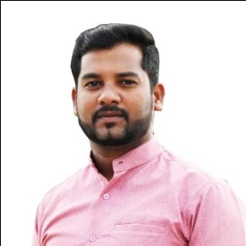

* Abdul Rahuman Abdul Raheem
* 17/3 Computer Center Road,Moorstreet ,Mannar
* 1992 /03 /09
* 920692834V
* Srilankan Moor
* Male
* Married
* 0757600549 , 0766217667
* goodfndmng@gmail.com
* Mannar
* Mannar
* Moor street
* Full Name
* Permanent Address
* Date Of Birth
* NIC No
* Nationality
* Gender
* Marital Status
* Mobile number
* E-mail Id
* District
* D.S. Division
* G.N. Division

PERSONAL DETAIL

Mr. A.R.A.Raheem

NO.17/3 , Computer Center Road,

Moorstreet ,Mannar

CURRICLUM VITAE

EDUCATION QUALIFICATION

|  |  |  |
| --- | --- | --- |
| **no** | **Subject** | **Grade** |
| 01 | Islam | B |
| 02 | Info.&.Com.Tech | C |
| 03 | Tamil | C |
| 04 | Art | S |
| 05 | Geography | S |
| 06 | Mathematics | S |
| 07 | History | S |
| 08 | English | W |
| 09 | Science | W |
|  | Advance Level |  |
| 01 | Islam | S |
| 02 | Geography | Ab |
| 03 | Ict | Ab |
|  |  |  |

**I hereby Declare That Above Mentioned Detail Are True And Correct To The Best Of My Knowledge.**

Personal Information

* **Smart And Well Presented With Practiced Communication Skill**
* **Flexible And Comfortable Working Under Pressure And Time Constraints**
* **An Open Mind And Flair For Learning, Makes Acquiring More Knowledge On A Subject Possible**
* **Reliability , Punctuality And Confidentially**

Special Participate Programs

* **Rally For Unity News 1st ( 60 Days)**
* **Uropiyan Film Festival**
* **Agenda 14 Short Film Makers Workshop (25 Days)**
* **Center For Performing Arts Drama Workshop (3 Years)**
* **NYSC Media Workshop ( 30 Days)**

OTHER QUALIFICATION

* **Successfully Completed Diploma in MS Office**
* **Successfully Completed Diploma In Drama And Theater**
* **Short Film And Documentary Maker**
* **I Can Photo And Video Editing ( Adobe Collections )**