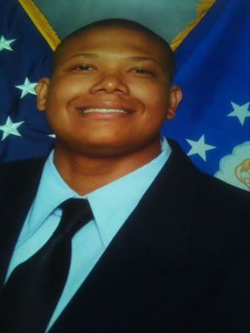

**Christian Kahnai Williams**  
71 Cherry Blossom Walk, Dallas, Georgia 30132  
Phone: 678-353-5001  
Email: Christianwilliams116@aol.com

**SUMMARY**  
I recently graduate from GSU, and I have a passion for helping others and learning new experiences.

**I do not have a lot of work experience as I have been pursuing my education in Film and Media

**Extras – work opportunities for film production – Naomi TV Series (CW), FOUND (NBC), BMF (Black Mafia Family) (STARZ), The Big Door Prize (Zoltar), and The Family Plan (The Holiday Road/A Mark Wahlberg movie)**

**Education:**

**Georgia State University,** Atlanta, Georgia MHS, Marietta, Georgia  
*August 2018 – December 2022 GPA: 3.18 August 2014 – May 2018 GPA: 3.0*

***Bachelor of Arts: Major Film & Media Minor: Theatre***

*Electives: Drama, Computer Technology & Health*

**Work Experience:**

**Six Flag White Water – Park Services Team Member**

* **Assist guests with park information and accurate directions to their next attraction**
* **Walk through the park with a broom and dustpan to ensure everything looks its best**
* **Hose down midways and patios before or after regular park hours**
* **Wipe down tables and benches**
* **Empty trash cans to maintain freshness**
* **Use chemicals to make restrooms and facilities shine**
* **Control inventory of paper products and supplies to keep restrooms stocked**

**Volunteer Experience:**

**MHS – Peer Leadership Program**  
• Act as a role model, attend quarterly meetings & provided school tours for new and middle school age students

**AFJROTC – Fund Raiser Participant**  
• Work with other cadets, walked in nearby community requesting donations for needy children and families during Thanksgiving and Christmas holiday season.

**Interests / Activities**

* *AFJROTC*
* *Band & Marching Band: Wind Ensemble, Stage Crew*