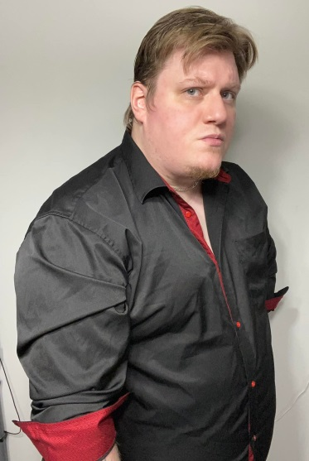
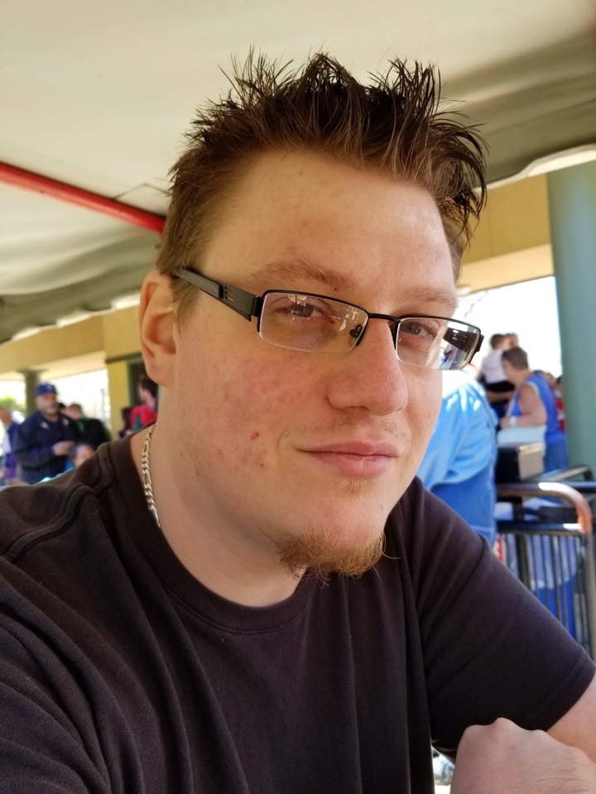
Daniel Lund
GuitarkidDD@gmail.com
220 Jonas Lane Ct, Winfield, MO 63389
636-486-5032
https://www.imdb.com/name/nm12197079/

BIO
Height: 6’ 0”
Weight: 350lbs
Hair Color: Blonde
Eye Color: Hazel

FILM CREDITS
We Spent Friday the 13th at Crystal Lake | Executive Producer | Kimberly Terasaki
Relationship Killers | Co-Producer | Flawless Arts Productions
Ravage | Producer | Dondi Inferno Productions
Redhead | Producer | CineSavage Films

ACTING Credits
Cult of Blood | Support | Cult Member Danny | Crude Cinema
A Day Having Doubts | Extra | Restaurant Extra | Synchro Productions Films
Mortician | Extra/Crew Member | Restaurant Patron/Clapper Board | Equinox Production Group
Slasher Scotty | Interviewee | Self | Gravestone Films
Serious Profession | Extra | Head Shop Patron 3 | Key 13 Film Partners
Z Dead End | Extra | Victim/Zombie | Bill Diamond Productions
72 | Support | David Adams | Gravestone Films
Getting Through | Extra | Patron | Synchro Productions Films
The 3rd Channel | Actor | Jimmy | Michelle Lynn Blasky
River Beauty | Actor | Dennis | Crude Cinema
Redhead | Actor | Jimmy | CineSavage Films
Springsville | Actor | Dallas | 7118 Productions
Critters: All You Can Eat | Actor | Cook | Crude Cinema

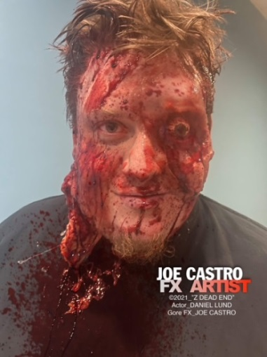
Skills and awards
- Uruvatti International Film Festival 2021 – Best Producer – Ravage
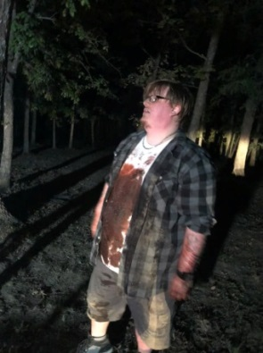
- Musician – Guitar, Bass, Sound Mixing
- Graphic Design / Character Art

