Height: 4’8”  Weight: 75  Hair Color: Light Brown  Eye Color: Blue  Vocal Range: F3-E6 | Oscar Hand  oscarhand26@gmail.com  470-208-8151 | 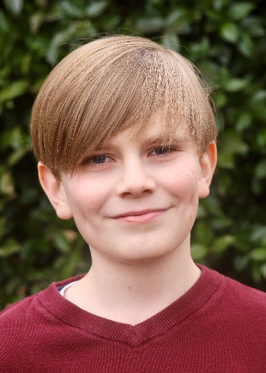

CREDITS
Production | Role | Company / Organization | Year
Tuck Everlasting | Beau | Red Phoenix Theatre Company | 2024
Big Fish | Young Will | FoCAL / Bellissimo Theatre | 2024
A Christmas Carol | Tiny Tim / Young Scrooge | School Street Playhouse | 2023
Finding Nemo | Squirt | Red Phoenix Theatre Company | 2023
The Little Mermaid | Ensemble | Red Phoenix Theatre Company | 2023
Disney’s The Descendants | Ensemble | Red Phoenix Theatre Company | 2023
Matilda | Nigel | Red Phoenix Theatre Company | 2022

TRAINING
Type | Organization | Instructor | Year(s)
Triple Threat | Red Phoenix Theatre Company | Eric Bragg | 2023
Voice | First Redeemer Music Conservatory | Kristanecia King | 2020 - 2022
Tap & Ballet | Cumming Dance Academy | Staff | 2020 - 2022

