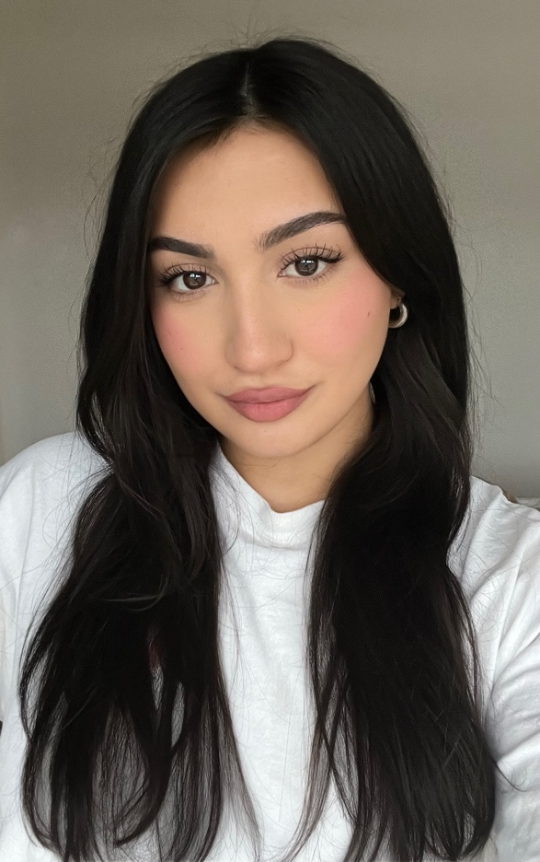
Persia Niknami
Location: London, UK
Email: persianiknami@icloud.com
Height: 5’5
Weight: 70kg
Hair: Dark brown
Eyes: Dark brown

FILM
Back to Black – Funeral Guest – Studio Canal, Monumental Pictures
Back in Action – Gala Guest – Exhibit A, Chernin Entertainment, Good One Productions
Wicked - Shiz Student – Mark Platt Productions
Eternal Return – Passerby – Village Roadshow Pictures, MACRO, BK Studios, Picture Films, New Name Entertainment, Gatherer Entertainment, Little Walnut, The Post Republic
Deadpool & Wolverine – Coffee Barista – Marvel Studios, Maximum Effort, 21 Laps Entertainment

TELEVISION
Sex Education S4 – Cavendish Student – Eleven Film
The Crown S6 – Coronations Celebrant & Jubilee Crowd – Left Bank Pictures, Sony Pictures Television
Varsity – Cambridge Student – Trinity Productions
McDonalds Christmas Advert – Christmas Tree Wig - Smuggler
Pepsi Commercial – Football Fan – Unknown

TRAINING
Acting – Michael P - Sylvia Young Theatre
Acting (Improv) – Mayflower Theatre Group

SPECIAL SKILLS
Languages- Fluent Persian (Farsi)
Accents & Dialects- British, Australian, American, Southern American, Welsh, Middle Eastern
Instruments- Vocals, Viola, Guitar, Percussion
Sports- Swimming, Yoga, Distance Training, Strength Training, Horse Riding

