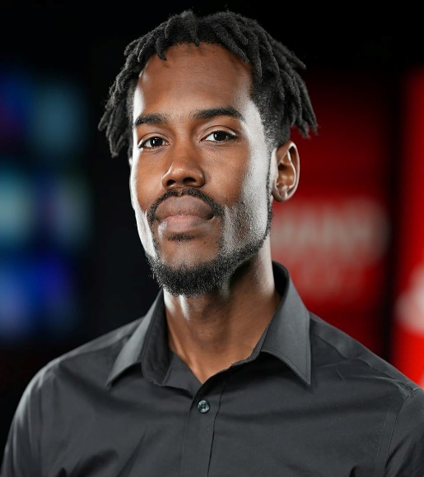 |  | Arthur Washington Jr  558 W Prairie St, Decatur, IL, 62522 | 217-420-0820 | Ajwashington03@gmail.com  Education  DEGREE | DATE EARNED | SCHOOL  High School Diploma, 2012, MacArthur High School.  Tech Academy 2011-2012.  Studied Media at Richland Community College.  Skills & Abilities  Videography  Editing (Grass Valley, Edius 9 Pro)  Conducting Interviews  Prompter Operating  Studio Camera Operator  Lighting  Audio  Experience  JOB TITLE | COMPANY | DATES FROM - TO  WAND TV Studio Camera Operator 2013-2014, WAND TV Videographer 2014-2023, WAND TV, currently still working position.  I have worked for WAND TV for ten years filming big events in the Central IL area.  To name a few I have filmed major events such as the; Farm Progress Show, IL State Fair, Decatur Celebration, Millikin Vespers, and much more. I am very skilled in live video broadcasting and setting up live shots. I've also reported on a story that was used on live television and helped shoot a short film movie. Graphics isn't one of my skills but a skill I would love to put down as a 9th skill in the future. In conclusion, I would love to learn more about your company. If would like to get in contact with me my information is listed above, and I will hear back from you. To whom this may concern I pray you have a great day or night and stay blessed.  Have a great rest of your day!

