**CV**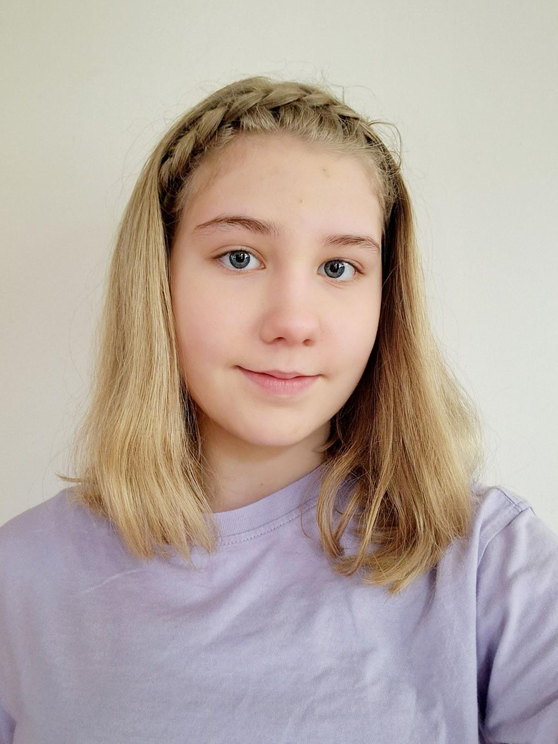

**Name:** Emily Sofie Meering

**Date of birth:** 23 - 04 - 2009

**Address:** In Het Midden 39

**Place of residence:** Uithoorn

**Phone number:** 06 18337107

**Mother's telephone number:** 06 14898721

**Father's telephone number:** 06 22108950

**E-mail address:** [221144@leerling.alkwin.nl](mailto:221144@leerling.alkwin.nl)

**Mother's email address:** [c.vd.reek@gmail.com](mailto:c.vd.reek@gmail.com)

**Father's email address:** [ramses.meering@medapak.nl](mailto:ramses.meering@medapak.nl)

**Competences**

To sing

Acoustic guitar

Electric guitar

Dancing

Act

Performance

Gymnastics

To skate

**Interests/hobbies**

2 years of piano lessons

2 years of guitar lessons

1 year of ballet

4 years of long track skating

2 years of figure skating

3 years of musical lessons

Previous education: Musical Master

**Experiences**

Theater play 'The Tempest' by William Shakespeare role: Ariel

Musical 'Missing' role: Bo, guard 2 and Sarah Seintjes

Musical 'The School of Good and Bad' role: Lizzy from Wonderland

Theater camp

Musical Master in Amsterdam

**Language skills**

Languages I speak fluently: Dutch, Norwegian and English

Additional languages I am learning: Spanish, French, Cambridge

**School**

Het Alkwin Kollege

3rd Class

Uithoorn

Level: VWO Atheneum

Additional subject: Cambridge

**Casting agencies**

Zaza Casting - Multa Casting - Backstage.com