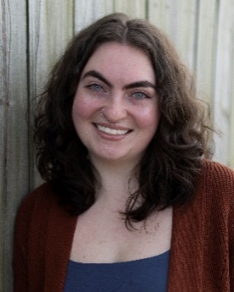 **Kyleigh Box**

**Bentonville, AR**

**Hair:** Dark Brown kyleigh.m.box@gmail.com

**Eyes:** Blue (479) 936-6096

**Film/Television**

“Back By Monday” Lecture Guest Lightweight Pirate Productions

“In Fortune’s Shadow” Nightclub Patron Crane Town Media

“Sovereign” Store Shopper All Night Diner

“The Threesome" Restaurant Patron Best Laid Plans LLC

“Traveling Mercies” High School Student Social Cinema Foundation

**Training**

Intro to Technique Harrison Thomas, Tali Rabinowitz

Industry Development for Actors and Models Kim Pease

**Special Skills**

• Photography • Firearm Handling

• Social Media Skills • Driver’s License/Passport

• Alto Saxophone (5 years of experience) • Soccer (Forward/Mid, 3 years of experience)