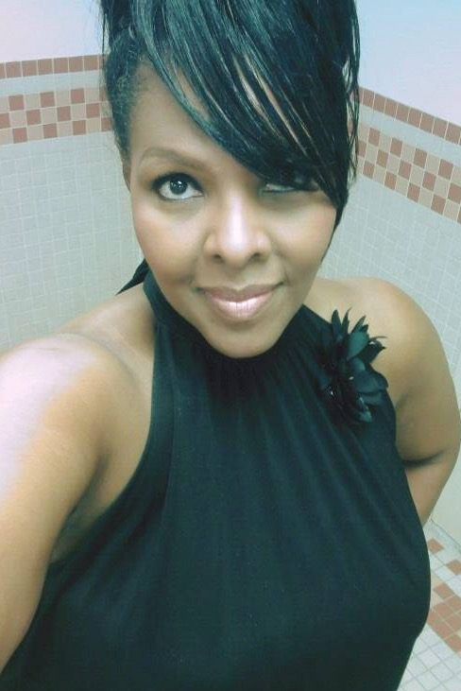 |  | Kim Freeman  Singer/Actor/Model/Lyricist
Skills:  - Singing (Mezzo-Soprano)  - Acting  - Model  - Lyricist |  | City, State: Atlanta, GA  Email: freep702@icloud.com
Contact  PHONE:  201-892-1225  WEBSITE:  https://open.spotify.com/album/0Ulz8kuFhlZwp6W8iXw6yz  Musical Genres  Gospel  Jazz  R&B  Opera  Musical Theatre  Off Broadway productions  Drama |  | EDUCATION  ’s okay to brag about your GPA, awards, and honors. Experienced mezzo-soprano singer with a passion for music and performance. With a recorded album under my belt, I am seeking opportunities to further my career and share my music and acting skills with a wider audience.  .  Skills:  - Singing (Mezzo-Soprano)  - Acting  - Modeling  - Lyricist  Experience:  **Singer/Songwriter**, *Self-Employed*, Atlanta, GA (2023-Present)  **Singer/Songwriter**, -- Recorded and released debut album "Been So Good", 2017 Available on Spotify.  - Performed at various venues across New York and  New Jersey, building a dedicated fanbase.  - Performed background and lead vocals  **Background Vocalist**, Michael Bolton – Time, Love, Tenderness Tour. 2017  **Background Vocalist**, Tremaine Hawkins 2016 – Gospel Concert  **Background Vocalist**, Vickie Winans 2015 - Gospel Concert  **Supporting Actress/Singer** The Lion King, New York, New York 2013-2015  --Performed background vocals  --Collaborated with other musicians for live  performances and recording sessions.  **Lead Actress/Singer** "Mama I Want To Sing" Tour Group  Chicago, Illinois 2006  Kim Freeman  -Performed lead role as “Mama.”  -Collaborated with director to bring role to life.  -Performed at various venues across Chicago, building a dedicated fanbase.  **Lead Actress/Singer**, *Mama’s Blanket*, (Off Broadway), New York, New York 2012  --Performed lead vocals as “Mama”  --Performed background vocals.

