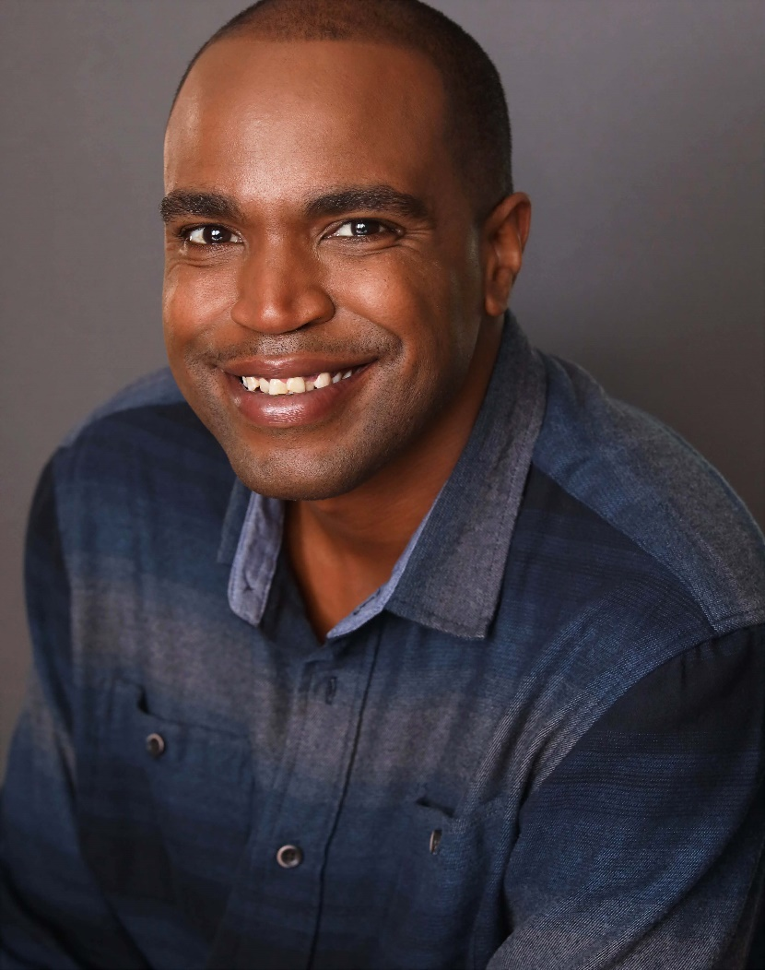
773-648-9388
Ralow86@gmail.com
Chicago, Illinois

FILM CREDITS
Film title | Role type | Director
“A Christmas On The Ranch” BG Restaurant Attendee

- Deli Boys Core BG Featured
- Chicago PD 3 times
- CHICAGO MED 3 times
- CHICAGO FIRE 4 tomes
- SOMEBODY SOMEWHERE
- EMPEROR OF OCEAN PARK
- The Bear season 4
- Power force Season 3
- The Chi
- Mr. Throwback 3 times

Bear Online class with Max Archienga
Height:6’4
Weight:215
Hair color: Black
Eye color: Brown
44L, T XXL, 16.5/40 40X34 SHOE SIZE 11

