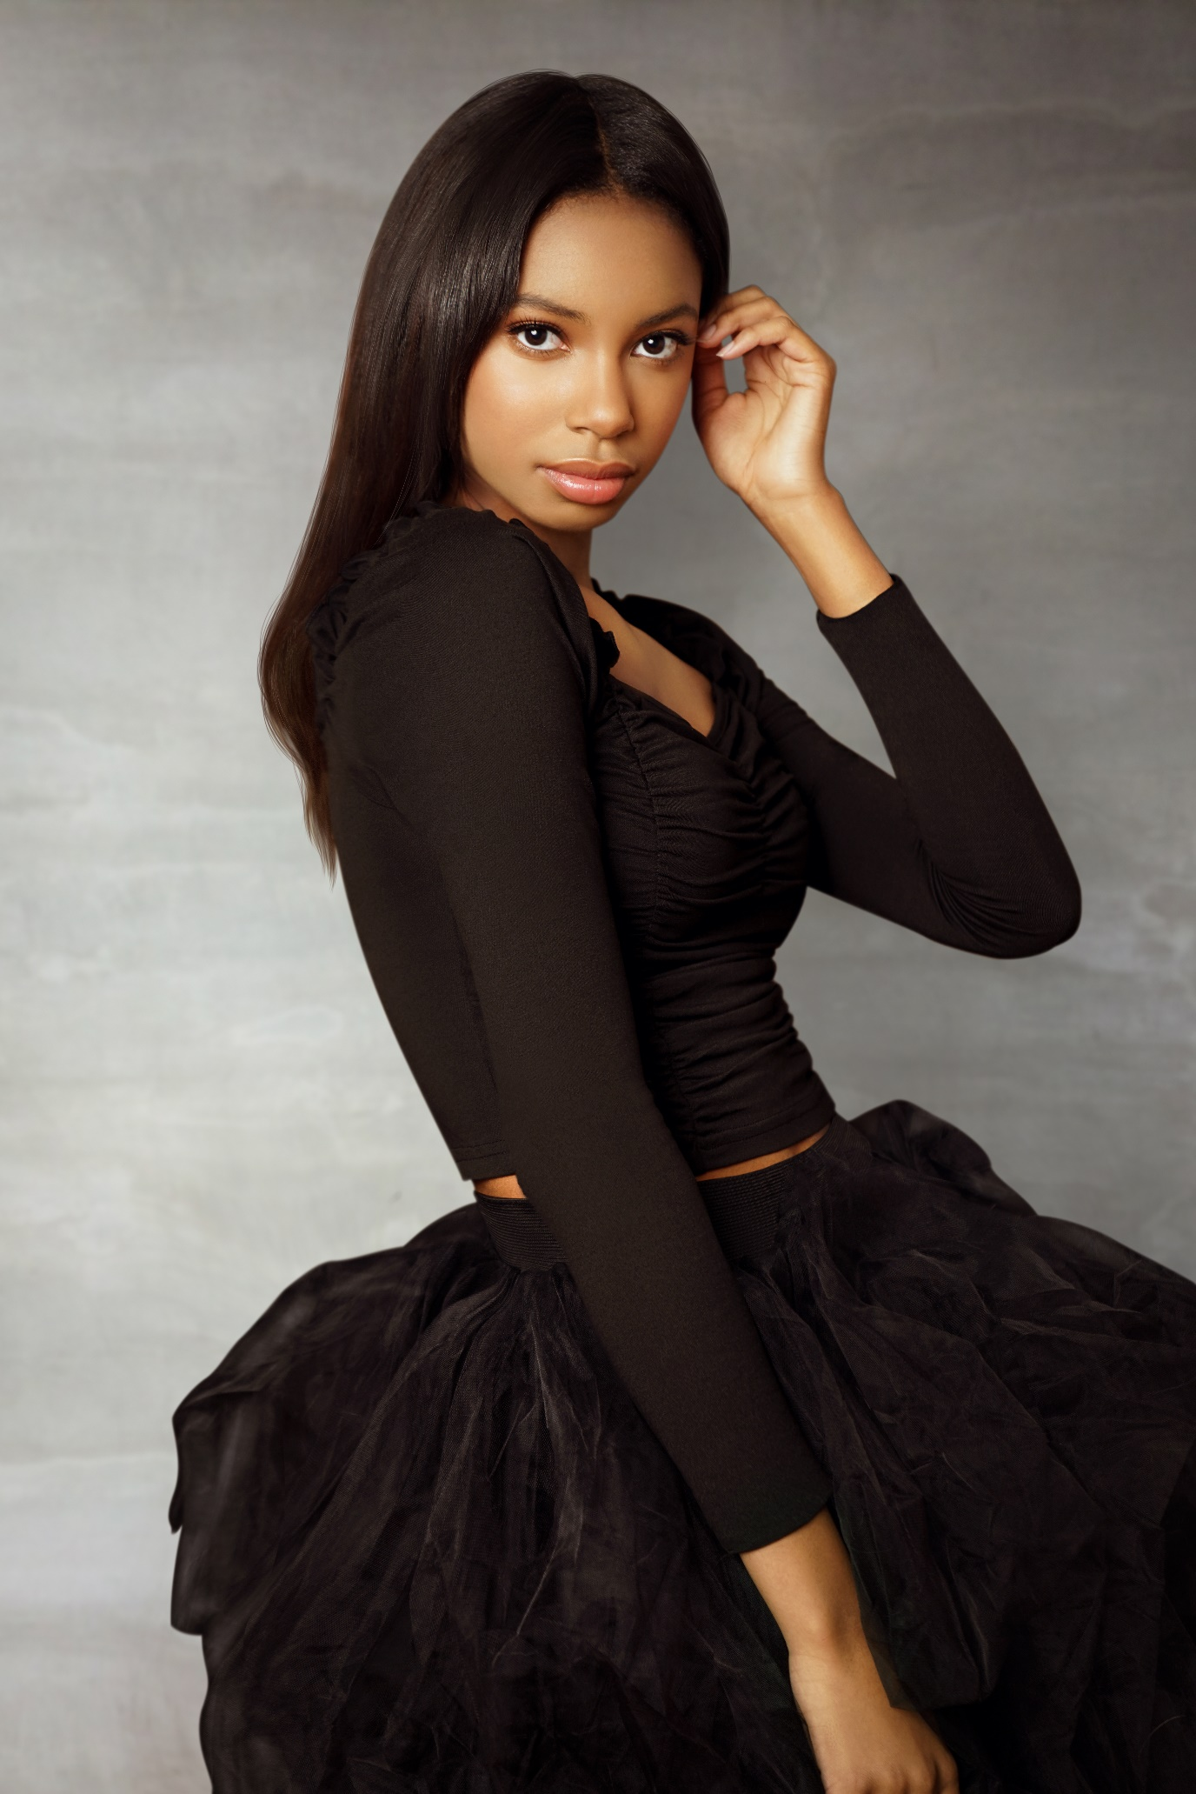

Maria Raquel Thomas

DOB: June 1, 2006 | Height: 5’8” | Hair Color: Dark Brown | Eye Color: Brown

Clothing Size: 2 | Shoe size: 10

Maria Raquel Thomas

AOAGWLLC Public Relations

2020 Pennsylvania Ave, Suite #319, Washington, DC 20006

Phone: (202) 374-8488 | pr@aoagwllc.com

**Television**

1-800-Contacts Customer The Rain Agency

Flacks Flooring Daughter Mnemonic Ad Agency

“Good Day Atlanta” Beauty and Fashion Correspondent Fox

“Good Day DC” Self/Entreprenuer Fox

“WUSA9” Self/Entreprenuer CBS

“Good Morning Washington” Holiday Fashion Model ABC

“Good Morning Washington” Self/Halloween Slime ABC

“Good Day DC” Fashion Model Fox

“Good Morning Washington” Self/Entrepreneur ABC

“Let’s Talk Live”  Self/Entrepreneur ABC

“Let’s Talk Live”  Hair & Fashion Model ABC

“Let’s Talk Live”  Fashion Model ABC

**Film**

Anti-bullying PSA Anti-Bully Kid Make Smart Cool

Charm City School Kid Big Mouth Productions

**Industrial**

Educational Robot-Builder Ambitious TV

Educational Felica-Teen Daughter Write-Brain, Films

**Print and Runway**

Bliss Magazine (April 2023) Model (Cover) Bliss Magazine

Teen Shine Magazine (2022) Featured Teen Shine Magazine

Teen HiLife Magazine (Dec 2021) Model (Cover) Teen HiLife <agazne

Vigour Magazine (July 2021) Model (Cover) Vigour Magazine

SELIN Magazine (July 2021) Model (Cover) SELIN Magazine

Teen Cruze Magazine (May 2021) Model (Cover) Style Magazine

Malvie International (Feb 2021) Model Malvie Magazine

Anon Fashion Magazine (Feb 2021) Model Anon Magazine

Authority Magazine (Feb 20221) Self/Feature Authority Magazine

Teen Cruze Magazine (Sep 2020) Model (Cover) Style Magazine, Inc

Teen Cruze Magazine (July 2020) Model (Shared cover) Style Magazine, Inc

DC Fashion Week Model DC Fashion Week

Doria Adouke Illustration Social Media Influencer Dorai Adouke

Kid Entrepreneur Self DC Black Newspaper

Kid Entrepreneur Self Afro Newspaper

Top Beauty Products Self Washingtonian Mom

Beauty and Fitness Self Fitness Magazine

Crayola Crayons Finger-paint demonstrator Crayola Crayon, Inc

Little Miss DC/DE America promo ad AOAGW, LLC

Little Miss PA/MD/VA America promo ad AOAGW, LLC

**Skills:**

Entrepreneur, Builds robots, Builds Rollercoasters, Gymnastics, Drawing, Cheerleading, Cross-Country Running

**Acting Classes:**

Julia Tasheva Acting Class, Brains and Beauties Coaching