**Maksym Gorai**

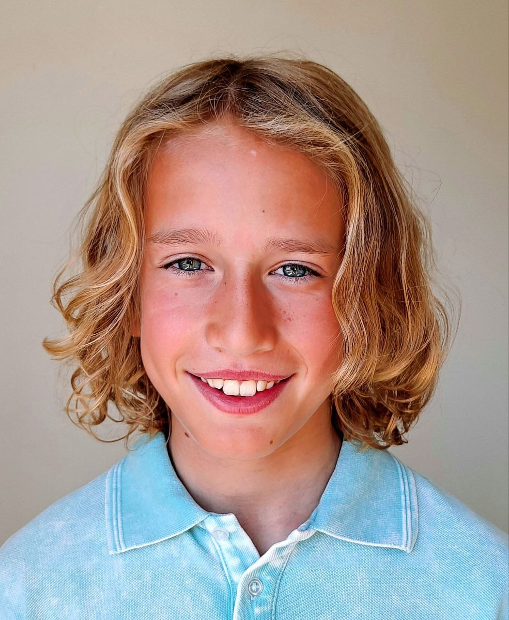

(818) 749 – 1057

(tel.mother Viktoriia Gorai)

vikagoraj2018@gmail.com

Hair: Blond Eyes: Gray Height: 4’8" (142 cm) Weight: 65 lbs (30 kg)

Age:11 ; Playing age 8-12

Vocal Range: Soprano

Profile on Casting Networks: https://app.castingnetworks.com/talent/public-profile/850acdf8-94a7-11ee-b43f-e9128316293f

**Projects 2024:**

**- Commercial , Back to school (Dental), dancing kid/supporting (06.2024)**

**- Netflix - series, Forever , 4th Grader (06/2024)**

**- Commercial , Waterdrop/Amazon, son/supporting (06.2024)**

**- Web-series , KISS ME ONE LAST TIME ,Young Blake/supporting (05.2024)**

**- Commercial, Trampoline Time happy jumper/supporting (04.2024)**

**- Outdoor E-commerce Photo shoot (picnic tents) siblings/lead (02.2024)**

**- Commercial ,Boost mobile flag football player/episodic (01.2024)**

**- Music video Lizzy Mcalpine, Older kid/episodic (01.2024)**

**- Shortfilm Lemon brother with the gun/lead (12.2023)**

**Film / TV**

"Why Im Alive" (feature film,2021) lead Novak (Ukraine)

21 projects in TV-series (2019-2022) supporting;episodic Ukraine

5 projects in Web-series (2021-2023) supporting;episodic Ukraine

5 projects in TV-programs (2019-2020) episodic Ukraine

**Commercials**

27 projects (2020-2023) lead;supporting;episodic Ukraine

**Modeling/Photography**

12 projects (2019-2022) lead;supporting;episodic Ukraine

**Music Video**

6 projects (2020-2022) supporting;episodic Ukraine

**Educational Video**

Ukrainian school online (2022) lead;supporting Ukraine

**Social Video**

3 projects (2019-2022) supporting;episodic Ukraine

**Voice-over**

5 projects (2019-2022) lead;supporting;episodic Ukraine

**Special Skills**

piano, gymnastics, acrobatic, trampoline, swimming , skate, bike, roller skating, scooter, soccer, football, volleyball

**Languages**

Ukrainian, Russian , English