ALL MATERIAL IN THIS DOCUMENT IS OWNED IN ITS ENTIRETY AND IS THE SOLE PROPERTY OF CARL JUSTICE NORDSTOM AND ANY DISTRIBUTION, COPYING AND OR OTHER MEDIA TRANSMITTAL IN ANY FORM WITHOUT THE EXPRESS WRITTEN PERMISSION OF CARL JUSTICE NORDSTROM IS STRICTLY PROHIBITED.

Unless otherwise expressly acknowledged in writing by Carl Justice Nordstrom all incidents and events depicted in this written overview of “CJ’s” life should be viewed as, at this point, a work of fiction and not based on actual events and or individuals. This overview is intended to portray a framework depicting the life of Carl Justice Nordstrom for any later media distribution in any form.

This document is intended to give a broad overview of Carl Justice Nordstrom’s, “CJ”, storied life. It is not by any means a full or detailed account of the good and bad life experiences that CJ has encountered. That would fill the pages of several books. It is meant to give a biographical framework showing the complexity and diversity of the life CJ has lived on both sides of the law since childhood. It is also meant to convey a small understanding of how extraordinary CJ’s life has been. A life that has made him a cultural icon who truly has become a “larger than life” figure thru all stations in life not only in Rhode Island but in many parts of the United States.
Brendan Doherty, a past RI State Police Superintendent, said in an interview with Tim White, “Nordstrom “was his own gang,” but mobsters benefitted from the biker’s close relationship with them. They liked him, and why wouldn’t you?” Doherty said. “You bring C.J. in a room and people stop talking, stop eating… he’s a serious-looking guy.”
In summation this document is intended to show, in a small way, that CJ’s life is as compelling a story as any underworld novel or movie ever made and more extraordinarily it depicts “real” events and is not a work of fiction! He has been a trusted associate of underworld figures, a renegade “lone Biker” with constant run-ins with the notorious Hell’s Angels. He trained with Muhamed Ali and associated with movie stars like Gene Hackman and Jack O’Halloran in Las Vegas. His story is worthy of being told either in a book, movie, or TV series.
Let me make one last very important point. Some of the incredible true accounts in this document will surprise you and give you a small affinity for CJ, nothing compares to getting to know him in person. CJ has that, for lack of a better word, “superstar” presence that not many possess. When you put together his real-life exploits with his extraordinary presence you understand that this guy is the ‘Real Deal” and there are not many left who you can say that about.
This document is not meant to be in precise literary form but rather a factual synopsis of some portions of CJ’s life, in no way a complete account, intended to be the starting point for future deliberations concerning possible media distribution of CJ’s story. There are hundreds of movie type incidences in CJ’s life that can be discussed in more detail.
Writing this synopsis of CJ’s life story, I realized that CJ is a much more complicated a person than you would imagine. To truly understand him you need to look past his intimidating appearance and reputation and try to see what really drives CJ.

Often the road to understanding can be found in childhood memories. I remembered an old TV western, Have Gun Will Travel, that depicted the life of a man called Paladin.

Paladin in the western was a gunfighter-for-hire who scoured the San Francisco newspapers looking for people who had been wronged or who needed help with some problem in their lives that was beyond their means to solve. Paladin had a high code of honor so if he agreed to help someone with a problem and found out that the situation was not as clear as depicted, he would make the moral decision to find a “just solution” even if it was not the result the person who hired him expected. He was not merely “muscle for hire” who would use his deadly capabilities regardless of where the justice of the problem laid. In many respects CJ is like the Paladin in that western.

The term Paladin is defined as “a person who fights for a cause as a knight fought for a king in the Middle Ages or Paladin is a knight renowned for heroism and chivalry. They are very religious, and have an extremely strict honor code, as well as a soft spot for children and animals.”

That definition aptly describes CJ. CJ’s middle name is “Justice” and there is no other name more appropriate to capture what has driven CJ throughout his life. One might not always agree with CJ’s idea of justice, but his sense of what honor is always guides his actions.

CJ stated in a news article that he would “rather talk a problem through to a solution” rather than use his well-known physical capabilities. But he won’t hesitate to use them if needed. Additionally, when he is tasked with solving a problem for someone and he finds the situation not as originally presented he will not hesitate to find a more equitable solution or even just walk away. His “code of honor” guides his actions.

CJ relates the story that one day he noticed 3 or 4 blacks scoping out a Jewish businessman and he knew that they were planning to rob him. He stopped and intervened and fought off the would-be assailants. To this day CJ and the businessman are close friends and CJ has spent many times with the man and his family. He did not have to stop and help but his code of honor compelled him to intervene.

Another incident CJ saw a policeman being attacked by a group of assailants and again his code of honor compelled him to stop and intervene and help get the police officer out of danger. CJ has done this many times. Police across the state know what he did and have never forgotten. CJ is a complicated man.

CJ WITH POLICE BADGES GIVEN HIM FROM ALL OVER THE STATE AND OTHER STATES.

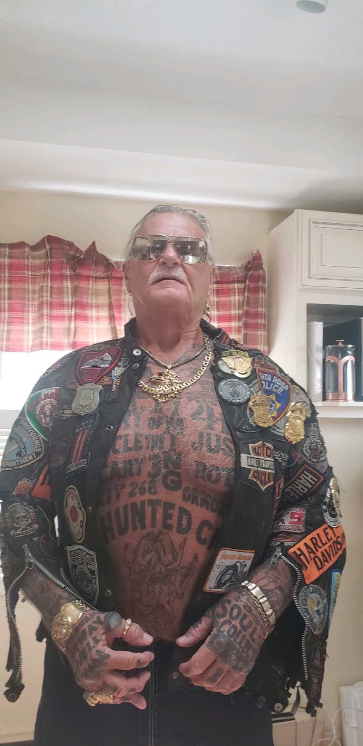

CJ and a few friends were on their way to Block Island to spend a few days. The State Police called the Chief of Police on the island, Vin Carlone, to let him know CJ and friends were on their way. The Chief saw CJ riding a moped and took a video of him falling off. He later approached CJ on the beach and introduced himself and told CJ if he caused any trouble on his island, he would post the video on the internet. CJ took a fit of laughing and to this day they are the best of friends. CJ is even building him a custom motorcycle.

Much like Paladin in the old western people who find themselves in situations they are not capable of solving themselves turn to CJ for help. Other times he is asked to solve some problem by underworld figures or people on the other side of the law and CJ always guides his actions by his code of honor.

A friend of CJ who owns a restaurant in Cranston, Dean, describes CJ as an “arbiter of justice” because when he agrees to help someone, he always looks for an equitable solution rather than the violent one to bring about an inequitable solution.

This is remarkable since people who have the fighting capabilities of CJ don’t always have that sense of honor.

CJ’s life as a Paladin has not come without many violent encounters.

Not too long ago at a gas station stop off Rt 146 a rider pulled up alongside CJ’s car and fired shots at him. He ducked under the steering wheel and a bullet hit the wheel and ricocheted into his head below the eye. He was lucky he survived.

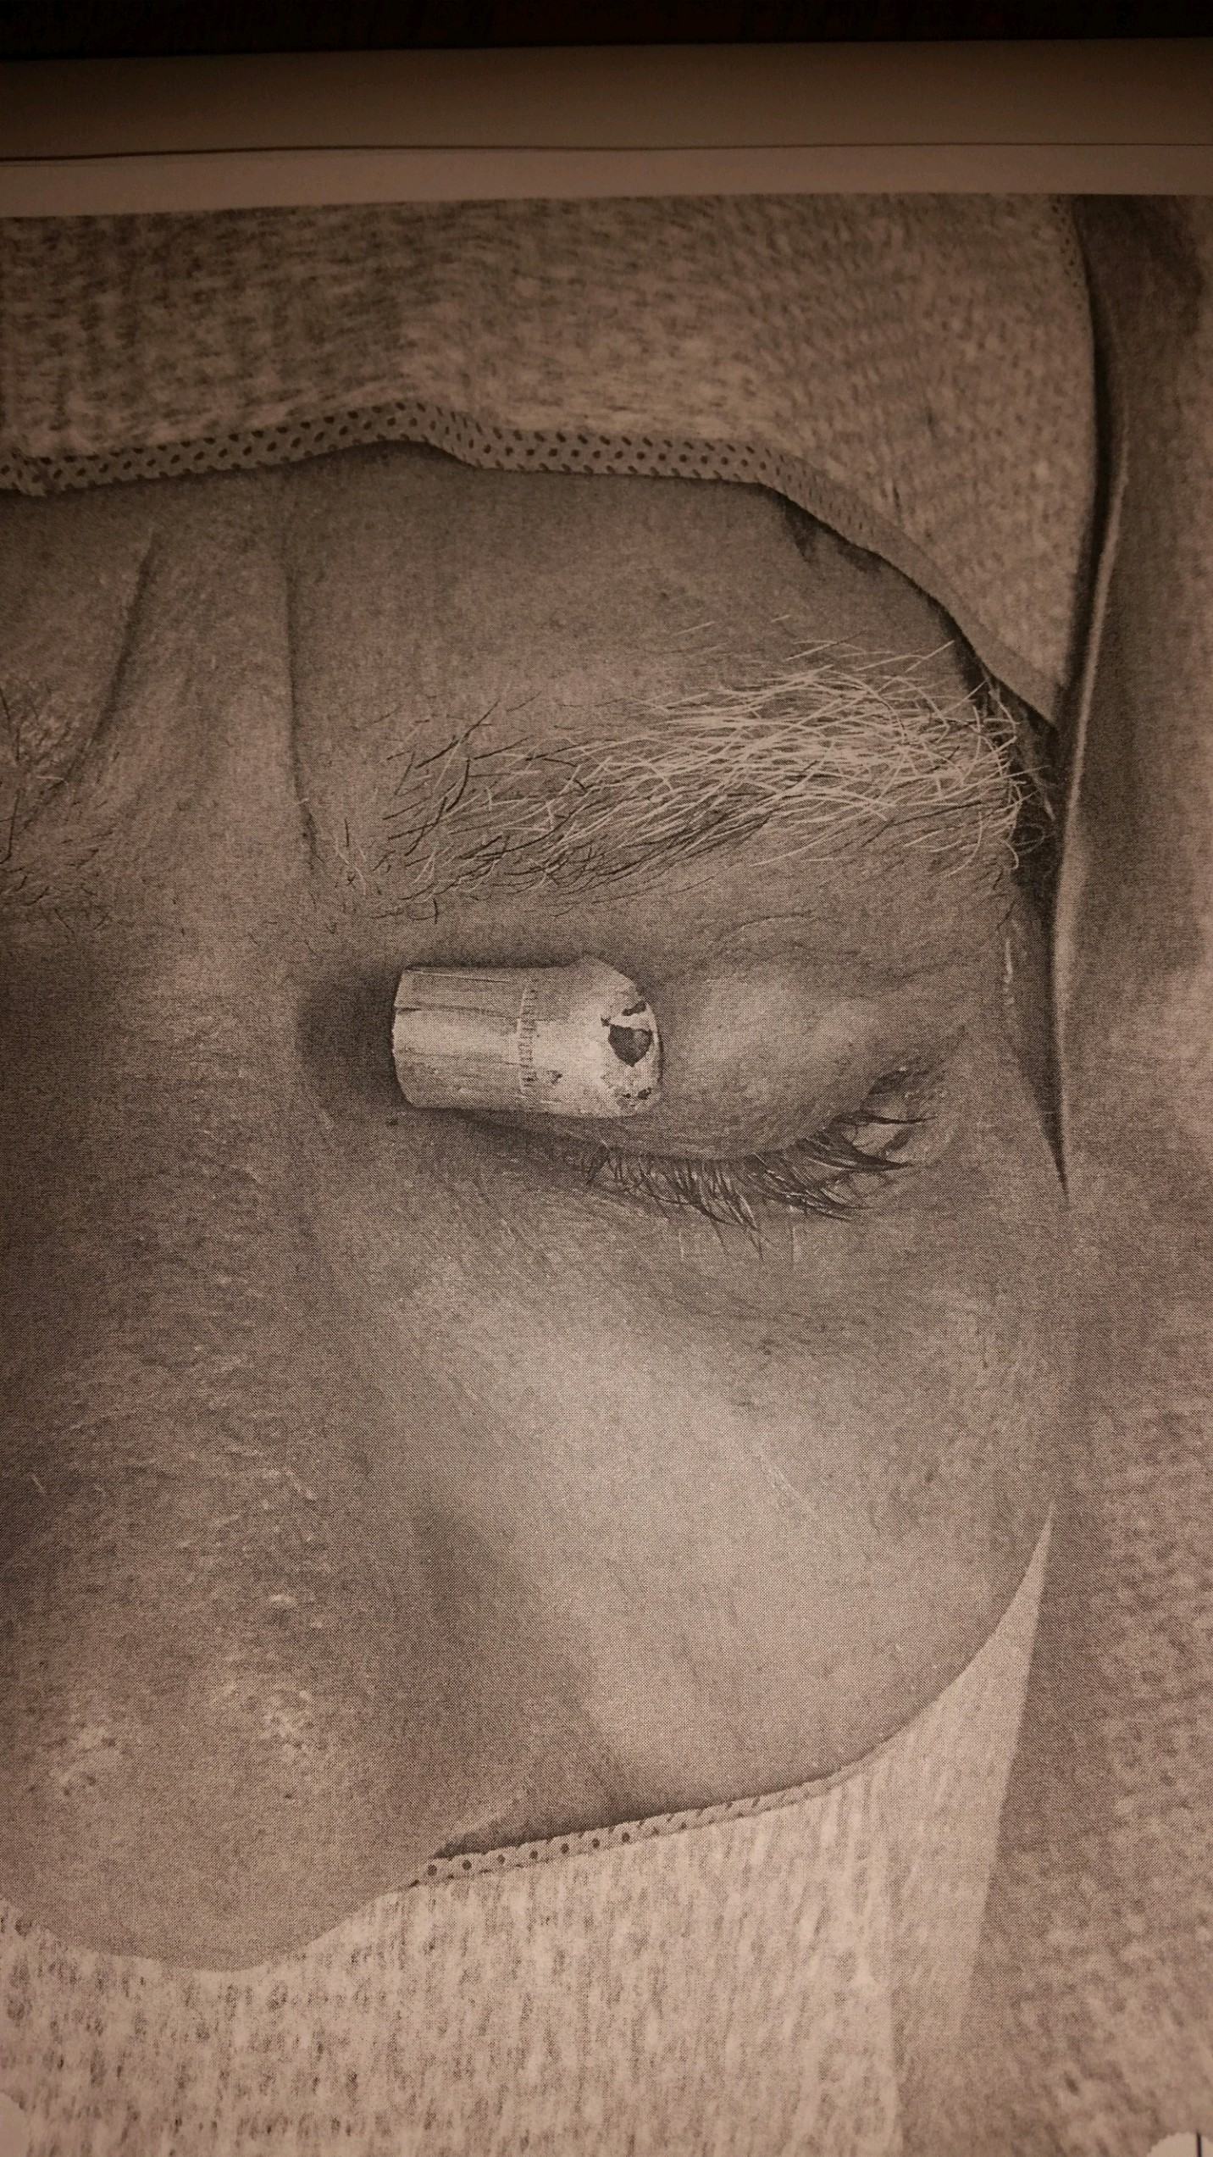

CJ’s life story reads like a work of fiction, but it is real, CJ is the real deal, CJ is a unique and iconic figure and CJ’s story is worthy of some form of media dissemination. Hopefully this document will help in making that a reality.

FACTS DEPICTING EXPERIENCES FROM CJ’S LIFE

CJ’s life has unfolded like a Hollywood movie. From his teenage childhood in Providence where he fell in with neighborhood gangs who were part of a stolen car and parts ring.

During a street fight CJ was noticed by John Ouimette 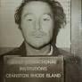who was a long- time underworld figure and brother of Gerard Ouimette. He saw potential in CJ’s fighting ability and brought him to Grundy’s Gym for training. He sparred with people from all sides of the law, future State Police Superintendent Brendan Doherty, Dino Denis and many more.

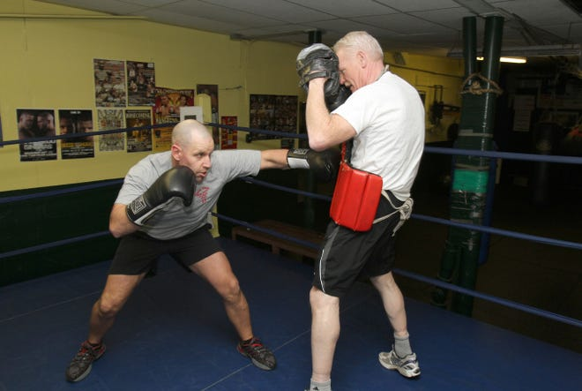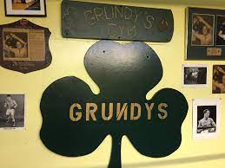

This started CJ’s life as an underworld associate. CJ’s fighting ability and stand-up guy persona earned him the respect of Ouimette and CJ was given “jobs” to perform. These ranged from delivering “goods” for the Ouimette’s to collecting debts owed to the Ouimette’s. Eventually CJ became John Ouimette’s personal bodyguard and became a part of numerous underworld endeavors.

Eventually CJ’s influence and trust grew among the Ouimette crew and in the late 70’s CJ was at the ACI awaiting bail for a serious Newport melee when he was noticed by Raymond Patriarca, who was also at the ACI, for his fighting ability in a prison boxing match. At first Raymond Patriarca did not take much interest in Nordstrom until he learned his mother was Italian, Vescio, Gerard Ouimette and Patriarca then decided to get him into the professional boxing arena.

During this stay at the ACI Gerard Ouimette 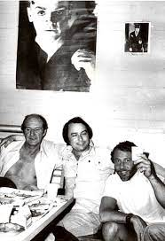told CJ his talent with his hands in fighting should not be wasted being a mob associate and he told him he wanted to get him into the professional boxing world.

When CJ was released on bail from the ACI Gerard Ouimette “sold” CJ’s fighting contact to boxing promoter and movie actor Jack O’Halloran (Superman Movie villain) and Don Elbaum because Ouimette being a felon could not legally be part of the professional boxing circuit or have an interest in a fighter. Ouimette and Patriarca still owned CJ.
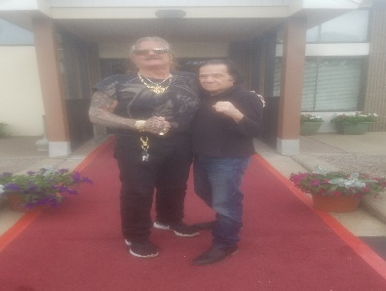Don Elbaum

CJ was sent to the Dunes in Las Vegas and began his training with O’Halloran, Elbaum and Gene Kilroy who was Ali’s friend, promoter, and road manager. He trained there for 2 years. He became good friends with O’Halloran, Elbaum and became Ali’s sparring partner.
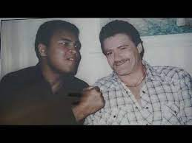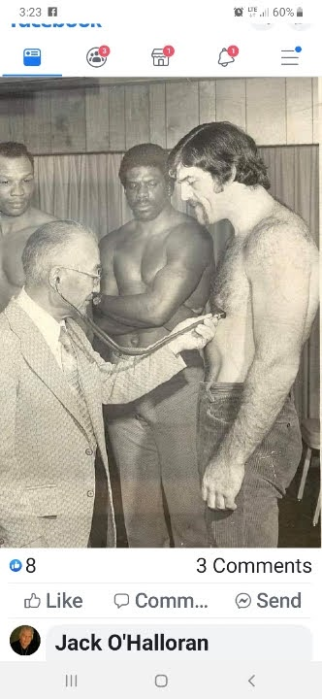Lyle & O’Halloran

CJ trained with O’Halloran and was also trained by heavyweight Ron Lyle. (above)

One interesting story-there were many more in Vegas:
Lyle picked up CJ every morning early and took CJ up to the mountains to train in the high altitude where he trained in places bobcats, lions and other wildlife roamed. One day Lyle’s car was stuck, and they took CJ’s Cadillac. On the way back to Vegas CJ told Lyle to take his feet off his dashboard. They got into an argument as they pulled onto Vegas Blvd and Lyle pulled a pen knife at CJ. CJ stopped the car grabbed a machete from under his seat and proceeded to chase Lyle down Las Vegas Blvd in daylight yelling “I will kill you, you black bastard”.
About 10 minutes after CJ returned to his room at the Dunes, he received a call from Gerard Ouimette, who was serving time in a federal prison, yelling, and screaming about him going wild in Vegas and that he will kill him and bury him where no one will ever find him again. Ouimette wanted him to stay out of trouble to protect his professional boxing career.

Another time after the bonded vault robbery one of the robbers, Dussault, went to Vegas and started gambling a lot, the other robbers started to be concerned so Danese and Flynn were sent to Vegas to kill Dussault. Dussault and Flynn had been childhood friends and Flynn couldn’t kill Dussault. Flynn and Danese wanted to hide out in CJ’s room because they were still hiding from the Bonded Vault aftermath. Gerard Ouimette found out and again called Vegas and told Flynn and Danese to leave CJ out of it or they will be killed. Ouimette also prevented CJ from taking part in the Vault robbery as some of the other robbers tried to do. They were very invested in CJ’s future fight career and wanted him to be free from any involvements that would compromise that future. CJ’s fights were starting to be broadcast on ESPN.

There are many other interesting stories from CJ’s stay in Vegas including meetings with actors, politicians and how his fighting career was “managed” at first to insure he would become a heavyweight champion contender. An example was when in one of his first fights, CJ was still relatively young and inexperienced as a professional boxer, there was an Olympic champion boxer, and they were concerned that there might be a chance CJ could lose. They took the Olympic boxer out the night before and had him party all night with booze, girls and other substances and made sure he did not get to sleep but instead went right to the arena before fight time. CJ won.

Just when his boxing career was beginning to lead him to an eventual heavyweight championship the 1976 fight in a Newport bar came home to upend CJ’s boxing career. He was sentenced to 15 years in prison and went to the ACI in 1987.

He was paroled 5 years later with the help of a past Speaker of the House.

After parole he became a close friend and associate of Raymond Patriarca who liked CJ and tried to advise him as to what part of this life would be best for him. For example, many of the underworld associates wanted CJ to get his own crew and be the boss. Patriarca advised him not to do this as the potential downside for him was too great. Patriarca told him to remain a “loner” and just do what is asked and be a friend to all. He also gave him advice on a lot of other subjects that can be related in more detail.

There are hundreds of stories that read like movie scripts that can be documented in more details that deal with judges, politicians, lawyers, businessmen and law enforcement officials. One candidate for Speaker needed a vote to become Speaker and CJ was tasked to get him that vote. He did and the person became Speaker. His history with Raymond Patriarca and now his son Junior reads like a work of fiction. Likewise, his relationships, many good, with law enforcement personnel would surprise many and make very interesting reading.

CJ’s had extensive personal dealings with figures such as John Gotti, Raymond LS Patriarca, Ray Patriarca, Jr, Vito DeLuca, Dino Denis, Richard Gomes, Robert “The Deuce” Dussault, Charles “Chucky” Flynn, Joe “the Dancer” Danese, Gerard Ouimette, John Ouimette, Gerry Tillinghast, Jacob Tarzian, movie stars in Vegas and countless others.

He has personal knowledge of the real circumstances of heists like the Bonded Vault Robbery. He knows the truth about mob killings, the how, the why, the when, and not the stories that are more widely accepted. He has personal knowledge of facts such as what Raymond Patriarca really wanted from the Bonded Vault Robbery, what he had flown back to a church in Italy located where his family originated. He has police officer badgers from scores of police departments in and out of RI given to him by law enforcement officials with whom he has shared experiences.

His life is filled with the stories that the movies love to document. It is not fiction but the real deal inside facts little known by most.

Below are some videos concerning the life of CJ. Just click on them.
(if they do not open on this page just hover over the picture and paste the URL address in your browser to reach the video page)

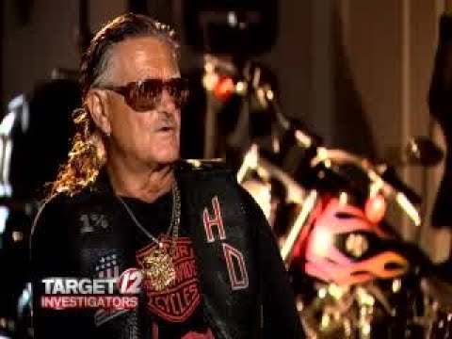

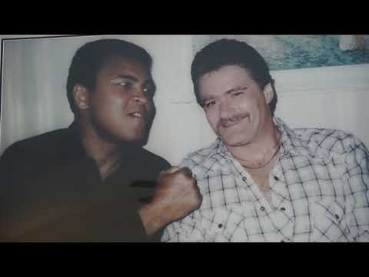

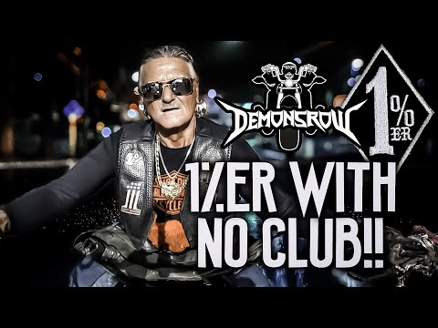

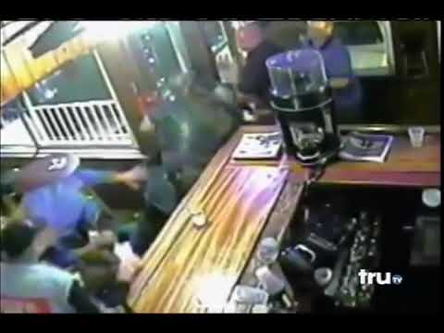

THERE ARE MANY ONINE VIDEOS FOR CJ. JUST GOOGE CJ NORDSTOM OR CJ VESCIO TO FIND MORE

SOME HISTORICAL REFERENCES CONCERNING THE LIFE OF CJ

BLACKSTONE VALLEY

Renegade biker CJ Nordstrom speaks about violent clashes, in the ring and out.
by: Tim White
Posted: Oct 27, 2017 / 01:00 AM EDT
Updated: Oct 27, 2017 / 01:00 AM EDT
SHARE
PROVIDENCE, R.I. (WPRI) – C.J. Nordstrom’s motorcycle was likely the magnet for trouble.
The custom Harley-Davidson he has been riding and modifying for more than four decades is well-known in the biker world with its long frame, metal skulls, high back seat and an array of dangling objects including a set of teeth.
“You see that bike, you know its C.J.’s,” Nordstrom, now 64, said in his first-ever TV interview. “I usually say it outlasted my marriage and all my girlfriends.”
ADVERTISING
He figures that’s just what a group of bikers – including two members of the Hells Angels – thought when they spotted it outside a Bristol restaurant days before the town’s landmark 4th of July celebration in 2009. Nordstrom said he and some friends went to what was then the Topside Lounge to scope it out for his college-aged daughter, who had just made friends with some students at the nearby Roger Williams University.
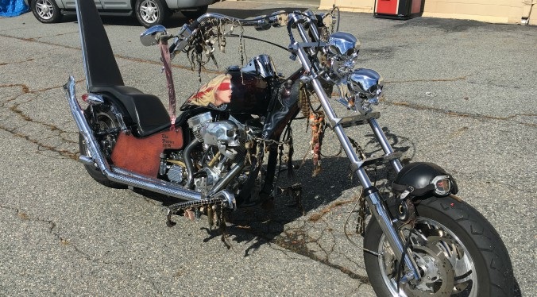
“I never knew how it was at night,” he recalled. “I just checked out the bar that night to make sure it was a cool place for her to be safe in.”
In surveillance video obtained by Target 12 from that night, one member of the Hells Angels is seen walking up to Nordstrom, a massive and imposing figure with hands like cinderblocks. After some words are exchanged, the Hells Angels member gives Nordstrom a shove. For a second, the video shows Nordstrom staring at the rival biker; then in the blink of an eye, a fist is thrown. A rapid right-hook from Nordstrom puts the Hells Angels member on the floor, and all hell breaks loose.
“In the street … there’s no rules,” said Nordstrom.
- WEB EXTRA: Watch an extended interview with C.J. Nordstrom
It wasn’t the first time Nordstrom had beaten a member of the Hells Angels, which is why investigators believe the fight in Bristol took place.
“He decked, laid out, almost killed a full-patch member of the Hells Angels,” said former R.I. State Police Col. Steven O’Donnell, who was second in command when the Bristol brawl broke out. “Typically, by their bylaws and their rules, there has to be retaliation.”
There was so much concern about the potential for violent payback by the Hells Angels that state police kept watch on Nordstrom’s home following the fight, Target 12 has learned.
The night of the fight, Nordstrom and his crew hopped on their bikes and were making their way out of the coastal community when they were stopped by Bristol police officers. An arrest report shows police found two knives on Nordstrom when they ordered him to the ground and cuffed his hands behind his back.
Neither weapon was used in the fight.
“I’d rather shake your hand than end up hurting you,” Nordstrom said in the interview. “You’re in that environment … and there are guys out there that wonder if they can kick your ass, you know?”
Nordstrom ended up pleading no contest to misdemeanor charges of disorderly conduct and “possession of a weapon not firearm,” and was ordered to pay a small fine. Nordstrom shrugged off the fight, acknowledging he can be a magnet for trouble.
“I felt bad for the bouncer,” he said. From street to ring fighting
Dustups between rival bikers have put local law enforcement on high alert, concerned that warring factions like the Hells Angels and the Outlaws Motorcycle Club could lead to innocent bystanders getting caught in the middle of a violent clash.
For his part, Nordstrom is unaffiliated with any gang, choosing instead to be an independent biker.
“He decided that those clubs were beneath his dignity,” O’Donnell said. “He decided to be an independent person and do what he thought he wanted to do.”

Part of it, Nordstrom said, was he would “embarrass some of his friends” in law enforcement if he became what’s called a full-patch member of a motorcycle gang.
“I’m a gypsy, I don’t fly patches,” he said. “I didn’t need that kind of recognition.”
But the biker world can be a small community, and Nordstrom has forged relationships with members of those clubs. Investigators tell Target 12 he has contact with the Outlaw Motorcycle Club, most likely they say because of the old saying “the enemy of my enemy is my friend.”
Nordstrom said he even had friends who were members of the Hells Angels in other states, but claims they are now forbidden to talk to him because of his clashes with the Rhode Island chapter of the club.
“I feel bad that I can’t talk to them or hang with them anymore because of what went on in Rhode Island,” Nordstrom said, punctuating the thought with an expletive. “I guess that’s a house rule.”
Before his sensational beefs with other bikers, though, Nordstrom was on the police radar for his close ties to a powerful and ruthless faction of organized crime in Rhode Island: the Ouimettes.
In the late 1970s, Nordstrom’s path crossed with Gerard Ouimette, the leader of a gang with strong ties to legendary mob boss Raymond L.S. Patriarca. Associates included Jerry Tillinghast and Ralph “Skippy” Byrnes – two men who were charged in the infamous 1975 Bonded Vault robbery.
Nordstrom speaks of Gerard and his younger brother John Ouimette like someone talking about beloved family members, and said it was a prison conversation with the eldest Ouimette at the Adult Correctional Institutions in Cranston that propelled him into a professional boxing career.
“He sat me down and told me that my talent with my hands I was totally foolish to want to be Joe Biker,” Nordstrom said. “They were fight fanatics – they were into the fight game big time.”
One man who sparred with Nordstrom was the future superintendent of the R.I. State Police, Brendan Doherty. An imposing figure himself, Doherty said he and Nordstrom worked out at the same gym – Grundy’s in Central Falls – and they occasionally faced off against each other.
“C.J. had unusually long arms and because of that he could surprise people with a jab because his arm extended another four or five inches,” Doherty said. “He was a tough guy. I was hitting him with brutal shots, and he would step back smiling at me just to let me know I wasn’t hurting him.”
Doherty wasn’t yet in the ranks of the state police when he fought Nordstrom and was also toying with a career in boxing at the time, but “it didn’t take a criminal investigator to figure out C.J. was up to no good sometimes.”
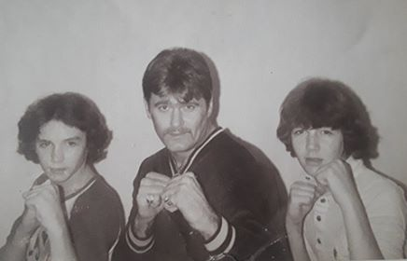
“That was an education for me,” Doherty said. “There were good guys and bad guys in the gym, but it was like a neutral zone: they could come in and get the workout in the ring, but once you stepped outside that door those two sides didn’t want to be affiliated.”
Nordstrom’s right hand – sporting rings the size of wrist watches – is a gnarled human meat cleaver with a couple of fingers pointing in the wrong direction. (Broken and never properly set, “mostly” from boxing, Nordstrom said.) His bike has “The Hunter,” his boxing nickname, etched on the side.
It was the Ouimettes who Nordstrom said helped fund his start in pro boxing, putting him up for two years at the Dunes Hotel in Las Vegas while he trained with big-name fighters.
“When you make a deal with a guy like Gerard Ouimette you learn really quick to stand by your half,” Nordstrom said. “That kind of straightened my world out.”
But it was too late to be straightened out. By the time Nordstrom’s matches were being aired on ESPN, another fight had already happened that would end it all. A criminal case stemming from a 1976 melee at a Newport bar – resulting in five people from a wedding party getting stabbed nearly to death – was looming over him.
While boxing, Nordstrom used his mother’s maiden name, Vescio, as his true surname was winding its way through the state courts.
After nearly a decade of legal wrangling, which included a new trial after a judge was overheard referring to Nordstrom and his crew as “bad bastards” – “the judge did me a favor on that,” Nordstrom smiled – the outcome was an 18-year sentence for the crime. Nordstrom walked into the ACI in 1987, but was granted parole after less than five years, according to prison records.
“His career was sidelined from prison,” Doherty said. “He wasn’t the first guy that happened to.”
Investigators say Nordstrom’s relationship with the Ouimettes was another occupation itself and it continued to thrive after his stint in the can. Those ties to organized crime landed Nordstrom firmly on the state and federal law enforcement radar screen as an associate of the infamous crew.
Relationships between outlaw bikers and members of La Cosa Nostra aren’t uncommon, according to O’Donnell. It’s the added muscle that increases fear and intimidation.
“Having a guy like C.J. around John [Ouimette], it just makes him more legendary,” O’Donnell said. “It’s always nice to have someone with that background that is capable with their hands to make sure that you’re intimidated … that you’re not going to mess with that faction.”
Doherty said Nordstrom “was his own gang,” but mobsters benefitted from the biker’s close relationship with them.
“They liked him, and why wouldn’t you?” Doherty said. “You bring C.J. in a room and people stop talking, stop eating… he’s a serious-looking guy.”
Nordstrom was never charged in any case that ensnared the Ouimettes, but he clearly enjoyed his status with the clan.
“I hung with [John Ouimette] night and day,” Nordstrom said. “He didn’t need a gun when C.J. was standing beside him.”
Gerard Ouimette died in prison in 2015 while serving a life sentence under the federal three-strikes law. John Ouimette died earlier this year.
“They taught me: give respect, you get respect,” Nordstrom said. “Somebody don’t give you respect, [expletive] them, they don’t get respect.”
Nordstrom has been pegged by law enforcement as a “one percenter,” a term used for bikers who are not the 99 percent of law-abiding riders.
“C.J. is a violent guy,” Doherty said. “There is no question about it.”
Nordstrom doesn’t hide from the outlaw biker designation, either, sporting a “one percent” patch on his leather vest and the number “1” tattooed on a finger. But confronted with the idea the label makes him a criminal, Nordstrom pushed back.
“I’m far from that – I don’t pimp off no broads, I don’t shake nobody down,” he said. “I make pay like a regular Joe blow [as an] ironworker, truck driver.”
“I used to be a bone-breaker, but it was professional,” he added, shrugging.
Nordstrom said when he adopted the one percent mentality and identity more than four decades ago, it wasn’t about being a scofflaw, it was about the type of motorcycle someone rode.
“A one percenter is someone who didn’t ride a stock motorcycle,” he said. “Back then it was all bikes, booze, and broads. We used to joke about the ‘three B’s.'”
Ironically, along with the one percent patch is a replica Providence Police badge, a nod, he said, to a street cop decades ago whom he had a lot of respect for. “I prefer my son to be Joe cop before some back-patch holder on some [expletive] motorcycle,” he said.
Still, he said he doesn’t reach out to police if he finds himself in a jam.
“I don’t prefer to call the cops,” he said. “I usually take care of my own laundry.”
That lifestyle, Doherty said, comes with risks.
“He had a lot of courage in the ring and in the street,” Doherty said. “Most guys in that situation don’t live to be old men.”

Is Jack O Halloran the son of Albert Anastasia?
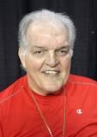
Early life and boxing
O'Halloran was born in Philadelphia, and was raised by his mother, Mary, and stepfather, Peter Paul Patrick O'Halloran; in his book Family Legacy, he claimed to be the illegitimate son of mafia hitman and crime boss Albert Anastasia. He lived in Runnemede, New Jersey.

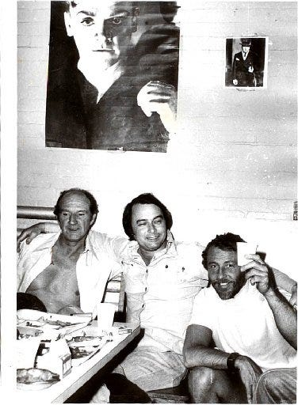
>From left, Richard Gomes, Gerard Ouimette and Ronnie Sweet live it up
in the ACI in the late 1970s.
Special to The Journal
NORTH PROVIDENCE - Richard "Red Bird" Gomes, a violent mobster
who terrorized the state for decades, died quietly on Sunday in his
apartment near the Smithfield town line.
The North Providence police reported that two of Gomes' nieces -
who were not identified - found their uncle at 6:15 p.m. lying
fully clothed on the living room couch in his apartment at 242 Waterman
Ave. He was unresponsive and the women called 911. The police said that
it appeared Gomes, 73, died of natural causes. Several bottles of
medication for respiratory problems were found on a kitchen counter.
On the wall of his apartment were photographs of two powerful old
friends: John Gotti and Raymond L.S. Patriarca.
"When it came to organized crime activity, the guy never took a day
off," said Brian Andrews, retired detective commander of the Rhode
Island State Police. "Prison never stopped him from doing what he did
every single day. He was a seasoned, cold-hearted killer. If there was
a New England Wise guy Hall of Fame, he would be a shoo-in."
Gomes, who grew up in South Providence, turned to a life of a crime as
a kid. At age 12, he was arrested for breaking into a freight car in
Providence. Twice, he spent time in reform school as a teenager, and at
age 17, joined the Army.
The disciplined life of a soldier was not for Richie Gomes.
In 1951, 10 months after joining the service, Gomes deserted after his
unit was about to move into combat in Korea. He was sentenced to five
years for desertion with intent to avoid hazardous duty. While in
prison at Camp Gordon, Ga., Gomes took part in a mutiny in which
several guards were injured, and the camp nearly destroyed. He was
court-martialed in January 1953 and sentenced to 45 years of hard labor
in Fort Leavenworth, Kansas.
Eventually, Gomes was released from prison, and he returned to Rhode
Island.
As a young man, he joined a crew of non-Italian mobsters led by Gerard
T. Ouimette, a feared mob enforcer who had strong ties with crime
families in Providence, Boston and New York City. Gomes and Ouimette
could not be formally inducted into La Cosa Nostra because their
mothers were not of Italian descent. Still, they had close ties to
powerful Italian mobsters across the Northeast and they were
well-respected in the underworld.
Gomes held a special stature in the Rhode Island criminal world. He had
been a lifelong friend and the onetime driver for the late Gotti, also
known as the Dapper Don, the charismatic head of the New York-based
Gambino crime family. In the late '60s, Gomes and Gotti struck up a
friendship while they were both serving time in the federal
penitentiary in Lewisburg, Pa.
In Rhode Island, Gomes was constantly in trouble. In 1972, he stabbed
to death Robert Cullen, 46, of Providence, in the basement of a
Johnston bar. He pleaded guilty to second-degree murder and was
sentenced to 25 years in prison.
In 1975, while serving that sentence at the Adult Correctional
Institutions, Gomes and three others ganged up on a fellow inmate and
nearly beat him to death with lead pipes.
Gomes spent more than 50 years in prison, and he lived a charmed life
behind bars. Retired state police Cmdr. Andrews said that Gomes and
Ouimette ran the North State Wing of the prison, also known as "Steel
City." They regularly had food catered into the maximum security
prison and, through messengers, they continued to oversee their
criminal empire on the outside, he said.
Gomes was freed from the ACI in 1979.
The bond between Gomes and Gotti grew even stronger after the murder of
Gotti's neighbor.
On July 28, 1980, John Favara, Gotti's neighbor, disappeared shortly
after he killed Gotti's 12-year-old son, Frankie, in a car accident.
The boy was riding a borrowed mini-bike on the street outside his home.
Shortly after Favara's disappearance, detectives visited Gotti at the
Bergin Hunt & Fish Club in the Ozone Park section of Queens.
"I'm not sorry the guy's missing," Gotti told the police. "I
wouldn't be sorry if the guy turned up dead."
According to several New York City newspapers and law enforcement
authorities, Gomes joined seven members of Gotti's crew, which
abducted Favara, stole his car, and killed him. They dumped his body and
had his car crushed in Brooklyn, destroying all evidence of the crime.
Andrews, the retired state police commander, said he has "no doubt"
that Gomes participated in the murder.
In the 1980s, Gomes descended into a world of late nights, cocaine and
violence. In March 1985, he opened fire on two men who were sitting in
a car eating wieners outside the New York Systems diner in
Providence's Olneyville Square. He emptied four shots into the two
men, leaving them seriously wounded.
A few years later, Gomes went on trial for the shootings and was
convicted of assault with intent to commit murder. As the guilty
verdict was returned, Gomes turned to his lawyer, John F. Cicilline,
and kissed him on the cheek.
Gomes spent the next 16 years in prison. He was released from the ACI
on Aug. 1, 2005. Gomes, who was frail and in poor health, spent his
days at a Johnston social club where he hung out with young men who had
served time with him in prison. State police Maj. Steven G. O'Donnell
said that, on the street after his release last year, Gomes made
"every attempt to ingratiate himself" with made members of the
Patriarca crime family.
"He was not welcomed with open arms," O'Donnell said. "Some
would deal with him. Some would not."
Gomes had lost his power. Gotti was dead and Ouimette is serving a
sentence of life without parole in federal prison. The old mobster was
just another old guy looking for a few bucks and some respect. On
Sunday, he left this world and joined his old friends Gotti and
Patriarca.

