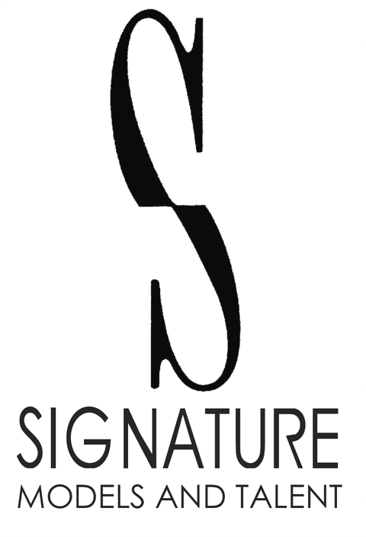
5743 E. Thomas Rd. Suite 1
Scottsdale, AZ 85251
Phone: 480-966-1102
Fax: 480-223-6444
mailbox@signaturemodelsandtalent.com

Kimiko Peterson

Height: 5’3” | Weight: 117lbs | Hair: Brown | Eyes: Brown

COMMERCIALS

Beltone | Principal | Windsong Productions
FightCamp  Seabourn Cruise Line  MGM Resorts  Zappos  LVCVA  Nevada State Bank  Southwest Medical  SNWA  Lexus of Henderson | Las Vegas  Absolute Dental  Cisco  Sunseeker Resorts  Blue Heron Living  International HomeBuilder  Laughlin | Principal  Principal  Principal  Principal  Principal  Principal  Principal  Hand Model  Principal  Principal  Principal  Principal  Principal  Principal  Principal | FightCamp  Seabourn Cruises  MGM Resorts  Zappos  R&R Partners  Nevada State Bank  Abe Froman Productions  Abe Froman Productions  Lexus of Henderson | Las Vegas  Levy Productions  Cisco  Sunseeker Resorts  Blue Heron Living  Lemonlight Productions  R&R Partners
THEATRICAL FILM

Animal Justice | Supporting | Danny Tesla, Director
Goldilocks and the Two Bears | Supporting | Jeffrey Lipsky, Director
Riot in Bloom | Supporting | Brett Levner, Director
Spilling Secrets  Skeleton’s in the Closet  Absolute Dominion | Co-starring  Featured  Stand-in | Faith Nault, Director  Asif Akbar, Director  Lexi Alexander, Director

VOICEOVER

“List available on request”

TRAINING

The Voice Actor’s Studio | Voice Acting | Melissa Moats
Film and Television | Theatrical | Ken Braun

SPECIAL SKILLS

Stand-in, Teleprompter, Host, Hand Model, Running, Hiking, Paddle boarding, Kayaking, Canoeing, Rafting, Horseback Riding (General), Pilates, Bike/Spin, Yoga, Cheerleading, Rappelling, Rock Climbing, Jump Rope (General), Boxing

