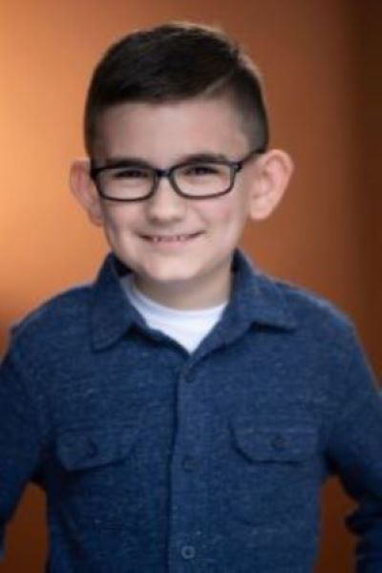 | - Aiden Flynn  Actor
CONTACT  Los Fresnos, TX 78566  (956) 923-1846  Aidenjflynn777@gmail.com  Physical characteriscics  Height: 54 in  Weight: 72 lbs  Eyes: brown  Hair: brown  Skills  YouTube Channel  Drawing  Gaming  _________________________________  Personality traits  Goofy personality  Friendly & Easy going  Caring  Good with animals | Education  Palmer-Laakso Elementary  Los Fresnos, TX 78566  ________________________________________________________  Ongoing class & training  MDA Acting, On-camera acting, audition prep, cold reading, improv,  07/2019 – Present, 517 E Schunior St, Edinburg, TX 78541  San Benito Music Academy, Voice lessons, 05/ 2024 – present, 295 W  Bus 77 Suite C, San Benito, TX 78546  Aquatots, Swim Lessons, 04/2024 - present  3340 Pablo Kisel, Ste. C-204, Brownsville, TX 78526  ________________________________________________________  Experience - MDA Acting  Short film: An Ungrateful Christmas scripted by Aiden Flynn, 12/2023  Short film: Evil Reflection scripted by Aiden Flynn, 04/2023

