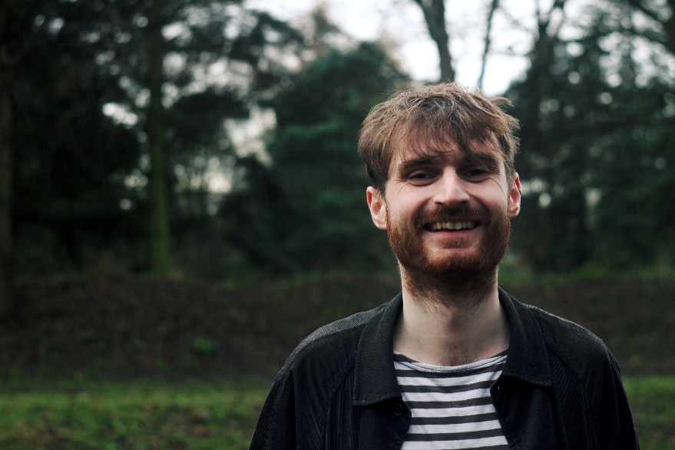

Will Frampton is a composer of acoustic and electronic music whose work has been commissioned for and performed by ensembles such as Psappha Ensemble, Ligeti Quartet, Berkeley Ensemble, Allegri Quartet, Orion Orchestra, and BBC National Orchestra of Wales. He is a member of the electronic music duo The Keeling Curve whose work has received funding awards from Sound and Music, Arts&Heritage, Arts Council Britain. They were shortlisted for the inaugural Tippett medal in 2020 and have undertaken a BrittenPears creative retreat in Aldeburgh. Will has taught composition at the University of Manchester, Junior Royal Northern College of Music, and delivered workshops for the Foundling Museum and Manchester Museum of Science and Industry. He is currently a composer for the Birmingham Contemporary Music Group’s ‘Listen Imagine Compose Primary’ project. https://www.willframpton.co.uk/.

