Roy Lin
E-mail: roylin0628@gmail.com
Skype/Teams ID: roy.lin5
WhatsApp number: 886965307971
OBJECTIVE
Application for the freelance translator from English to Simplified Chinese and Traditional Chinese (Taiwan) and vice versa. Equipped with a bachelor degree in Jin-Wen College, I majored in English. I started a career as a translator at Medi-Lan Limited in May 2005. The scope of my duties encompassed translation for the fields of government, automobile, renewable energy, energy storage, general, transportation, fashion, agriculture, politics, finance, banking, subtitle, medical science, health care, crypto, construction, economy, marketing, app, education, chemistry, gaming, localization, CSR, technology, tourism, travel, dental content, IT, pharmaceuticals, medical equipment, automobiles, machinery, rail transportation, and legal. A cheerful disposition, can-do attitude and interpersonal ability make me a strong candidate for the translator and I am certain that my experience will add value.

Employment History
- Freelance Subtitle Translator | Zoo Digital
Jan. 2017 – July. 2023
Translate, proofread, and transcript subtitles of movies, general domain documentary film, and dramas from English to Traditional and Simplified Chinese, and vise versa.
Freelance Translator | ONEHOUR TRANSLATION
Aug. 2016 – Now
Translate and proofread documents and books, including gaming, fashion, finance, banking, government, engineering, manual,medical records, proof of diagnosis, chemistry, patient information leaflet, discharge summary, clinic trial, politics, construction, press release, app, pharmaceuticals, medical equipment, automobiles, machinery, rail transportation, economy, crypto, design, Environmental sustainability, Human development, Human rights, Social justice, agriculture, Arts, pharmaceutical (CMC), environmental science, beauty, education, automobile, health care, legal, marketing, life science (CTA), travel, tourism, IT, and technology from Traditional or Simplified Chinese to English and vice versa.
- Freelance Translator | PTSGI
Jul. 2016 – Now
Translate and proofread documents, including IT, finance, automobile, chemistry, banking, fashion, beauty, government, Social justice, Arts, mechanical engineering, app, pharmaceutical (CMC), education, politics, press release, banking, economy, design, CSR, agriculture, environmental science, education, marketing, travel, tourism, pharmaceuticals, medical equipment, automobiles, machinery, rail transportation, technology, gaming, construction, life science (CTA), drug clinical trial informed consent, Investigator's Brochure, and law from English to Traditional or Simplified Chinese and vise versa.
- Freelance Translator | TransPerfect Translation
Aug. 2011 – Now
Translate manuals, documents, including marketing, automobile, design, fashion, beauty, IT, law, Environmental sustainability, Human development, Human rights, agriculture, Social justice, gaming, life science (CTA), medical law and statute, medical device, DMF, app, medical promotion policy, education, pharmaceutical (CMC), finance, banking, pharmaceuticals, medical equipment, automobiles, machinery, rail transportation, technology, tourism, and travel from Traditional or Simplified Chinese to English and vice versa.
Freelance Translator | Medi-Lan Limited
May 2006 - July 2011
Translate subtitles of dramas and document translation for the fields of government, fashion, politics, finance, banking, Arts, pharmaceutical (CMC)design, subtitle, medical science, health care, economy, marketing, education, gaming, localization, CSR, IT, and law from English to Traditional or Simplified Chinese and vise versa.

Finished Projects:

Subtitle projects finished:
Escape to the Country Collection: Season 22 (Netflix) | May 15, 2018
Escape to the Continent: Season 1 (Netflix) | Feb 11, 2018
Great British Menu: Season 7 (Netflix) | Feb 05, 2018
Great British Menu: Season 7 (Netflix) | Jan 24, 2018
Big Dreams, Small Spaces S2 (Netflix) | Jan 12, 2018
Chrisley Knows Best: Season 2 (Netflix) | Jan 10, 2018
Tiempos De Guerra (Netflix) | Dec 06, 2017
The Little Mermaid (Disney) (8 episodes) | June 2 to June 18, 2021
The Practice (Disney) (22 episodes) | June 20 to July 31, 2021
Jungle Explorer (Disney) (5 episodes) | June 20 to July 31, 2022
The Muppet Show (Disney) (8 episodes) | Nov. 12 to Dec. 31, 2022

Experience of Gaming field for English to Traditional and Simplified Chinese and vise versa (From 2005- Now)

Online Game : Dungeon & Fighter(84,200 words) , Black Desert(126,000 words), Kingdom Under Fire 2(48,000 words), Lost Ark(67,000 words), Street Fighter V (23,000 words), Call of Duty: Modern Warfare I (55,000 words)
Single Player Game: Sword and Fairy 7(20,000 words)
Mobile Game :Black Desert Mobile (95,200 words)

Document translation finished:
2025/02/20-- regulatory submissions and product leaflets
2025/01/13-- clinical study reports
2024/09/28— Operation manual of tomography equipment
2024/9/23-- Strategic planning document of Business Consultation
2024/08/19-- Carpal tunnel syndrome
2024/08/09-- AI-driven training material development (Amazon)
2024/08/06-- Orthopedic Suction Tube
2024/07/23-- Regulatory Authorities Documents
202407/19-- Financial management system
2024/07/16-- Study Protocols and Amendments
2024/07/13-- Federal Voting Rights Act (F-VRA)
2024/06/20—Operation manual of X-ray machine
2024/06/19-- Marketing to operations management
2024/06/18-- i-Sports betting Website visitors and apps users translation
2024/06/15-- Candidates’ political views of the state assembly
2024/06/09—Optimized Training AI tool (Facebook)
2024/06/05—Policy Papers
2024/06/04-- Congenital musculoskeletal conditions
2024/06/03-- Localization of Gaming and online casino websites and apps
2024/05/30-- Congress reports
2024/05/28-- County Voter Information Guides (CVIGs)
2024/05/26-- Documentation and circuit diagrams for systems (Toshiba)
2024/05/20-- Localization of bookmaker websites with sports bets and gambling software
2024/05/14-- Technical documentation for electrical installations (Sony)
2024/05/12-- Torn ACLs and meniscuse
2024/05/10—Operation manual of articulated beds
2024/05/09 Local Ballot Measure Information
2024/05/06-- Environmental studies (19,000 words)
2024/04/19-- Fire protection documentation (Sony)
2024/04/17-- SOP Documentation
2024/04/16-- Energy security reports (13,000 words)
2024/04/12-- Bone breaks and fractures
2024/04/10—Manual of electrocardiograph
2024/04/08-- Translation and adaptation of feature stories, videos and other types of iGaming
2024/04/02-- Internet shopping sites (Look Fantastic)
2024/03/29-- Search engines (Google)
2024/03/28—Informed Consent Forms
2024/03/27—Reports on integration, discrimination and migration
2024/03/26— Printer Manual (HP)
2024/03/23-- Token documentation
2024/03/18-- Wind farm reports (8,000 words)
2024/03/17-- Vote Center voting materials and instructions
2024/03/15—Texts on development and humanitarian aid
2024/03/15—Bank Statements (E. SUN Commercial bank)
2024/03/08-- Initial Coin Offering (ICO)
2024/03/06-- Press releases (Microsoft)
2024/03/05—Architect planning
2024/03/04-- Report of vaccine adverse event
2024/03/02—Bank Agreements and contracts (First Bank)
2024/02/29—Apps and Software for Crypto
2024/02/25-- Documentation and circuit diagrams for systems (Panasonic)
2024/02/22-- Marine ecology studies (25,000 words)
2024/02/18-- Operation manuals of heavy machine
2024/02/09-- Drug registration documentation
2024/02/05—Slot Machine operation
2024/02/04-- User and service manuals of the vehicle
2024/01/29-- Field Safety Notices (FSN)
2024/01/27-- California Voter Bill of Rights
2024/01/26—Fund commentary (HSBC)
2024/01/25-- Test reports and protocols (Siemens AG)
2024/01/23-- Engineering specifications
2024/01/20-- device labeling and packaging
2024/01/16-- Safety training materials for heavy machine
2024/01/13-- Oprating Manual of X-ray machine
2024/01/06-- Product and vehicle specifications.
2023/11/03-- instructions for use (IFU)
2023/10/26-- Voter’s Choice Act notices
2023/10/20-- implant cards (ICs)
2023/09/23-- Licensing agreements
2023/09/20—Operating manual of Electric Dential patient chair with Instrument of light and arm
assembly
2023/08/19-- Request for trial for invalidation
2023/08/07-- Parts and equipment manuals of the vehicle.
2023/08/04—EVO of fighting games tournament
2023/07/28-- medical product information leaflets
2023/07/13-- Patent specifications
2023/07/09—Dential articles in medical journals
2023/06/25-- travel itineraries (Taipei City Government)
2023/05/17—Hotel brochures of Hilton
2023/05/09-- restaurant menus of Chinese restaurant
2023/05/02—Treatment Guidelines for Dential usage
2023/04/16—Dential research documents
2023/04/10—Regulatory Approval Packets for Dentist
2023/03/12—Marketing content of Dential Website content
2023/01/29—Shopping cart and production description localization (Look Fantastic)
2023/01/05—Booking system localization (Airbnb)
2022/03/19—Patent of Bayer blockbuster Xarelto enjoys surprise success at EPO
2022/02/16—Patent of Hanwha Q-Cells and Longi go pan-European over solar panels
2022/01/04—Patent of Meril and Edwards fight over transcatheter heart valves
2021/11/30—Intel® NUC M15 Laptop Kit

2021/11/26-- Intel® Retail Edge Program

2021/11/24--Intel® Retail Edge Program Worldwide - Build a Gaming Rig

2021/11/21--Intel® Evo Laptops description

2021/11/03—Stereo system manual (Logitech)

2021/10/23-- civil engineering training programs (New Taipei City Government)

2021/08/15-- operator manuals of construction machines ( Taipei City Government)

2021/08/11—Child Care Stabilization Grant, Office of Children and Family Services (New York City
Government)
2021/07/26—Office of Medicare Hearing and Appeals, Department of Health and Human Services
Office of the Secretary (New York City Government)
2021/07/15—Homeless, Unemployment, and State’s Failing Education System (Election for STATE ASSEMBLY)

2020/11/5—California General Election, Vote Safe (California Government)

2020/09/04-- An Ordinance Of The Board Of Directors Of The Lakeside Fire Protection District Enacting A Special Tax To Fund Fire Protection Services And Capital Improvements Subject To The Approval Of The Voters (Lakeside Fire Protection District) (Election)

2020/07/26-- UI and function description for AutoCAD software (AutoCAD)

2020/06/21-- Human Rights at Sea (15,000 words) (Human Right At Sea Organization)

2020/05/07-- Modern slavery conditions in fishing industry (Sebastien Malo, Reuters Foundation)

2020/05/05—MRT Dashboard operational manual (Kaohsiung City Transit Authority)

2020/05/03-- Medicinal Products for Human Use Documents for CMC Development (EMA Committee)

2020/04/25—Environmental harm &human rights abuses (World Wide Fund)

2020/04/05—Privacy Policies (Rakuten website)

2020/04/03 – UFC 4 (EA)

2020/03/26-- INDs for Phase 2 and Phase 3 Studies of FDA Guidance for Industry for CMC
Development (FDA)

2020/03/19 -- Human Rights and Social Welfare Baseline Project (Human Rights at Sea)

2020/03/14-- Career and Technical Education Planning (The Open University)

2020/03/08—Terms of Use (Abercrombie & Fitch website)

2020/03/05-- CGMP for Phase 1 Investigational Drugs, including INDs for Phase 1 Studies of Drugs.

2020/03/02—Individualized Education Program (NYC Department of Education)

2020/02/26—Terms of Services (BloomMe Pro)

2020/02/24— Battle Field One (EA)

2020/02/20—Immigration rights of fishing workers (Environmental Justice Foundation)

2020/02/15— The Sims 4 (EA)

2020/02/09-- Hotan Mineral Water Survey Summary

2020/02/06— Apex Legends (EA)

2019/10/8— Insurance Clause (Nan Shan Life Insurance Company, Ltd)

2019/09/26-- UBS Certification Derivatives (UBS)

2019/09/21-- Contract pertaining to the implementation of the Registry (CTA) (AO Foundation)

2019/09/17-- Pre-CTA Legal Fee Agreement (TransPerfect)
2019/08/24-- Scope only_PSOLAR_Taiwan_CTA (PSOLAR)
2019/08/19-- DV comparison btw GSI (CTA) (Gilead)
2019/08/02—ATS Integration (Glassdoor)
2019/07/29-- Securities Report (HSBC)

2019/07/21—Recruiting posting (Indeed)
2019/07/15--- HPETMA_Crystal-APJ (HP)
2019/07/06—Annual Report (E. SUN Bank)
2019/07/02--- Terms and Conditions (BloomMe Pro)
2019/06/21--- HPETMA_Prism-Structured-ACG (HP)
2019/05/18--- Creating Sweet Residence (Airbnb)
2019/04/15—Financial Statement (First Bank)
2019/04/08--- Federal Regulation of Tobacco
(INGCAT - International Non Governmental Coalition Against Tobacco)
2018/09/15--- Tobacco Regulation and Cost-Benefit Analysis (National Clearinghouse on Tobacco and Health)
2018/08/25 ~ 12/21--- Google Marketing Ads for cosmetics, apparel, fashion
2018/08/13---- Clinical Trial Agreement (Prahealthsciences)
2018/05/09--- Office 365 APIs platform overview (Microsoft)
2017/05/23---- Introduction of Taipei 2017 Universiade (Taipei City Government)
2017/01/05---- Summary Report of Mineral Water Survey (Hotan Inc.)
2016/03/19---- Labor Dispute Arbitration (Tandem Law Office)

Education
1999 – 2004
Jin-Wen Technology College
Major in Applied English
Translation Software
- Crowdin, MateCat, SDL Trados 2019, Lingotek, Google Translator Toolkit, Idiom, Workbench, XTM, Wordfast, Memoq, Smartling, SmartCat, Memsource, SubtitleEdit, Aegisub, Ooona

Certificates

1. Certified Translator of ALTA (American Literary Translators Association)

Earned on August 26, 2019

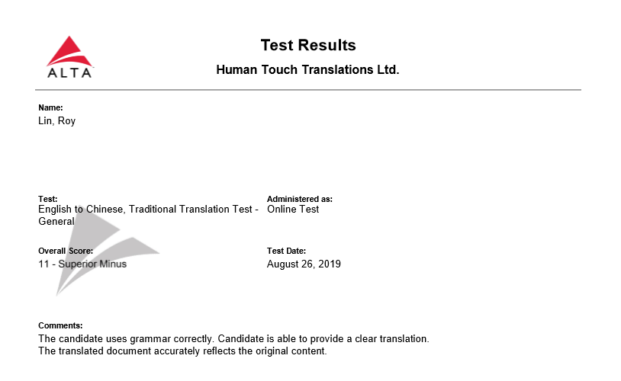

2. Gold Translator



Mars Translation Company

Earned on October 12, 2018

- Certified Translator



OneHour Translation Company

Earned on May 4, 2017

These are quality certification of translation and clientsatisfaction.
- Certificate of Attendance
International Language Institute (ILI)
Earned 08/18/2014
This International Language Institute provides a variety of resources in translation. I learned a lot of skills for translation.
- Pro Certified Translator

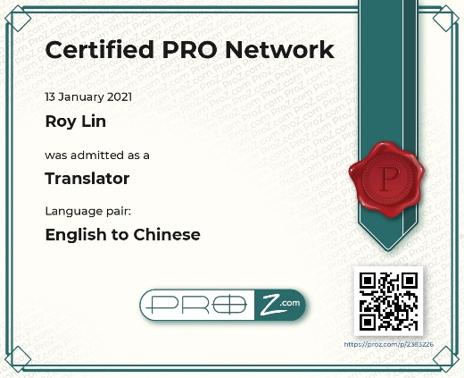
Proz.com
Earned 01/13/2021

Thank you very much for considering me for the above mentioned vacancy.
I look forward to your reply.
Yours faithfully

Roy Lin

