OLUFAYO LAWRENCE
Multilingual Translator · English ↔ German ↔ Chinese
London, UK · Available worldwide — remote · lawrence.olufayo@aegislinguistics.com
proz.com/next/profile/4684001
Video call verification available on request

CONTACT  London, UK  Available worldwide — remote  lawrence.olufayo@aegislinguistics.com  proz.com/next/profile/4684001  LANGUAGES  English  Professional working proficiency  German  Professional translation proficiency — ProZ C1 (Advanced)  Chinese (Mandarin)  Professional translation proficiency  CERTIFICATIONS  ProZ.com Professional Language Assessment  - German — C1, Advanced (Sep 2026)  - English — B2, Upper Intermediate (Jul 2026)  Full certificates on final page  CORE SERVICES  - Translation & Localization  - Machine Translation Post-Editing (MTPE)  - Subtitling & Subtitle QA  - Audio Transcription & Translation  - Proofreading & Editing  TOOLS & PLATFORMS  - Phrase (TMS / CAT)  - Starling (subtitling)  - Client-provided transcription tools  INDUSTRIES  - Technical / Industrial  - Media & Entertainment  EDUCATION  University of Manchester  Translation and International Studies | PROFILE  Translator with close to ten years of experience working across English, German, and Chinese, including six years as a senior translator with Achieva Lingua, where I translated more than 7,000,000 words and contributed to growing the company's terminology glossary. Independently, I've also delivered subtitle quality assurance, machine translation post-editing, and audio transcription and translation projects, managing deadline-driven work end to end using industry-standard CAT and subtitling tools. Background in Translation and International Studies from the University of Manchester.  Note on accessibility: I manage a mild stutter, which is why I focus exclusively on written translation, localization, and QA work rather than live interpretation — it's where I do my best and most precise work. I'm always happy to complete a video call for identity or skills verification.  EXPERIENCE  Senior Translator — Achieva Lingua (6 years)  - Translated more than 7,000,000 words over six years as part of the translation team, working across English, German, and Chinese content.  - Contributed to growing and maintaining the company's terminology glossary to support consistency across long-running accounts.  Freelance Translator — Independent  - Provided Chinese-to-English subtitle quality assurance for an 83-episode Chinese drama series, working in Starling; client relationship secured through referral.  - Carried out Chinese-to-German machine translation post-editing (MTPE) on a 3,000+ segment industrial parts catalog for rotary drilling rig equipment, managed in Phrase; systematically reviewed and corrected industry-specific terminology.  - Delivered a German-to-English audio transcription and translation project covering 200+ audio files, using a client-provided transcription tool to produce and verify the German transcript before translating into English; client sourced through referral from a fellow translator, project coordinated by email.  WHY WORK WITH ME  - Reliable turnaround on deadline-driven, high-volume projects (multi-episode subtitle batches, multi-thousand-segment catalogs).  - Practical experience with CAT/TMS tools (Phrase) and subtitling platforms (Starling).  - Client base built primarily through referral and repeat work — happy to provide references and complete a video call for verification.  REFERENCES  Achieva Lingua — reference available on request (contact: info@achievalingua.com)

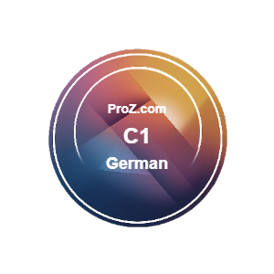
VERIFIED LANGUAGE CERTIFICATIONS
ProZ.com Professional Language Assessment — proz.com/next/profile/4684001/overview
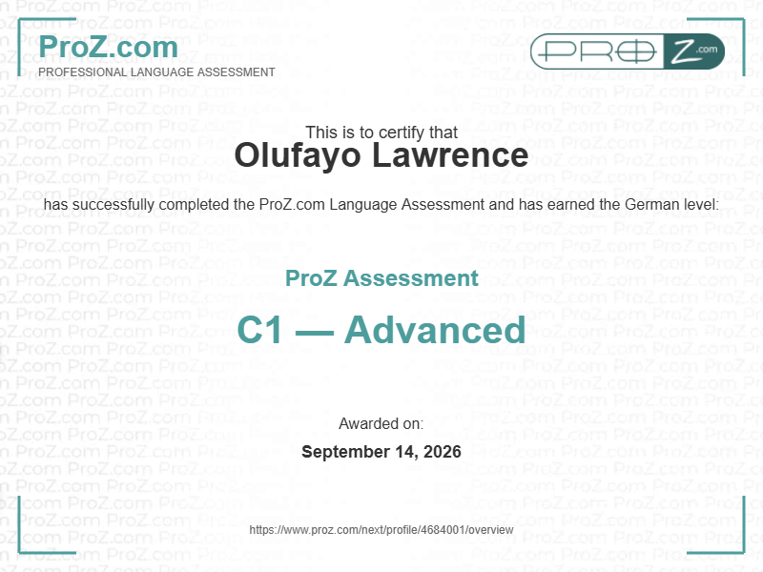
German — C1, Advanced · Awarded September 14, 2026
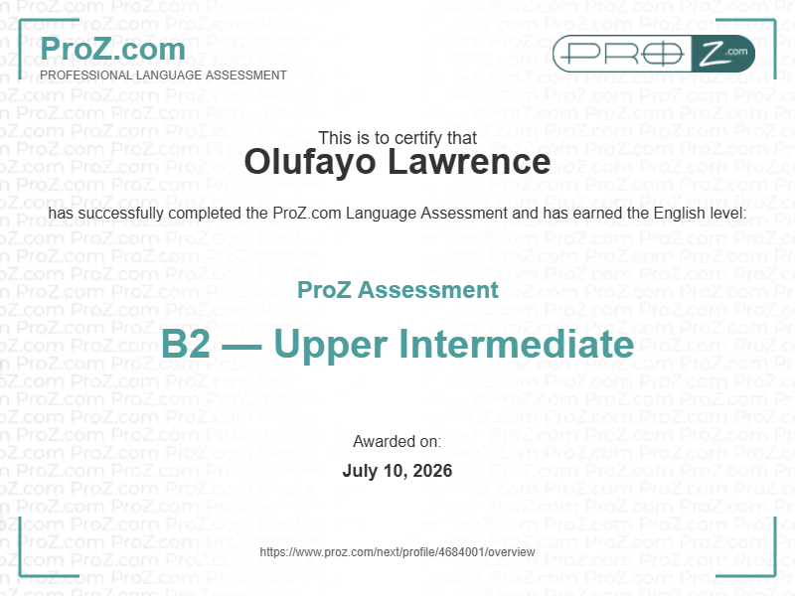
English — B2, Upper Intermediate · Awarded July 10, 2026

