PERSONAL INFORMATION | 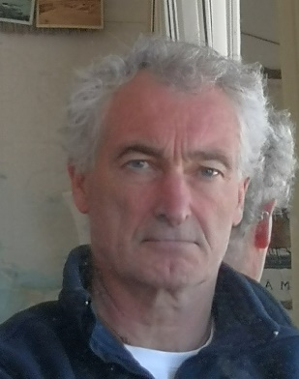

Profile | TRANSLATOR / TEACHER / PURCHASER

PROFESSIONAL EXPERIENCE

(2004 – present) | Freelance Translator en, de, es, se, no, da > fr
(2004 – present) | - Main fields: IT, Marketing, Finance.  - Regular collaboration with various translation agencies: Languagewire, AdHoc, TheBigWord, ... (see examples on p. 4 and 5 of this document)
(2002 – 2004) | Inhouse Senior Lead Translator
(2002 – 2004) | SDL Sheffield Ltd (UK)
(2002 – 2004) | - Technical support to clients, selection of freelancers and linguistic monitoring (translation/proofreading).
(2002 – 2002) | Inhouse SAP Translator
(2002 – 2002) | Nestlé (Switzerland)
(2002 – 2002) | - On-site translation as part of the Globe project. Mass translation using the SE63 transaction, then access to user screens for adaptation/correction.
(2000 – 2002) | Freelance Translator
(2000 – 2002) | - Freelance translation on the Internet (I am one of the first paying members of Proz.com).

(1993 – 2020) | Teacher

Lycée Sainte-Marie (St Père-Marc-en-poulet), 2019/20 Spanish Teaching in High School
Alliance Française (Madrid), 1999/02 Corporate Language Teaching (English and French)
Lycée SJB de la Salle (Camblain l’Abbé), 1995/97 Physics and English Teaching in High School
Oise Chamber of Trades and Crafts, 1993/95 Teaching of Mathematics and French
(1982 – 1999) | Purchaser  Interim assignments at Plastic Omnium, Sextant Avionique, Modus Media, HS Hydro (France and Spain, 1998/99)
(1982 – 1999) | Fujitsu Spain (Madrid), 1987/92 Procurement of computer equipment  ITT Standard Electric (Toledo), 1985/86 Procurement of integrated circuits  Bouygues Offshore (Paris), 1982/84 Procurement of electrical and mechanical equipment

EDUCATION AND TRAINING

(1994–1999) | L.E.A.
(1994–1999) | University of Amiens, France.
(1994–1999) | - Master in Applied Foreign Languages (English/Spanish)
(1981–1982) | Translation
(1981–1982) | 44 RT in Landau (Germany)
(1981–1982) | - Military service as a translator (German to French)
(1980–1981) | English Language | Level 5
(1980–1981) | Paris III Sorbonne University
(1980–1981) | - DEUG in English
(1977–1980) | Mathematics, Physics and Chemistry | Level 5
(1977–1980) | Saint Louis High School, Paris
(1977–1980) | - Preparatory classes for entrance to Grandes Ecoles
(1976–1977) | Swedish Language
(1976–1977) | Uppsala University (Sweden)
(1976–1977) | - Svenska IV (Swedish language course for foreign students)

PERSONAL SKILLS

Mother tongue | French
Other language(s) | UNDERSTAND |  | TALK |  | WRITE
Other language(s) | Listen | Read | Be part of a conversation | Continuous oral expression
Spanish | C2 | C2 | C2 | C2 | C1
 | 15 years in Spain
English | C2 | C2 | C1 | C1 | C1
 | 35 years of study, 5 years in Great Britain
German | C1 | C1 | B2 | B1 | B1
 | 7 years of study + military service in Germany
Scandinavian Languages | B2 | C1 | A2 | A1 | A1
 | 1 year in Sweden
Job-related skills | - Translation Project Management  - Didactics, group supervision  - Industrial Supply Chain Knowledge

Digital competence | SELF-ASSESSMENT
Digital competence | Information processing | Communication | Content Creation | Security | Problem solving
 | Independent user | Power User | Basic User | Basic User | Power User
 | Office/Trados Studio 2017/Google Translate
- Good command of office suites (word processing, spreadsheet, presentation software)
- Good knowledge of computer-assisted translation and machine translation software
- SAP Concepts

Other skills | - Volunteer Athletics Coach

ADDITIONAL INFORMATION

Conferences | - Participation in Proz conferences in Oxford (2004) and Budapest (2007)

APPENDICES

- Copies of diplomas and other qualifications on request

List of recent works in the no>fr combination:
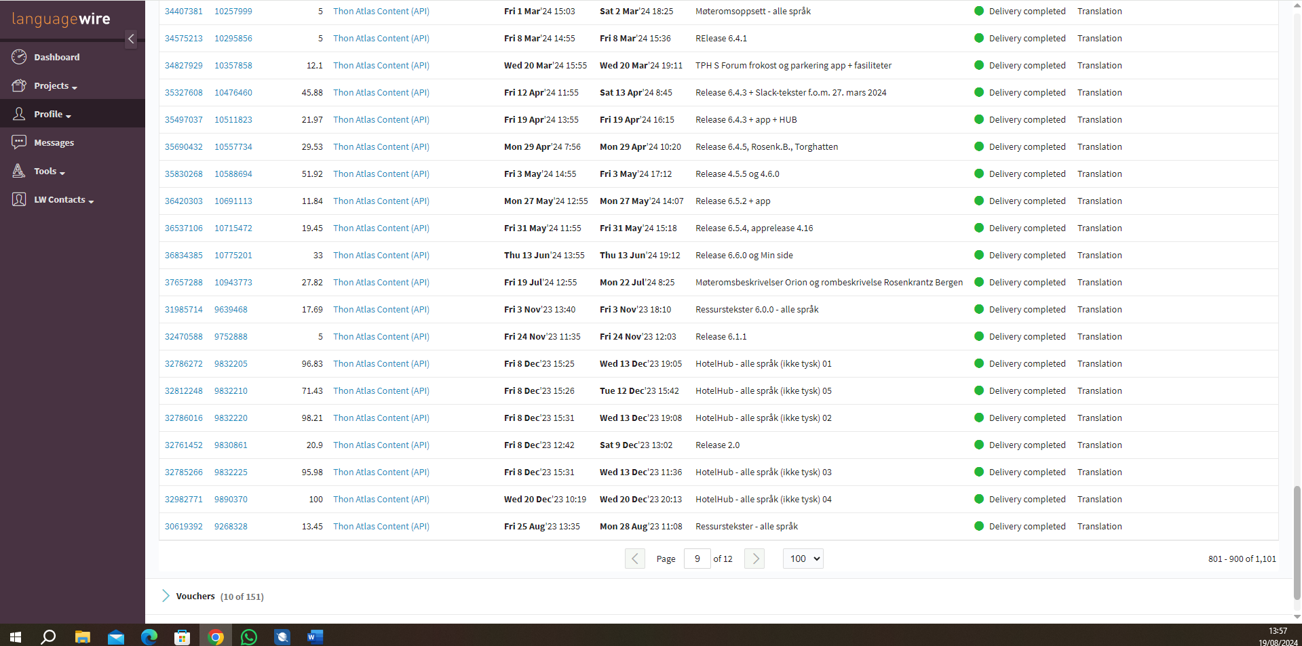

Client:
  Emiliano Martínez Galera | He/Him/His
  Senior Localisation Project Manager
    Live
    +34 961 12 32 41
  Email |  | emmg@languagewire.com
  LanguageWire Translation Services, S.L.U.
  Avenida del Marqués Sotelo 6
  46002 |  | Valencia
  Spain
  www.languagewire.com

Example of recent work in the da>fr combination:

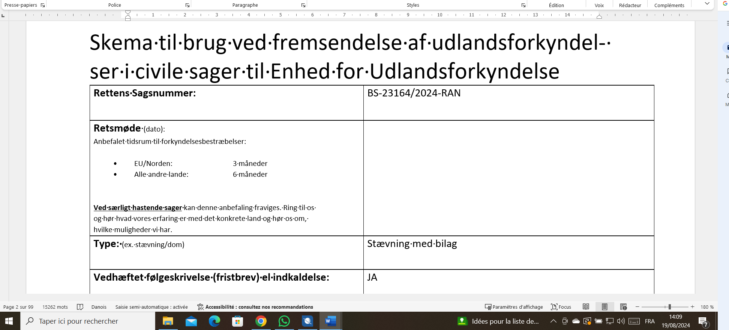

Approximately 12,000 source words, in 3 days
Client :
