Yılmaz Özkan
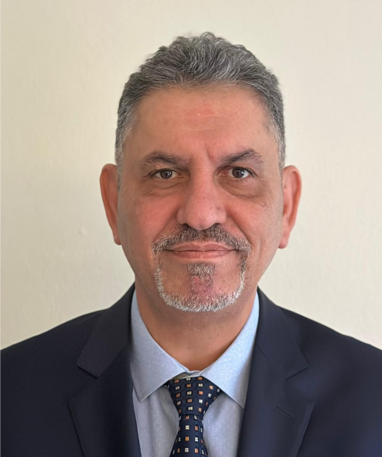
BSc, Mechanical Engineer
Gazi University, Ankara
Linkedin

Vatan Mah. İnanç Sok. No: 39/1
Bayrampaşa - İstanbul Türkiye
ozkyilmaz@gmail.com
@Yaz_Pit

+90 532 611 90 09
Translation Summary;

Fluent and Professional in English, Native in Turkish, Beginner in Japanese …

- Highly experienced in the field of;
  - Business Administration,
  - Automotive Business Management,
  - Network Management,
  - Sales, Technical, Parts & Accessories, Dealer Mngt of both Automotive and Construction Machinery,
  - Window Films
  - Car Detailing
  - Production and Design
  - Vendor Management
- Worked within major global brands of; Caterpillar, Hughes Int. Raytheon Systems, Toyota, JCB, General Motors, Hyundai Constr. Mech, Adam Opel, AG, Hanita Coatings…
- Advance Computer Skills; MS Office, Corel Draw Suite, MS Project, AI-Adobe Illustrator ) and Most Translation (CAT) Programs
Experiences in Brief;
- Senior Trainer & Management Consultant Freelancer 09/2003 – Current
- Network Development Mng. HOMER Auto Services 01/2022 – 12/2024
- Managing Director, Yenikoy Peugeot 10/2002 - 07/2003
- After Sales Director, [JCB & Hyundai] Sif Otomotiv / STFA 12/1999 - 08/2002
- Training Curriculum Manager, Raytheon Germany 11/1998 - 06/1999
- Country Manager / Training Manager, Raytheon Türkiye 12/1996 - 11/1998
- Service Coordinator, General Motors Türkiye 09/1995 - 11/1996
- Senior Service Training Instructor, Toyota Türkiye 08/1990 - 09/1995
- Service Training Engineer, Caterpillar -İstanbul 06/1989 - 08/1990
- Service Engineer, Field Operations Caterpillar – Ankara Branch 02/1987 - 06/1989

Harley Davidson Training Presentations such as
Translations Proceeded (EN to TUR)
Training Presentations & Notes | More than 12 of Course materials and Curriculum

Atlas Copco
Persuasive Inquiry | Course Attendee Material, Presentation and Instructor Manual
Sif Otomotiv AS
Management Skills
Conditional Leadership
Finance For Non-Finance Managers
Strategic Management

Raytheon Systems
Advance Consultative Selling | Course Curriculum
Time Management | Course Curriculum

Toyota Motor Company
Toyota Training Curriculum – translation by Personal | 19 of 37 Books & Trai. Manuals
Toyota Training Curriculum – proof reading by Personal | 18 of 37 Books & Trai. Manuals

Caterpillar Construction Machinery
User Manuals and Repair instructions for… | Load Sensing Hydraulic Systems
 | Hydraulic Hammers
Service Workshops for… | Failure Analysis
 | Scrapers and Trucks
 | Wheel & Track Loaders
USA Custom Office
U.S. Custom Inspection Directions & Methods

Xerox UK
Cars User Manuals – Proof Readings | for different GM & Opel Models

Roto telescopic handlers
User Manuals and Repair instructions for… | All Roto Models imported

An Italian Transportation Company (name hidden)
Handling and Transportation Instruction of  Harmful and Poisoning Materials by Sea and Land | Users Manuals & Instruction Handbook

