ACM TRANSLATIONS
STOCKHOLM SWEDEN

Education/Training:
English > Swedish Swedish > English


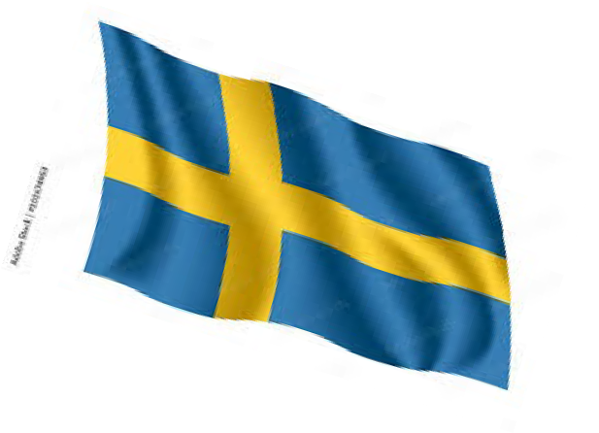
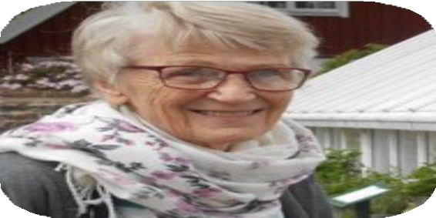
PROFILE

My name is Ann-Charlotte Minnaar and I am a freelance Swedish translator. I translate and proofread English to Swedish and also Swedish to English.

My specialties are materials on
IT, marketing but also manuals -
dental implant devises, medical texts. Also instructions for medical implements and electrical cars.

Translation tools: SDL Trados Studio 2021. Add experience in XTM, AWS, Transdoc, and Gentrans and all CAT tools.

My motto: To accurately convey a concept from one language to another within the deadline professionally.
Feel free to contact me back for any questions on rates and availability.
PHONE:
s
+46 (0)73 936 2734
EMAIL:
anncharlotteminnaar@gmail.com

proz.com/translator/3362450

HOBBIES
Gardening Nature hikes Kayaking Reading

1962 - 1966 Högre allmänna läroverket för flickor i Göteborg
25 April 1966 Student exam with university entrance credits. Distinction in Swedish literature and World Religions.
1966 - 1968 University of Gothenburg Science of Swedish literature 40 points Science of literature 40 points
Spanish 20 points

Advanced Organization International
1970 Advanced Course in Organization
1970 Advanced Executive Course in Organization 1999 Advanced Organization, Sydney Australia Advanced course in English
Advanced course in English grammar

EXPERIENCE:
February 1969 – May 2021Worked with English speaking organizations in South Africa, Australia, United States and became proficient in spoken and written English (both GB and US).
Copenhagen Denmark Advanced Organization 1969-1976
Los Angeles USA 1976-1980 International HQ for LRH Communicator Network Johannesburg South Africa 1980-1988
Continental Liaison Office Sydney Australia
1999 – 2007 Continental Liaison Office and Advanced Organization 2007-2020 International Liaison Office

January 2019 – March 2023
Translation Unit International i Los Angeles
Swedish Translator and proofreader at Management Translation Unit International in Los Angeles. Including texts of administrative legal, medical and educational nature.
Moved to Sweden 2021; registered Enskild firma ACM TRANSLATIONS and have been translating commercially as a freelancer. Am translating from English to Swedish on IT texts, marketing, medical and educational texts at the moment. Between January 2021 to January 2023 I completed translations for 59 projects of a total of 178,892 words. This is an average of 3 032 words per project.

March 2023 – Oct 2025
52 projects of IT, marketing, medical manuals, dieselmotor manual and MPTE. Average 1,000 – 3,000 words per project. Another 10 IT and marketing projects of 2500 words. A series of 10 car marketing and marketing projects concerning accessories of 11,800 words. Approximately 200 translations projects professionally of average 3000 words per project. Approx 381,000 - 400,000 words.
Oct 2025 – Oct 2025
Tasks regarding machinery - 77,501 words; regarding traffic – 18,052 words; regarding industrial automation – 9,035; regarding watches, devices and cars – 67,223 words

