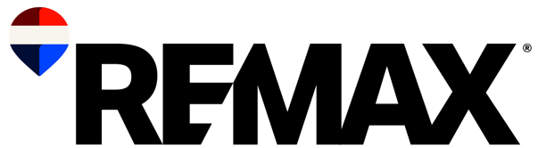
Below is a sample media pitch for July, focusing on vacation properties and second homes. Modify the highlighted areas to work for you and your market. Remember, personalization and customization are key pitch components when reaching out to reporters. For more PR tips, check out the RE/MAX Public Relations Guide.

Subject: Mid-Year Getaway: Key Considerations for Buying a Vacation Home
Dear Journalist's Name,
With summer inf full-swing and many people hitting the road for seasonal escapes, July is the perfect time to explore the exciting world of vacation properties and investment-worthy second homes. As a real estate expert with REMAX Office Name, I am thrilled to share top tips for finding your perfect getaway – and spotlight some of the most in-demand markets where dreams of owning a vacation home can become a reality.
Key Considerations for Buying a Vacation Home: The following are just ideas to get you started. Make sure to update the key points below to reflect what you’re seeing in your market. When you’re done updating, make sure to delete this comment.
- Location, Location, Location: Choose a location that you love and that has strong rental potential if you plan to rent it out. Consider proximity to attractions, amenities and the overall appeal of the area.
- Budget and Financing: Determine your budget and explore financing options. Keep in mind that vacation homes may require a larger down payment and higher interest rates compared to primary residences.
- Maintenance and Management: Consider the maintenance needs of the property and whether you will manage it yourself or hire a property management company. Remote management can be challenging, so plan accordingly.
- Rental Income Potential: If you plan to rent out your vacation home, research the rental market in the area. Look at occupancy rates, rental prices and local regulations regarding short-term rentals.
- Seasonal Use: Think about how often you will use the property and during which seasons. Ensure the location suits your lifestyle and vacation habits.
- Insurance and Taxes: Vacation homes may have different insurance requirements and tax implications. Consult with professionals to understand the costs and benefits.
With more than ## years of local real estate experience, I’d be happy to provide more detailed insights and commentary for vacation properties. I am available for an interview if you are interested.

Thank you for considering my perspective. I look forward to hearing from you.
Warm regards,
[Your Name]
[Your Title]
[Your Real Estate Agency]
[Contact Information]
[Website]

Remember: Feel free to customize this pitch to better fit your voice and specific insights and remove any yellow highlights before sharing. Happy vacation home hunting!

