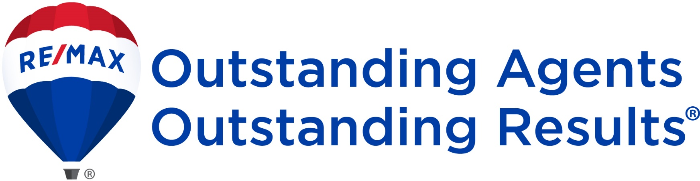

**RE/MAX** ……….

Single Office Terms and Benefits – (Date)

(This franchise offer will expire on ………. )

|  |  |
| --- | --- |
| BG2.jpg  **Investment** **Initial Franchise Fee** US$........for a five-year franchise agreement. This agreement can be renewed for additional five year terms at …….. % of the initial franchise fee.   1. **Continuing Franchise Fees** 2. **Annual Fee:**   US$....... per Sales Associate and Broker/Owner for the benefits of affiliation with RE/MAX. **Monthly Fees:**  1. Fixed: 2. Year 1: US$..... 3. Year 2: US$..... 4. Years 3, 4, 5: US$….. 5. Percentage:   …..% of gross commissions includes:   1. Technology Fees (depending on package)   US$..... to US$..... per User  Note: All above prices might be subject to taxes.  **For more detailed information contact:**  ***(Your Name)***  (Title)  RE/MAX (Region name)  (email)  (Regional website)  (Regional address)  Phone: +  Fax: +  Mobile: +  Note: Total initial investment varies depending on the costs incurred to setup the office and other costs. | Benefits  * **Global Recognition** with one of the most recognized real estate brands in the world that uses “Nobody sells more real estate than RE/MAX” slogan. * The **flexible RE/MAX Business model** is built to support those who desire the freedom to create their own future. * **Premier Global Web Presence.** Upload your listings to [**global.remax.com**](http://www.global.remax.com)**,** our multi-lingual, multi-currency site, with potential exposure to millions of consumers around the world. * Opportunity to receive fee-free **International** **Referrals** from other RE/MAX agents. The RESAAS powered Global Referral Exchange will provide your agents with the tools to gain referral business. * On RE/MAX **Mainstreet** andmultilingual **Global Training** platform, you can access various RE/MAX products, marketing and training materials, operation manuals, advertising and communication templates. * Watch online videos through **RE/MAX University,** anon-demand source for the best ideas, training and real estate information in the industry for Brokers and Agents. * Develop abilities through education to **Recruit and Retain** the best agents in the marketplace adhering to a Code of Ethics. * Attend **Broker/Owner Training** at Regional or World Headquarters. * Attend **RE/MAX International** **Conventions** and other **Regional Events**:   + Learn the latest real estate techniques.   + Showcase your listings and your markets at the Global Referral Exchange.   + Shop for business-enhancing products and services at the RE/MAX Maketplace.   + Receive awards and recognition for your effort. * Receive the **RE/MAX Broker Advance** newsletter and **ABOVE** magazine, the online RE/MAX publications filled with news and tips for your business. * **Trademark and Graphic Standards Manual** to take maximum advantage of the brand standards and logos. * Promote your luxury listings with **The** **RE/MAX Collection** a marketing program specifically designed for upscale customers and properties. * Take advantage of **RE/MAX Commercial** and its vast array of commercial real estate resources. * Obtain the **Certified International Property Specialist** **(CIPS)** designation at a discounted cost, to learn how to market properties internationally. * Utilize the **RE/MAX Design Center** to create and customize your own professional marketing materials.   (Optional and full capability limited to Latin 1 languages)   * Take advantage of the **best practices**, developed by other Global RE/MAX regions and offices and ongoing support and mentorship by your regional office team… |

**Letter from Regional Director**

Date

Dear (name of the franchise candidate):

First, I would like to thank you for your interest in the RE/MAX brand and let you know that working with you has been a great pleasure.

RE/MAX is a global leader in the real estate industry, with over 7,200 offices and 110,000 Agents in more than 100 countries and territories around the world. Some of the many benefits that are offered by RE/MAX include the most recognized worldwide real estate brand name, profitable and flexible business model, education and technology, company intranet, Broker/Owner and Agent training, international referral network, and opportunity to participate at the annual local and international conventions.

As a Broker/Owner, you would benefit from the RE/MAX system by recruiting and retaining top-producing Agents and helping your Agents provide world-class real estate services to their Clients.

Based on our discussions and your intentions to (insert your own text here) ……………………… I am pleased to attach the below offer for your review and confirmation at your earliest convenience.

Please do not hesitate to contact me for any clarification required.

Finally, it is our honor and we look forward to having you and (name of the RE/MAX franchise) join our RE/MAX (name of the region) network at the soonest possible.

Sincerely yours,

(Your name)

Regional Owner