**SOCIAL NARRATIVE FOR**

**THE RELAXED PERFORMANCE OF**

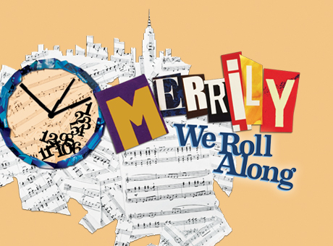

**at Roundabout Theatre Company**

March 30, 2019

**The Laura Pels Theatre at**

**The Harold and Miriam Steinberg Center for Theatre**

**111. W. 46th Street, New York, NY 10036**

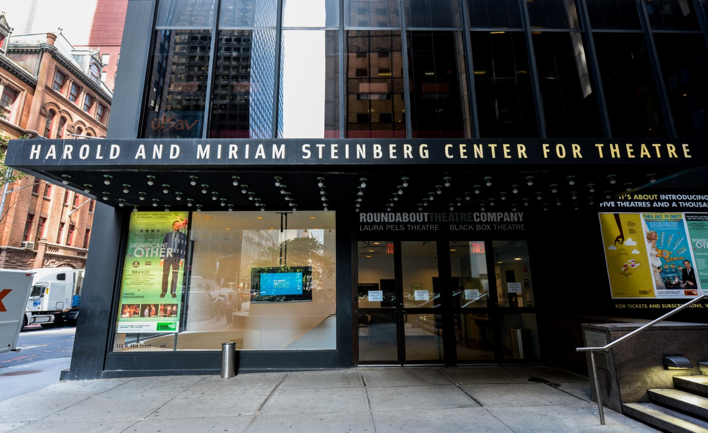

I will go to Roundabout Theatre Company’s show, *Merrily We Roll Along*.

The theatre is located at 111 W 46th Street, New York, NY 10036.

When I arrive at the theatre, I may have to wait in line at the box office.

I have a ticket which means that when I go inside the theatre, there is a seat just for me.

I will show my ticket to a person who works for the theatre and they will scan it.

I will take the stairs and escalator down to get to my seat. There is also an elevator available if needed.

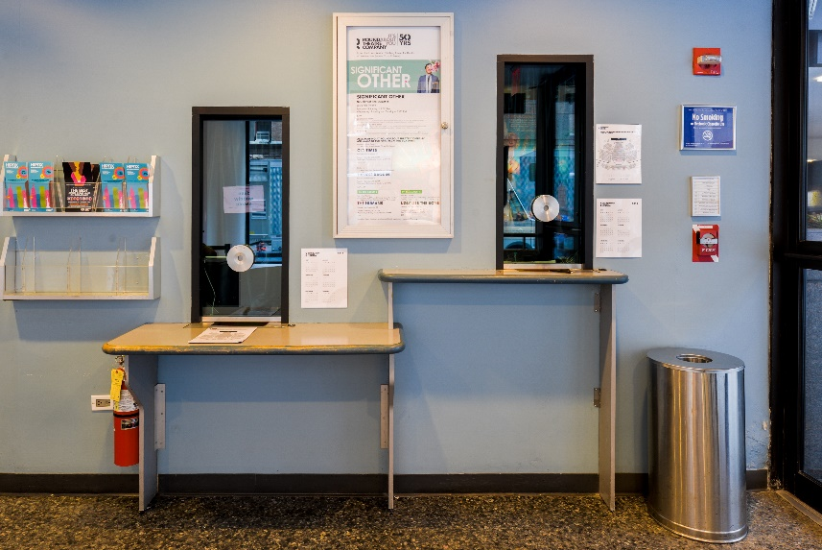

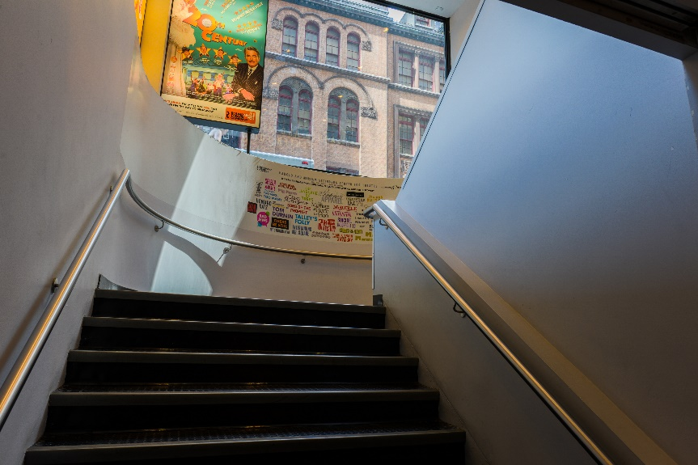

I will go into the theatre. The theatre has over 400 seats.

I will hand my tickets to the Usher so they can show me where my seats are.

The numbers on our tickets tell us where we have to sit.

It is not a choice.

The usher will give us a Playbill. A Playbill is a book.

The theatre will get dark and quiet.

I will try to be quiet during the show so I can hear everything.

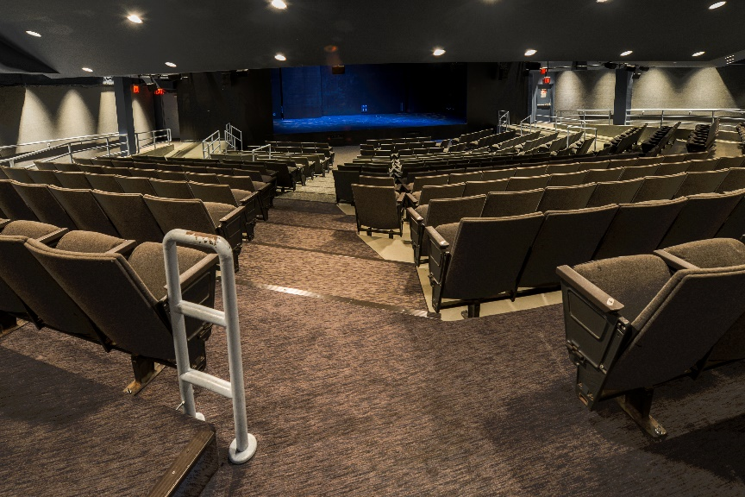

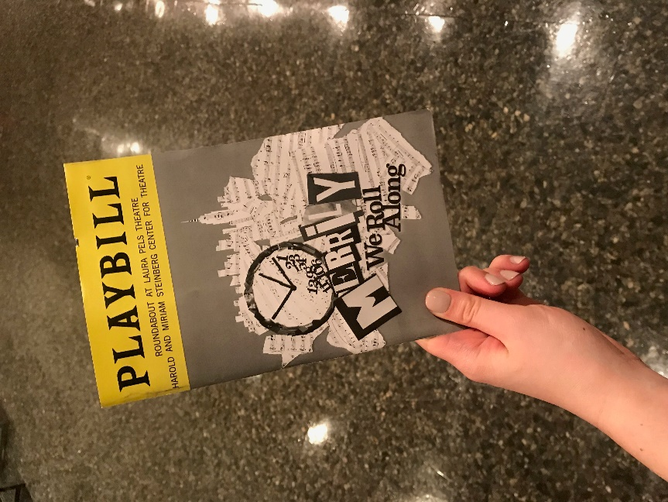

I will see actors who will tell the story.

**The time moves backwards in this show!**

**The beginning of the show takes place in 1976.**

**The end of the show takes place in 1957.**

**This means I know how the story ends first,**

**Then we find out how the characters became who they are by moving backward through time to the beginning of their journey as friends.**

To learn more about the story and characters, look at pages 7-8.

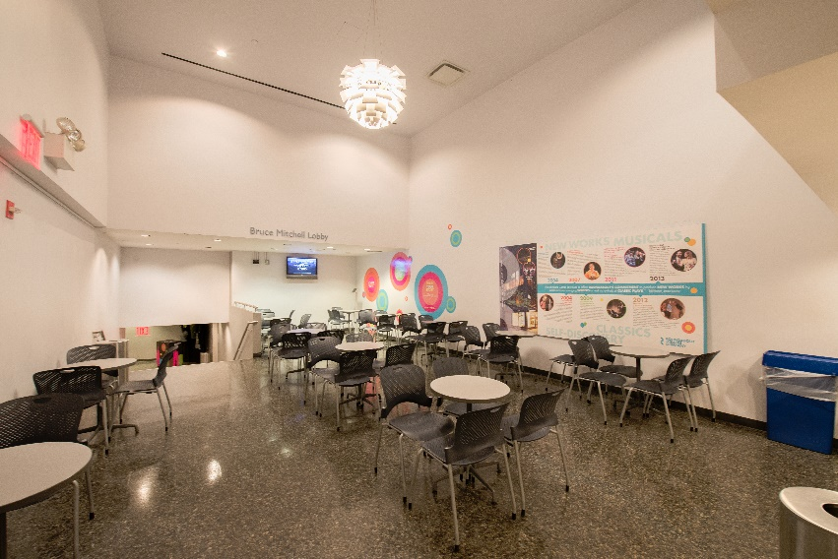

I will try to stay in my seat.

But, if the show is ever too loud or too bright I can take a break in the Break Area.

Once I feel better I can go back into the theatre to enjoy the show!

When the show is finished, we will leave the theatre. I can take my ticket and program with me.

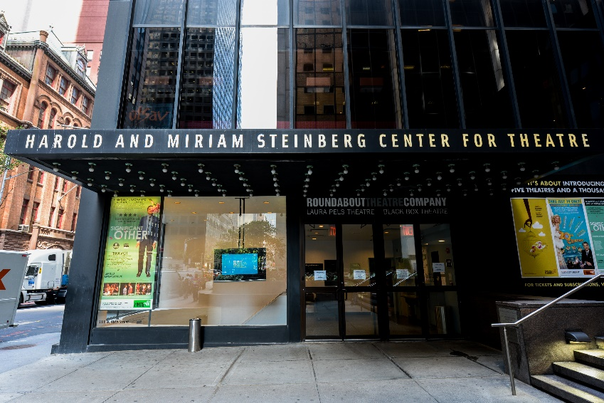

**CHARACTER GUIDE**

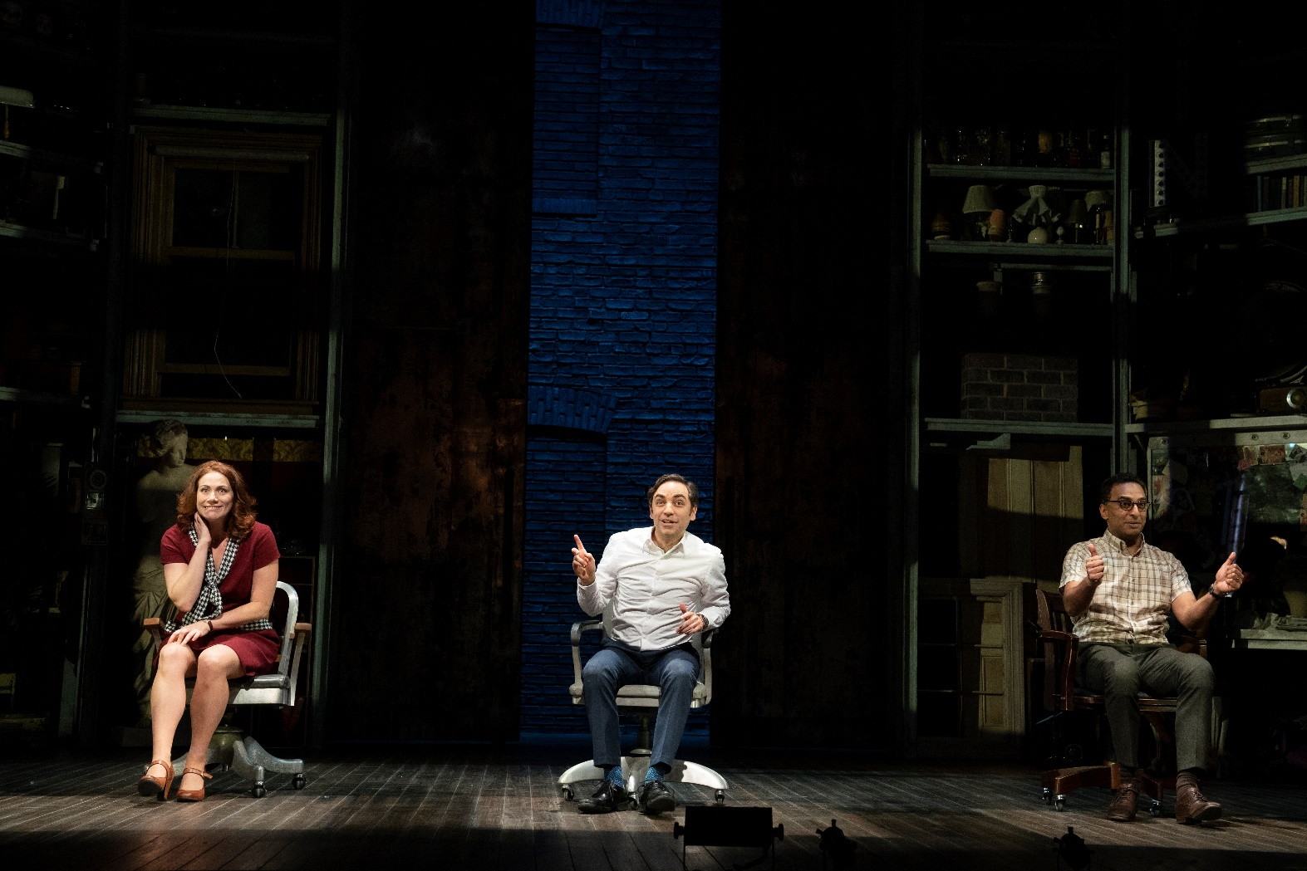

Frank (Franklin) Shepard is a Broadway composer who becomes a Hollywood producer. He is Charley’s writing partner. He is friends with Mary and Charley. His first wife is Beth. His second wife is Gussie. He has an affair with Meg.

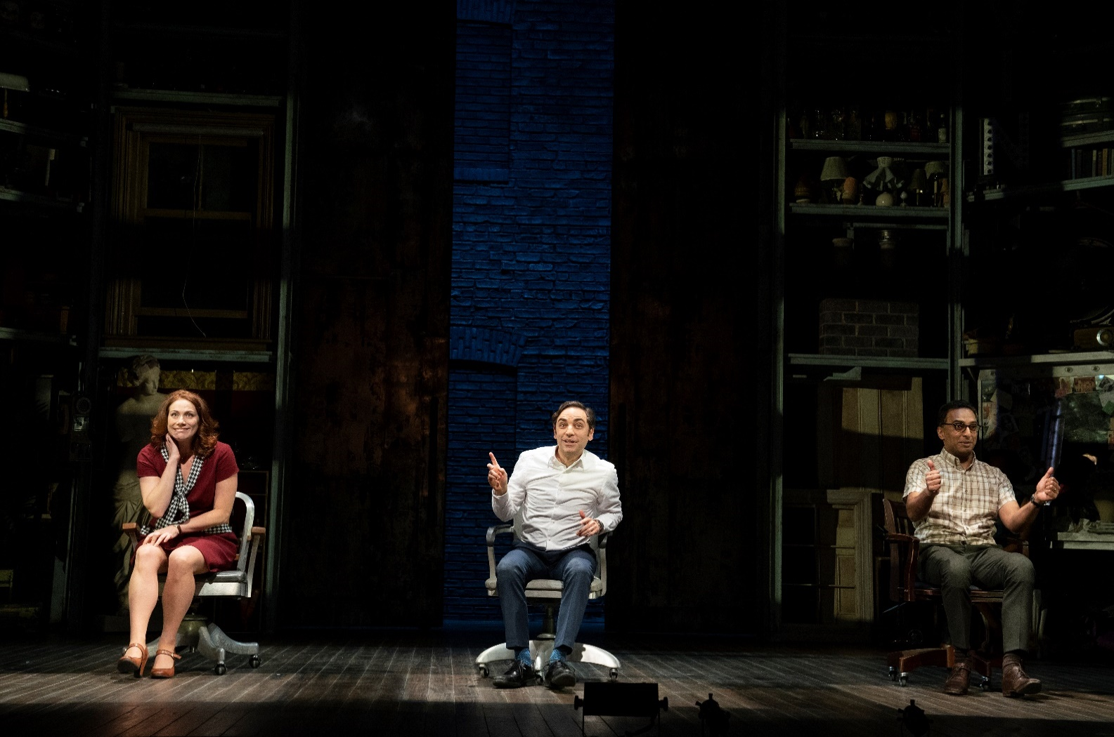

Mary Flynn is a writer who becomes an accomplished theatre critic. She becomes friends with Frank and Charley in college. She is also in love with Frank. She drinks a lot when she is older.

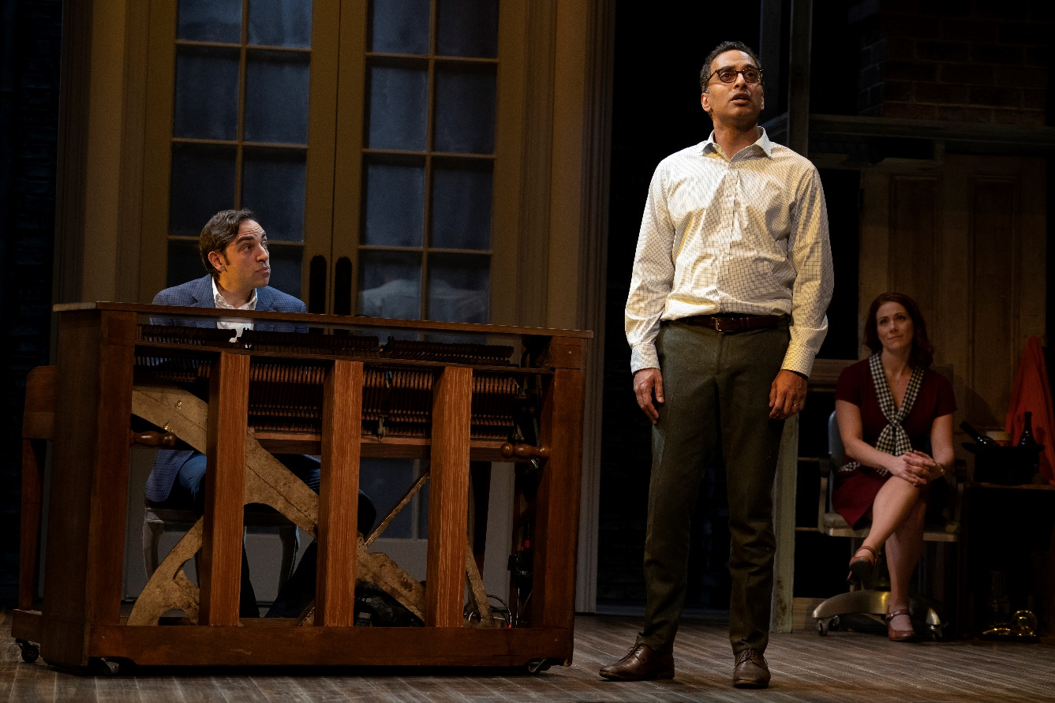

Charley Kringas is a lyricist who partners with his friend, Frank, to write musicals. He is friends with Frank and Mary. He wants to keep writing with Frank, though Frank wants to focus on making money.

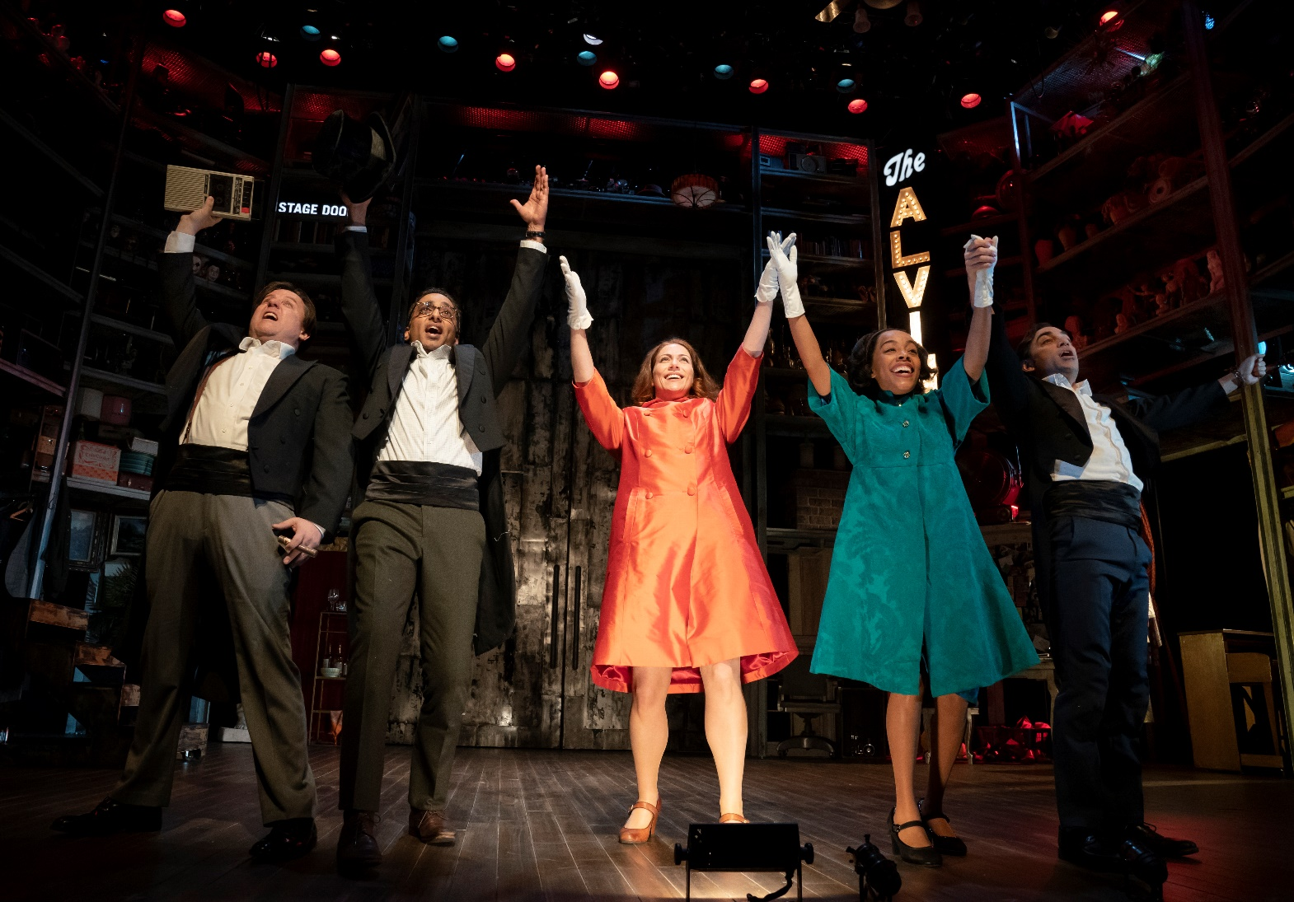

Joe Josephson is a Broadway producer who is married to Gussie. He produces Frank and Charley’s first Broadway musical.

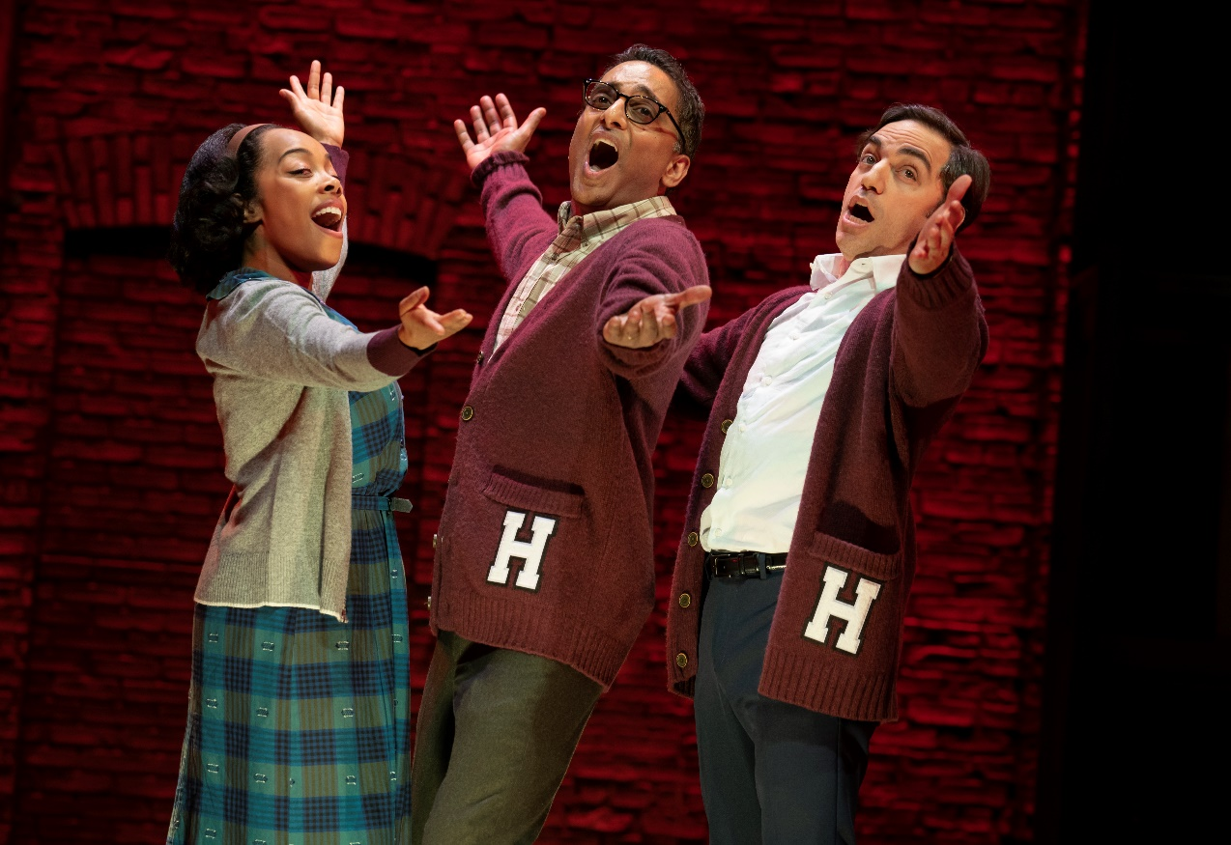

Beth Spencer is Frank’s first wife. She also is a singer who performed with Frank and Charley.

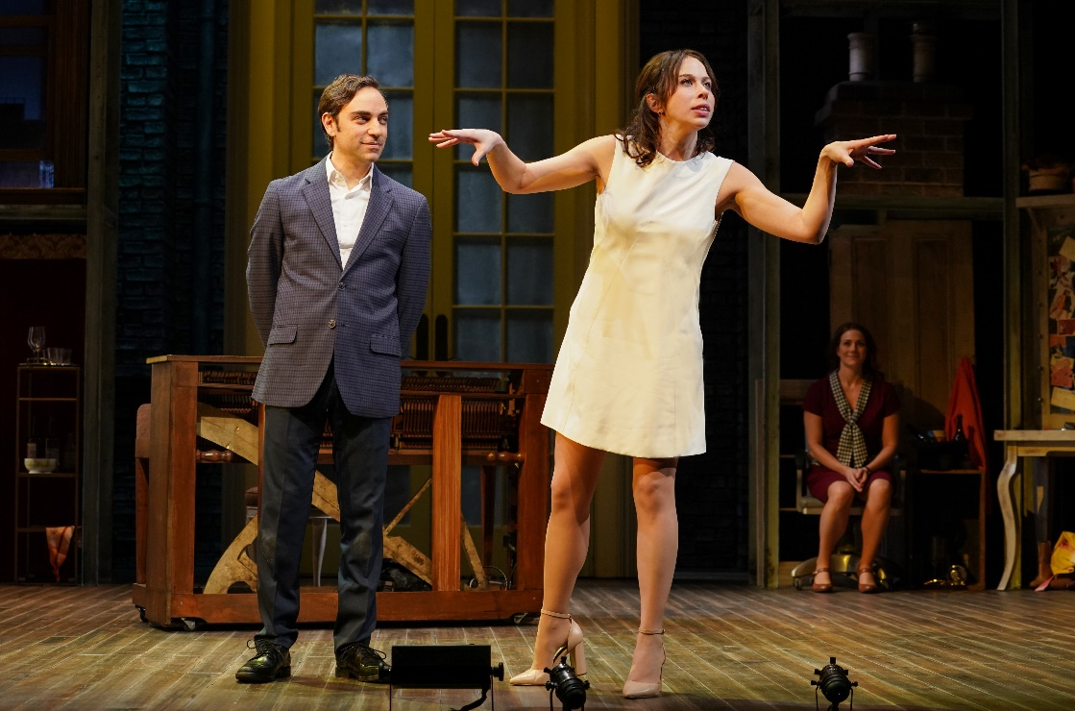

Gussie Carnegie is a Broadway star who is married to the Broadway producer Joe Josephson. She has an affair with Frank and later marries him.

*The actors play multiple characters. For example, the actor who plays Beth also plays Meg.

*Sometimes actors stay on the edge of the stage when they are not in the scene. It is helpful to watch the actors in the middle of the stage who are speaking and singing to follow the story.

**TIMELINE**

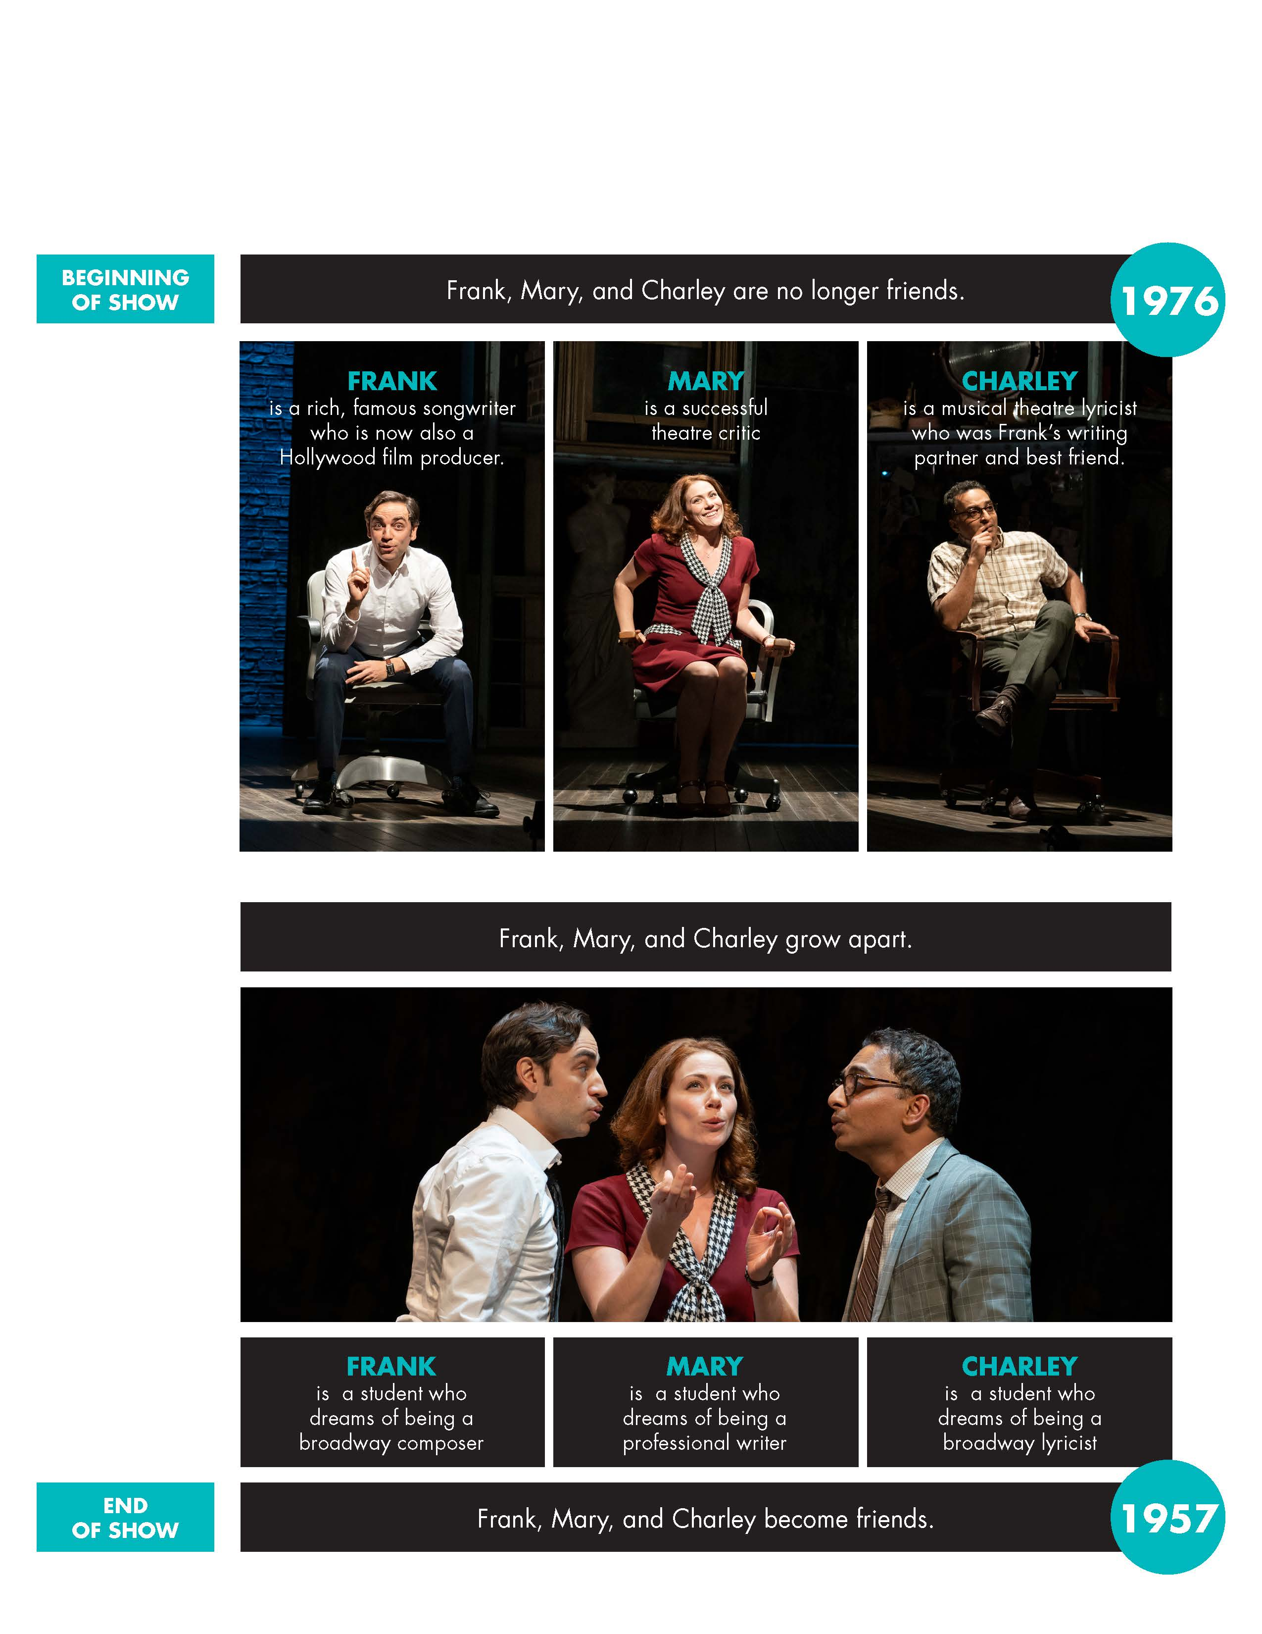

**DISCUSSION TOPICS**

1. What are some differences between old friends (friends you have known for a long time) and new friends (friends you have met more recently)?
2. What makes a person a good friend? How do people become good or close friends?
3. Have you had certain friends for a long time? If so, how has your friendship changed, or not, over the years?
4. How have you changed over time? Have your goals or dreams changed?
5. What has stayed the same about you over time?