CRM Instructions
Service Requests

http://extranet.denver.simpleviewcrm.com

Reviewing Service Requests:
- Once you are logged in, click on the “Service Requests” tab in the upper menu bar.
- You will be able to view all Service Requests that your property was included in.
  - Groups (Meeting, Tour, Media, Misc Leads, Other Events)
- You are able to sort your list of service requests by clicking on any of the column headers (i.e. Service Request, Contact, etc)

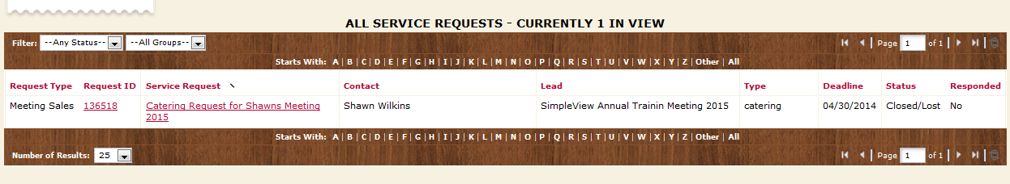
Viewing Service requests:
- Click on the Service request ID or Title to open and view.

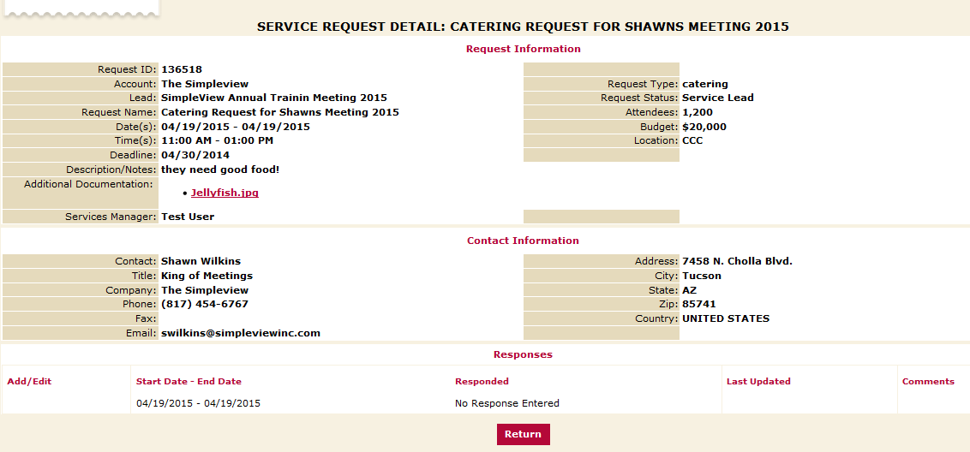

- You will notice the Contact information is available on the detail screen, use the email address provided to send your response directly to the client.

