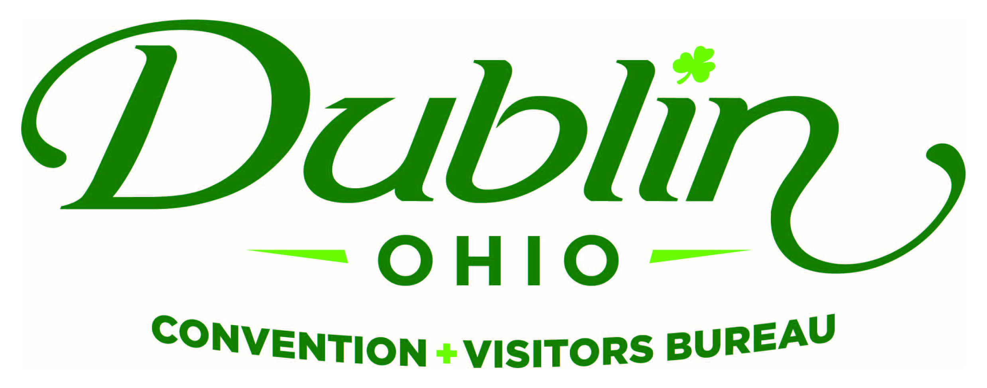
Executive Committee Meeting Minutes
April 6, 2017
DCVB Offices

Present: S. Kowaluk, P. Smith, C. Rose, N. Brinker, C. Baldridge, E. Belfrage, P. Fingerhut

Absent: None

Staff: S. Dring

Board Action Items:

- Phil made a motion to approve the February Meeting Minutes. Nichole seconded. All approved.
- The May 25 Executive Committee Meeting has been moved to Friday, May 19 at 11:30 a.m. @ the Bureau’s offices. The Committee will review the proposed FY18 budget during this meeting.

Detailed Minutes:

I. Welcome/Call Meeting to Order

- Approval of March Meeting Minutes – Sondra welcomed the group to the April Executive Committee Meeting. Phil made a motion to approve the February Meeting Minutes. Nichole seconded. All approved.

II. Financials

- Balance Sheet – Staff provided the financials earlier in the week and the committee reviewed and discussed. The current total in the checking and saving accounts after the month of March is $88,081.82. Account receivables total $32,091 due to the invoicing for the 2017 Destination Guide. It is the Bureau policy to have at least 15 percent of the overall budget for the reserve fund and the reserve fund balance stands at $183,000.

- P&L Budget vs. Actual – Through March, total expenses year-to-date stand at 63.9 percent and the total income year-to-date stand at 73.8 percent. The Telephone category will be higher than budgeted due to the switching of providers and new phone systems. All account lines are where they should be at this point of the fiscal year.

- Bed Tax Revenue – Fiscal Year-To-Date bed tax revenue thru the month of January totaled $721,714 an increase of 3.1 percent over 2015 and a 0.38 percent increase over the YTD budget of $719,000.

III. Committee Discussion Items

- City Council Update – Frank Willson and Phil Smith (City Council Representatives) will accompany Scott for an update to Dublin City Council on Monday evening. Scott provided a memo that was included in Council’s packet and provided an overview. Staff provided a results-oriented update in four categories – New Business, Marketing, 2016 Results/ROI and Strategic Plan Progress. The top three results were highlighted in each and showed the new Downtown Dublin Video that was created for the top meeting planners in the state attending the Ohio Society of Association Executives Conference. Scott provided greater detail on results from Smith Travel Research on Dublin’s hotel performance for 2016 and how it directly related to the Bureau’s results and ROI from Council’s increased funding in 2016.

Dublin City Council provided an increase in bed tax revenue to the Bureau in 2016, in part, to create the first-ever regional campaign in Pittsburgh, Detroit, Indianapolis, Charleston/Huntington and Lexington with the goal of raising awareness of Dublin and increase overnight stays during weekends. The results and DCVB’s Key Performance Indicators from Smith Travel Research included:

- Occupancy rates increased 3 percentage points to a total of 70% (One percentage point = an estimated $1.1 million in revenue). In comparison, the occupancy rate for Greater Columbus was 66%.

- Weekend occupancy rates increased 5 percentage points – the largest increase in 18 years.

- Bed tax revenue reached a record level of $3.1 million. The average daily rate for Dublin hotels remained flat over last year at $107.

The Committee discussed the impact of the increased supply of two new hotels – the consensus was that the new supply will not substantially increase the average daily rate in the market, thus any increased revenue will need to come from occupancy and, in particular, increased occupancy during the weekends. Scott noted that staff continues to work closely with the private sector on creating a new indoor athletic facility that will meet the needs of residents and attract visitors.

- Marketing Staff – The Bureau has posted the position of Marketing Coordinator – this position will replace the position of Group Tour and SMERF Sales Manager vacated by the departure of Amanda Mikkelson. Per last month’s Executive Committee discussion, Sara’s title has been changed to Marketing Manager and she will oversee this new position. With the new responsibilities, Scott will be making a recommendation for a new salary level for the Marketing Manager position as part of the upcoming FY18 Budget. Scott noted that the search for the Marketing Coordinator is ongoing with hopes of filling the position as soon as possible.

- FY18 Board of Directors – Sondra noted that there are a few updates in regards to the FY18 Board of Directors slate. Diane Phillips may be moving to Boston so her role as President-Elect is in question. Sondra and Phil have already spoken to Dr. Lee about the position after Diane so they will discuss with him the possibility of moving into the President-Elect role earlier. Scott also noted that he had a good discussion with Bob Hoying about a possible Board Position and has a meeting tomorrow with him to discuss in more detail.

IV. Executive Director Report

- FY18 Budget Timeline – The first draft of the FY18 Budget will be submitted to the Executive Committee on May 12 and the Committee will review and provide comments in person during its May 19 Meeting. The recommended budget will be presented to the full Board of Directors at its June 12 Meeting for final approval.

- Downtown Dublin Strategic Alliance – Efforts for the Alliance continue to make great progress in the collaborative effort to market and promote a united Downtown Dublin. There has even been a social media committee created that includes staff from each of the Alliance organizations. The committee has created a strategy and plan that will help raise awareness of the area as a destination. The City of Dublin also utilized the group for a Parking Study Focus Group. Meetings are being held monthly and Scott will keep the Board updated on the progress.

- New Product Update – Scott noted there will be more detail provided at Tuesday’s Board Meeting, but the two new hotels are progressing with the AC Marriott scheduled to open in August and the Home2 Suites in July. The Exchange Conference Center is slated for a September opening. Other new restaurants and shops in Downtown Dublin will begin opening this summer.

- DIF Anniversary Recognition – There is no update on the Dublin Irish Festival recognition gift from the Bureau to the City of Dublin celebrating the 30th Anniversary of the festival and the positive impact it’s had on the Dublin tourism industry. Staff has been working with Alison LeRoy on an Irish Harp Sculpture that will be part of a larger area to include recognition pavers. Scott reiterated that 100 percent of the monies used for this recognition would come from private dollars and industry support – no bed tax dollars would be used. Scott, Pete and Sara will be meeting with the Dublin Irish Festival’s Marketing team to discuss collaborative opportunities celebrating the event’s 30th anniversary.

V. Other

The May 25 Executive Committee Meeting has been moved to Friday, May 19 at 11:30 a.m. @ the Bureau’s offices. The Committee will review the proposed FY18 budget during this meeting.

- Board of Trustees Meeting – Tuesday, April 11, Noon, Muirfield Village

- Executive Committee Meeting – Thursday, May 4, 11:30 a.m., DCVB Offices

“People in our places, feet on our streets, heads in beds”

