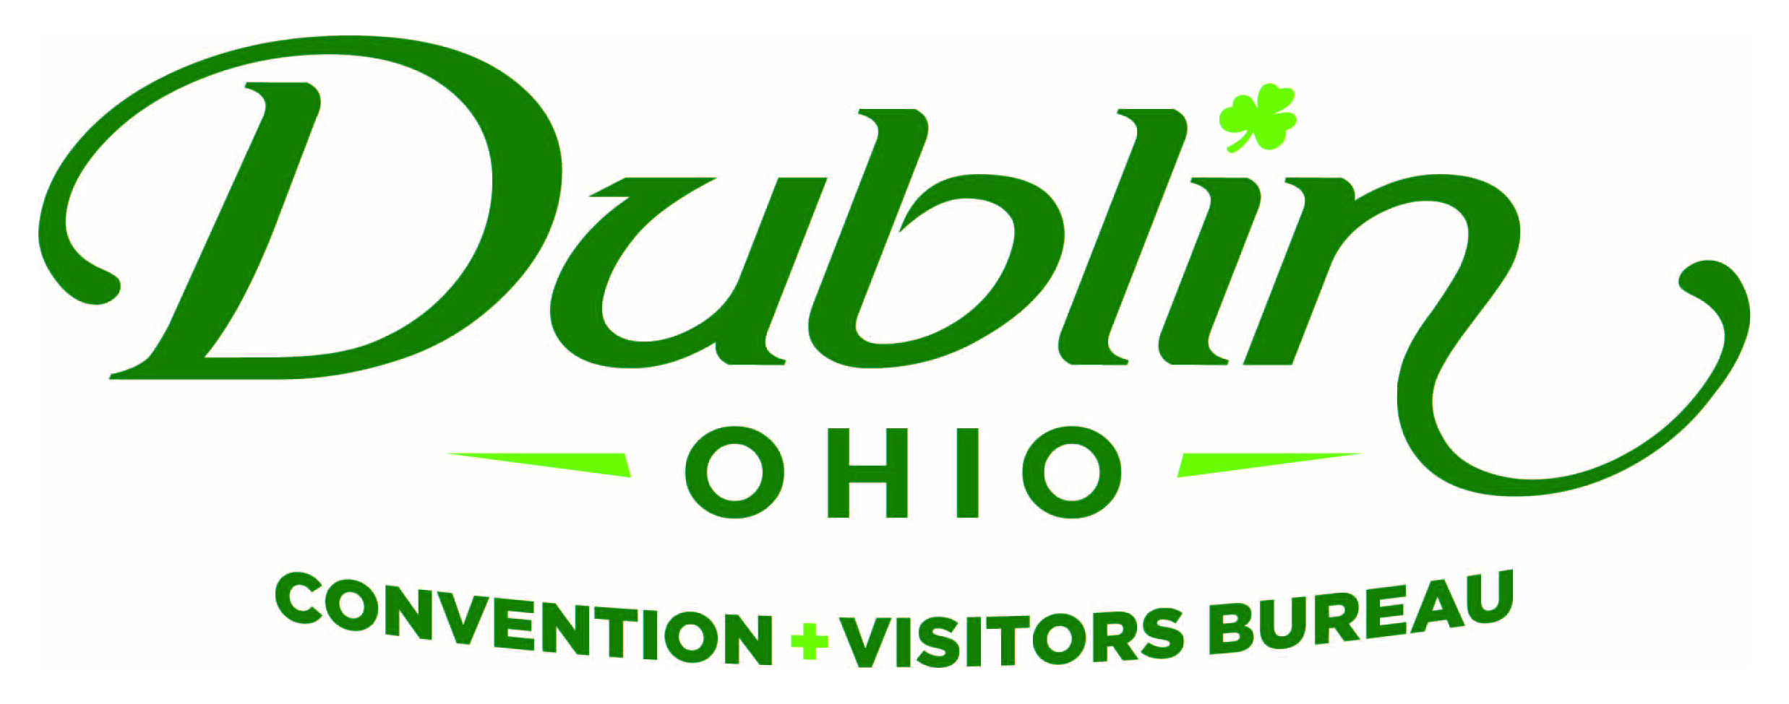
Board of Directors Meeting Minutes
April 11, 2017
Muirfield Village Golf Club

Board Members Present: Sondra Kowaluk, Becky Miller, Clay Rose, Heather Baxter, Nichole Brinker, Phil Smith, Dr. David Lee, Diane Phillips, Frank Willson, Michelle Crandall, Eric Belfrage, Pete Fingerhut

Board Members Absent: Kimberly Kayler, Craig Baldridge

Guests: Dave Cecutti (OCC); Amy Numbers (Constructive Communications); Tim Wolfe (Marriott NW), Gerrilyn Rozich (Cardinal Health); Orcun Turkay (AC Marriott); Jodie Hutchins (Home2 Suites); Bo Bentele (Homewood Suites); Tim Wolfe (Marriott NW); Megan Emerick and Amy Harman (Fahlgren Mortine); Dan Sullivan (The Memorial Tournament)

Staff: Scott Dring, Pat King, Sara Blatnik, Josh Bricker, Katie Rich

Board Action Items:

- Becky made a motion to approve the Consent Agenda as presented. Phil seconded. All approved.
- Board to determine next steps for a new Strategic Plan after the completion of the current 2015-18 plan.
- Staff to present a draft of FY18 Budget, Sales and Marketing Plan and Slate of Board of Directors prior to the June 12 Board Meeting for Board review and revisions.

Detailed Minutes:

I. Welcome/Call Meeting to Order

- Welcome – Sondra welcomed guests to Muirfield Village Golf Club.

II. 2017 Memorial Tournament Preview

Dan Sullivan provided a preview of the upcoming Memorial Tournament. He noted that 8 of the top 10 players in the world are committed to play in the tournament. They are improving the Guest Experience by adding several new hospitality areas around the course and in the Bogey Inn parking lot. There will also be a new village that will offer interactive experiences sand simulators. Dan also showed the current commercial for the event.

III. Consent Agenda

- Consent Agenda Approval – Becky made a motion to approve the April Consent Agenda, which included the February 6 Board Meeting Minutes and April 2017 Financials. Phil seconded. All approved.

- Financials – A summary of the financials for April 2017: Staff provided the financials earlier in the week as part of the Consent Agenda and the Executive Committee reviewed at its meeting last week. The current total in the checking and saving accounts after the month of March is $88,081.82. Account receivables total $32,091 due to the invoicing for the 2017 Destination Guide. It is the Bureau policy to have at least 15 percent of the overall budget for the reserve fund and the reserve fund balance stands at $183,000. Through March, total expenses year-to-date stand at 63.9 percent and the total income year-to-date stand at 73.8 percent. The Telephone category will be higher than budgeted due to the switching of providers and new phone systems. All account lines are where they should be at this point of the fiscal year. Fiscal Year-To-Date bed tax revenue thru the month of January totaled $721,714 an increase of 3.1 percent over 2015 and a 0.38 percent increase over the YTD budget of $719,000. The Bureau’s Executive Committee reviews and the Finance Committee receives detailed financials on a monthly basis.

- 2016-17 Sales & Marketing Plan Update – The entire plan with current updates and results were submitted as part of the Consent Agenda and also distributed at the meeting. Due to the items on the agenda, Scott noted that there would be no highlights provided by staff at this meeting.

IV. Committee Discussion Items

- Strategic Plan – Scott noted that in the Board Meeting Packet was a memo to Dublin City Council that was presented Monday night as part of the DCVB Presentation. He said the last page of the update included the 2015-18 Strategic Plan Scorecard. He reviewed the highlights and successes, including: securing additional marketing funding; space for the DVIC and Administrative Offices; launching first-ever regional awareness campaign; establishing education for local industry through DCVBU Program; Investigating the need, feasibility of new athletic complex; hiring first-ever National Sales Manager. Scott noted the Board will need to determine the timeline and process of the next Strategic Plan and how staff can assist.

- Downtown Dublin Strategic Alliance -- Scott updated the Board on the Downtown Dublin Strategic Alliance efforts being led by the Bureau. Efforts for the Alliance continue to make great progress in the collaborative effort to market and promote a united Downtown Dublin. There has even been a social media committee created that includes staff from each of the Alliance organizations. The committee has created a strategy and plan that will help raise awareness of the area as a destination. The City of Dublin also utilized the group for a Parking Study Focus Group. Meetings are being held monthly and Scott will keep the Board updated on the progress. Scott showed the new Downtown Dublin video, created for Ohio Meeting Planners, to the group. He said that the video was shown at Dublin City Council last night and it was well-received.

- FY18 Board of Directors – Sondra said the Executive Committee continues to work on the FY18 Board of Directors slate. She introduced potential new Board Members for the next fiscal year – Amy Numbers (Constructive Communications), Gerrilyn Rozich (Cardinal Health) and Dave Cecutti (Ohio Capital Conference). Each of the guests provided a brief overview of their experience and interest serving on the Board. Sondra noted that the Dublin Hotel General Managers have selected Tim Wolfe at the Marriott Northwest as its representative on the Board starting July 1. Tim replaces Nichole Brinker who will move to an ex-officio position on the Board.

Sondra announced that Diane Phillips will be moving to Boston and will not be seeking another term on the Board in July. The Board thanked Diane for her service and dedication to Dublin.

V. Executive Director Report

- Hotel Performance Results – The Board reviewed the Smith Travel Research (STR) Report which contained 2016 results from Dublin’s hotels. Scott noted that the key message to Council last night was its ROI from the increased funding it provided the Bureau in 2016. The primary results from the STR Report included: hotel occupancy for Dublin’s 15 hotels increased 3 percentage points to 70 percent. Scott noted that one percentage points is equal to $1.2 million. Weekend occupancy increased five percent to 64 percent – the largest increased in weekend occupancy in 18 years. Scott reiterated that the Bureau launched its first-ever regional campaign last year focusing on increasing weekend occupancy. The average daily rate remained flat at $107. Eric noted that the occupancy will decrease slightly next year due to the additional 276 rooms being added to the Market via AC Marriott and Home2 Suites. Tim provided an overview and explanation of RevPar (a key metric for hotels).

- Staffing – Scott announced that Sara Blatnik has been promoted to a newly-created position as Marketing Director. In her new role, she will oversee a new Marketing Coordinator, which staff hopes to hire in the next month or so. The new position of Marketing Coordinator replaces the position of Group Tour and SMERF Sales Manager vacated by the departure of Amanda Mikkelson. Ultimately, the overall staffing for the Bureau will remain the same, there was a shift in responsibilities that will better position the organization for success in the future.

- Athletic Facility – There continues to be great momentum about creating a new indoor, multi-purpose athletic facility in Bridge Park. The discussions are still early and being led by Crawford Hoying. The vision of the facility includes: 6-8 multi-purpose indoor athletic courts (+- 14 volleyball courts, Basketball, volleyball, futsol as main sports with Badminton, pickle ball, wrestling, gymnastics, cheerleading, sports camps as less frequent sports); Bathrooms/locker rooms/concessions/viewing and gathering areas, WIFI/cameras/live streaming...best technology available; Ample parking with adjacent parking garages utilizing “shared” parking with other users within Bridge Park; Users -- local users during weekdays (Dublin Parks and Rec typical programing, local organizations and teams, local basketball and volleyball leagues) and Weekend users being national/regional/local tournaments; Management to be determined but best in class. Dave noted that there is a large demand in the market for a 4,000-seat facility to host regional and district basketball games for boy’s high school.

The Bureau continues to be a resource to all parties involved. Staff is working with Crawford Hoying on an economic impact study for the facility.

- FY18 Budget, Sales & Marketing Plan – The first draft of the FY18 Budget will be submitted to the Executive Committee on May 12 and the Committee will review and provide comments in person during its May 19 Meeting. The recommended budget will be presented to the full Board of Directors at its June 12 Meeting for final approval.

VI. Regional Awareness Campaign

Scott said historically the Bureau only had the funds to market the City of Dublin to in-state markets, but that changed with the increase of funding in 2016. Subsequently, staff completed research that determined the key regional markets were – Pittsburgh, Detroit, Indianapolis, Lexington and Charleston/Huntington. During the first Regional Awareness Campaign in 2016, the Bureau created several #sodublin videos and focused on the Charleston/Huntington Market with strong public relations efforts for the other markets. There were great results with the campaign surpassing its goals. Staff challenged Fahlgren Mortine to extend the marketing dollars in 2017 to reach all the key outer markets.

Sara along with the Fahlgren Mortine Agency presented the Bureau’s 2017 regional awareness campaign. Scott noted the first-ever campaign experienced tremendous results from last year’s #sodublin video campaign in Charleston/Huntington and its public relations efforts in the other regional markets of Detroit, Pittsburgh, Indianapolis, Lexington and Charleston/Huntington. This year’s campaign will run from April – June and will focus on Pittsburgh, Detroit, Indianapolis and Lexington.

Fahlgren Mortine noted that Pittsburgh & Indianapolis have many family friendly destinations within the city that draw the target Dublin CVB target user. Surrounding these locations are impactful opportunities to reach users and drive awareness for Dublin CVB in creative ways. The campaign includes placing large Boards and street decals highlighting Dublin in high traffic areas such as, Children’s Museum of Pittsburgh, Natural History Museum, Pittsburgh Zoo & Aquarium, and Carnegie Science Center. Large boards will be displayed at Bus Stops/Transit Shelters -- eye catching to both those taking the bus, those driving by or pedestrians. There will be five strategically placed boards that will reach families on their way to the zoo, science center, etc.

Street Decals -- Guerilla effort that allows us to choose where we want them to be. The standard size is 20” X 20” and usually lasts 1-2 weeks. There will be 25 placements throughout the city.

Mobile location-based ads will also be used in the campaign to target the desired audience as they are at the zoo or the children’s museum reinforcing the out-of-home message. This type of partnership will allow us to draw boundaries around desired locations targeting and retargeting this audience. Executions can include both banners and video. In addition, 60 days after the campaign is complete the media partner will provide reporting that shows the number of visitors to Dublin that saw this messaging.

The Key Performance Indicators (KPI) and goals for the campaign include: 857,624 out-of-market impressions; 6,568,637 digital impressions, 5 percent click-through rate and 300,000 site sessions.

VII. Industry Update/Other

The AC Marriott is still scheduled to open in August 2017 and the Home2 Suites in mid-June. Zoombezi Bay added some additional lighting to extend its summer hours to 11 p.m. Dublin City Council “untabled” the Dublin Library and parking garage discussion and it will be on their April 24 agenda.

- Board of Trustees Meeting – Monday, June 12, Noon, Ohio University

“People in our places, feet on our streets, heads in beds”

