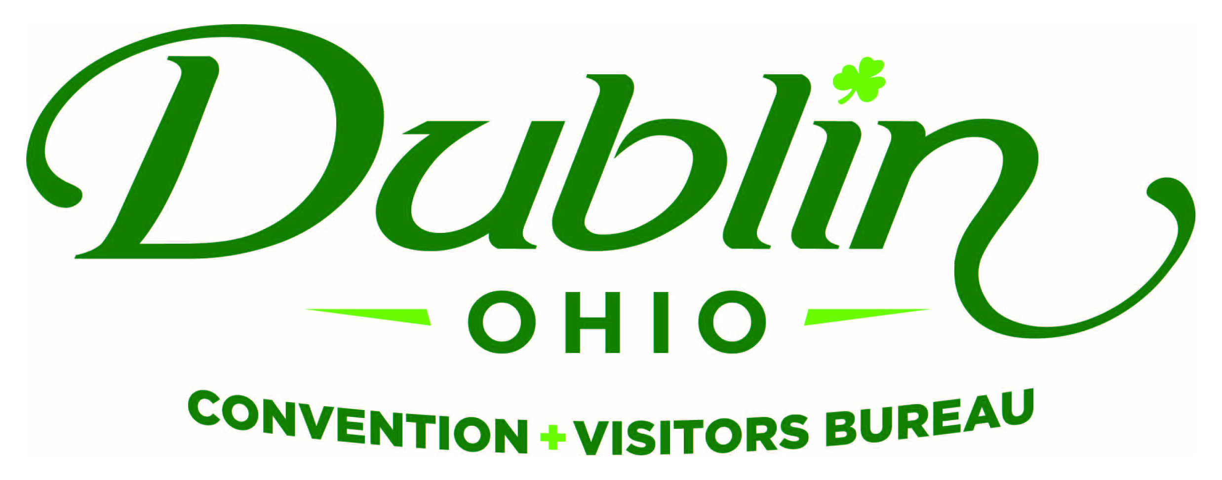
Executive Committee Meeting Minutes
December 7, 2017
DCVB Offices

Present: S. Kowaluk, P. Smith, C. Rose, D. Lee

Absent: B. Miller, C. Baldridge

Staff: S. Dring, P. King

Board Action Items:

- The March Executive Committee has been moved to Thursday, March 8.
- Sondra made a motion to approve the November 2017 Meeting Minutes. David seconded. All approved.
- Board/Staff Holiday Reception will be held on Wednesday, December 13 from 6 – 8 p.m. at VASO Rooftop Lounge.

Detailed Minutes:

I. Welcome/Call Meeting to Order

- Approval of November Meeting Minutes – Phil welcomed the group to the December Executive Committee Meeting. Sondra made a motion to approve the November 2017 Meeting Minutes. David seconded. All approved.

II. Financials

- Bed Tax Revenue – Fiscal Year-To-Date bed tax revenue thru September totaled $427,070, an increase of 0.1 percent over 2016 and a 1.6 percent decrease over the YTD budget of $434,000.

- Balance Sheet – Staff provided the financials earlier in the week and the committee reviewed and discussed. The current total in the checking and saving accounts after November is $216,655.57. Account receivables total $1,600 due to the invoicing for 2018 partners who prefer to be invoiced prior to publishing the Destination Guide. It is the Bureau policy to have at least 15 percent of the overall budget for the reserve fund and the reserve fund balance stands at $183,000. Scott also noted that health insurance expenses increased 16 percent for the upcoming year.

- P&L Budget vs. Actual – Through November, total expenses year-to-date stand at 31.5 percent and the total income year-to-date stand at 43.3 percent. All account lines are where they should be at this point of the fiscal year.

III. Committee Discussion Items

- The Exchange – Staff is working with the Exchange to attract meeting business that will attract overnight hotel rooms to Dublin in addition to social events. The Bureau is compiling feedback from customers and providing the information to Cameron Mitchell so that it can meet the future needs of meeting planners and capitalize on the leads and new business the Bureau is providing.

- Market Assessment Study – Eric and Scott have met several times with DVAC Group on creating a market assessment study for the City of Dublin. The discussions were initiated after the future influx of hotel inventory in the market. The Bureau’s Board determined that it is not advocating for new hotels or the exclusion of hotels, rather a strategic process to help guide future development. It was determined that the Bureau and City would collaborate on creating a market study.

The Committee reviewed the proposal with the objective of “developing a strategic tool and resource that will inform key stakeholder decisions concerning the future direction of the Dublin hotel market.” The study will also educate Dublin hoteliers, the CVB and others on market specifics, forecasts, comparisons with other like cities and more. The study will gather information via interviews from local hoteliers, businesses, community leaders and develop a market-wide SWOT analysis.

The committee reviewed the deliverables for the study which includes – area reviews, demographic analysis, local/regional/national lodging review and forecast, comparative City analysis, SWOT, etc. The expense for the entire study is $15,000. Eric and Scott are recommending the study be completed in this summer during the next fiscal year. The reasons being that the current expense is not budgeted in this fiscal year and it will give the new AC Marriott and Home2 Suites six months since their opening to get a proper assessment.

- 2019-22 Strategic Plan – Phil updated the group on the Board’s 2018-2021 Strategic Plan. The Board and Staff will be receiving an online survey in January and the Board Retreat will take place in late January. The retreat will be no longer than 3 hours with the final product being completed by February. Scott will be sending out potential dates and location in the coming weeks.

- Suburban DMO Roundtable Results – Scott again participated in a Suburban DMO Think Tank that includes 10 similar Bureaus from across the nation. Last year’s meeting was extremely successful with numerous ideas being brought back from the meeting and implemented at the Bureau. This year’s meeting was held in West Chester, Ohio. One of the items the Executive Committee asked to be discussed was regarding Panhandling – all communities noted that it was a local city ordinance issue and the CVBs did not involve themselves in the issue. Some other insights included: CVBs need to take an active role in future hotel and product development for the betterment of the entire community; Market assessment studies are helpful and provide a third-party endorsement, although they are expensive and should be done every five years or so; Bloggers will be more influential than ever; Do not create a housing bureau within the organization; Creating trails (i.e. Fairy Door Trail) continue to help drive business and economic impact to communities; Visitor Centers are still a resource but staff should not spend a lot of resources on the facility; Several ideas were shared on Strategic Plans which will be included in the development of the Bureau’s plan.

IV. Executive Director Report

- Annual Report Video – Staff completed a video shoot of the Bureau’s 2017 Annual Report. Scott said this year’s annual report will feature highlights over the overall positive impact the travel and tourism industry has on Dublin as well as accomplishments from the Bureau over the past year.

- Downtown Dublin Campaign – The inaugural Advertising Campaign funded collaboratively by the Downtown Dublin Strategic Alliance was launched a few weeks ago. The campaign included print ads in Dublin Villager, Upper Arlington News, Olentangy Valley News, Worthington News and in the December issue of Dublin Life with the theme of “Opposites Attract.” Several bloggers were in town over the past week as well touting about the destination during the holidays.

The Bureau created the Alliance last year with the goal of positioning Bridge Park and Historic Dublin as one world-class destination attracting visitors and economic impact to the area. The Alliance has already executed numerous initiatives including creating new events, raising awareness via social media channels, wayfinding and other collaborations. Strategic Alliance members include: The Bureau, Historic Dublin Business Association, City of Dublin, Crawford Hoying and the Dublin Historical Society. Scott also noted that Dublin Life will be featuring the Alliance in an upcoming issue.

- Celtic Cocktail Trail – The Celtic Cocktail Trail is off and running. Staff created a passport with all participating restaurant stops and Celtic offerings that will guide residents and visitors throughout Dublin to find a spirit with Irish flair! All participating restaurants will offer an Irish-themed cocktail to be available to any trail participants. (Irish mule, Green Martini, Celtic Cosmo, etc.) Each restaurant will receive a branded stamp that your staff will use to stamp the customer’s passport once they purchase a Celtic Cocktail. After completing the trail, the Bureau will award participants with a tee-shirt and branded, green cocktail shaker and possible other prizes. There are 11 local restaurants participating in the Trail, including RAM, VASO, Dublin Village Tavern, Matt the Millers, Tuccis, Bogey Inn, The Pint Room, 101 Beer Kitchen, J. Liu, Mezzo and Pins Mechanical.

- Holiday Reception –The event will be held on Wednesday, December 13 from 6 – 8 p.m. at VASO Rooftop Lounge at the AC Marriott. Food will be provided complements of the Bureau and there will be a cash bar.

V. Other

There was a discussion on potentially adding another voting Board Member to the Executive Committee in the future. There are currently four voting Board Members on the Committee. Staff will review the Board Slate for discussion at a future meeting.

- Board of Trustees Meeting – Monday, December 11, Noon, Ohio University

- Executive Committee Meeting – Thursday, January 4, 11:30 a.m., DCVB Offices

“People in our places, feet on our streets, heads in beds”

