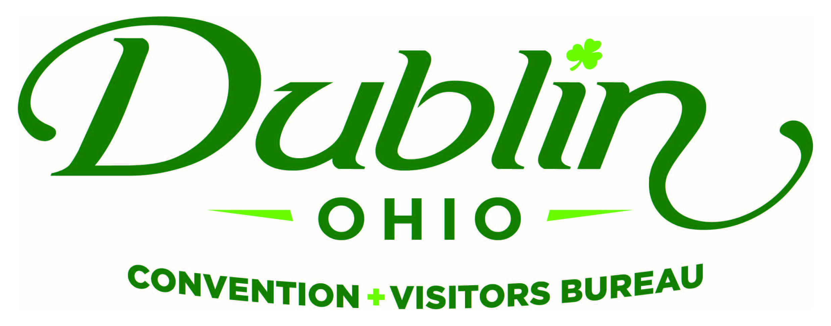
Executive Committee Meeting Minutes
March 9, 2017
DCVB Offices

Present: S. Kowaluk, P. Smith, C. Rose, N. Brinker, C. Baldridge, E. Belfrage

Absent: None

Staff: S. Dring, S. Blatnik, J. Bricker, P. King

Board Action Items:

- Phil made a motion to approve the February Meeting Minutes. Nichole seconded. All approved.
- Staff to begin outlining a job description for a new Marketing Coordinator position.

Detailed Minutes:

I. Welcome/Call Meeting to Order

- Approval of February Meeting Minutes – Sondra welcomed the group to the March Executive Committee Meeting. She noted a few revisions to the February minutes. Phil made a motion to approve the February Meeting Minutes. Nichole seconded. All approved.

II. Financials

- Balance Sheet – Staff provided the financials earlier in the week and the committee reviewed and discussed. The current total in the checking and saving accounts through the month of February is $148,505.33. Account receivables total $39,325 and invoices for the 2017 Partnership Program have been distributed. It is the Bureau policy to have at least 15 percent of the overall budget for the reserve fund and the reserve fund balance stands at $183,000.

- P&L Budget vs. Actual – Through the month of February, total expenses year-to-date stand at 59 percent and the total income year-to-date stand at 67.6 percent. All account lines are where they should be at this point of the fiscal year.

- Bed Tax Revenue – Fiscal Year-To-Date bed tax revenue through January of the fiscal year totaled $721,714, an increase of 3.1 percent over FY16 and a 0.3 percent increase over the YTD projected budget of $719,000.

III. Committee Discussion Items

- Future Staffing – Scott noted with the departure of Amanda Mikkelson as Group Tour and SMERF Sales Manager it provided an opportunity to look at the current staffing needs and Group Tour Market. He said that Pat and Josh worked the Heartland Travel Showcase, one of the largest Group Tour shows in the nation. They took the opportunity during the show to meet with tour operators to get an honest assessment of the Dublin group tour product and the viability of the market in the future. Staff made the following observations/recommendations relating to the Group Tour Market: 1) Continue in the Group Tour market with the goal of attracting day-trip and overnight buses; 2) Utilize current staffing with no need to replace the position. Pat and Josh will collaborate and utilize other staff resources as necessary; 3) Be more proactive and attend 2-3 shows a year for business leads; 4) Eliminate serving as the “middle man” and encourage local businesses to handle logistics of groups, thus improving efficiencies; 5) Establish realistic goals for FY18 Marketing Plan.

Scott noted that the current environment and goals of the Bureau dictate that there needs to be more marketing support for the organization. He noted that new responsibilities include overseeing the Regional Campaign, new interactive Website with accompanying CRM/CMS, increased social media presence with new Dublin product being introduced in the coming year, resurrect Irish Experience Program, Co-Op Program, etc. Sara presented a vision and job duties for a new Marketing Coordinator position. She noted that the ideal candidate will have up to two years of experience. Scott said the current budget would remain that same with this reorganization and there will be no need for a paid intern.

In summary, based on in-depth research and taking into account the future goals for the organization, staff is recommending that the Bureau continue to work to generate business from the Group Tour Market utilizing the current staff. The past position of Group Tour and SMERF Sales Manager would be eliminated. A new position would be created entitled Marketing Coordinator that would report to the Marketing Director.

The Executive Committee agree with staff’s recommendations and directed them to begin a search immediately for a new Marketing Coordinator. Staff will begin outlining a job description for a new Marketing Coordinator position.

- FY18 Board of Directors – Sondra noted that most all tasks for the FY18 Board from last Executive Committee Meeting has been completed. Sondra and Phil spoke with Diane Phillips and David Lee about serving in the role of President-Elect and both were very interested. Diane will serve as the President-Elect if she decides to remain living in the Dublin area. Phil will speak with Becky Miller about her interest in joining the Executive Committee. The following nominations will be made to the Board of Directors during the June Board Meeting for FY18:

  - Phil Smith to serve as President.
  - Sondra Kowaluk to serve as Past President.
  - Diane Phillips or Dr. David Lee to serve as President-Elect.
  - Gerrilyn Rozich, Cardinal Health, to serve as Corporate Representative.
  - Tim Wolfe, Marriott NW, to serve as Hotel Representative.
  - Dave Cecutti, OAC Commissioner, to serve as Community Representative.
  - Amy Numbers, Constructive Communications, to serve as At-Large Representative.
  - Eric Belfrage and Nichole Brinker to serve as Ex-Officio Board Members.

IV. Executive Director Report

- DIF Anniversary Recognition – Scott noted that Michelle Crandall provided a great lead for a potential DIF recognition gift from the Bureau to the City of Dublin celebrating the 30th Anniversary of the festival and the positive impact it’s had on the Dublin tourism industry. Staff has been working with Alison LeRoy on an Irish Harp Sculpture that will be part of a larger area to include recognition pavers. The sculpture will have great visibility being located in Coffman Park at the end of Post Road. Staff is still in discussions but the preliminary cost for the sculpture is in the $5,000 range. Staff has contacted DCVB Board Members Frank Willson and Pete Fingerhut, both Past Honorary Chairperson for the Festival, and they were excited about the opportunity and endorsed it.

Scott noted that 100 percent of the monies used for this recognition would come from private dollars and industry support – no bed tax dollars would be used. Scott will keep the Committee updated on the progress.

- City Council Update – The Bureau’s quarterly update will now take place on April 10 at the request of the Mayor and City Manager. The Bureau’s two City Council Representatives – Frank Willson and Phil Smith – will be attending as well.

- St. Patrick’s Day/Fairy Door Trail – The Bureau’s new Fairy Door Trail will be launched on St. Patrick’s Day. The new trail includes several new stops and a new Enchanted Fairy Garden in the Dublin Visitor Information Center serving as a photo opportunity. Scott also noted that there will be a breakfast reception for key stakeholders on St. Patrick’s Day from 8-10 a.m.

V. Other

- Executive Committee Meeting – Thursday, April 6, 11:30 a.m., DCVB Offices

- Board of Trustees Meeting – Tuesday, April 11, Noon, Muirfield Village

“People in our places, feet on our streets, heads in beds”

