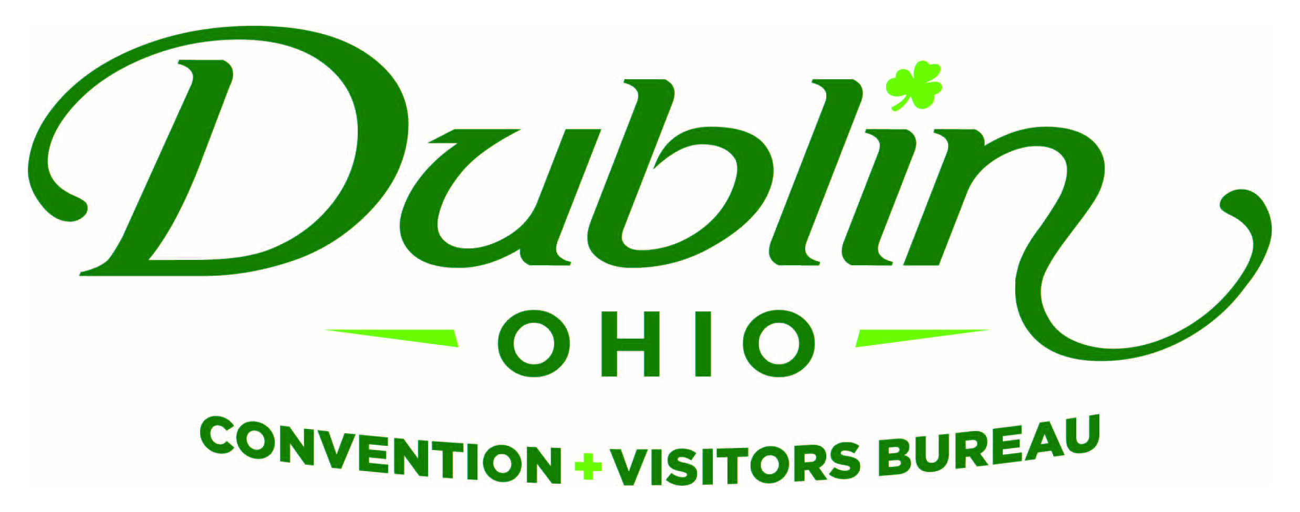
Executive Committee Meeting Minutes
October 5, 2017
DCVB Offices

Present: S. Kowaluk, P. Smith, D. Lee, C. Rose, C. Baldridge

Absent: B. Miller

Staff: S. Dring

Guests: E. Belfrage, P. Fingerhut

Board Action Items:

- November’s Executive Committee Meeting has been moved to Thursday, November 9.
- Scott and Phil to review proposals from Strategic Plan facilitators.

Detailed Minutes:

I. Welcome/Call Meeting to Order

II. Financials

- Bed Tax Revenue – Fiscal Year-To-Date bed tax revenue thru two months totaled $221,072, a decrease of 0.63 percent over 2016 and a 1.3 percent decrease over the YTD budget of $224,000.

- Balance Sheet – Staff provided the financials earlier in the week and the committee reviewed and discussed. The current total in the checking and saving accounts after the first quarter of the fiscal year is $149,898.57. Account receivables total $2,150 due to the invoicing for 2018 partners who prefer to be invoiced prior to publishing the Destination Guide. It is the Bureau policy to have at least 15 percent of the overall budget for the reserve fund and the reserve fund balance stands at $183,000.

- P&L Budget vs. Actual – Through September, total expenses year-to-date stand at 20.3 percent and the total income year-to-date stand at 27.1 percent. All account lines are where they should be at this point of the fiscal year.

III. Committee Discussion Items

- Hotel Development – Scott led a discussion on future hotel development in the City of Dublin. He noted there are 17 hotels and 2,300 rooms in the City and two new limited serve hotels (Townplace Suites and Motel 6) are going through planning and zoning. He shared historical data that showed the growth in supply, occupancy and average daily rate since 2000. Scott asked the Committee if they believed it was the Bureau’s role to initiate a community-wide discussion on future hotel development? Scott also noted that it’s not so much the type of hotels that are of interest to the Bureau, rather the type of customer the City is currently unable to attract.

The Committee agreed this was an important discussion to have at the board level. The recommended next step from the Committee was to gather City and Industry leadership to have a discussion on the need to create a procedure and process for future hotel development. The Bureau is not advocating for new hotels or the exclusion of hotels, rather a strategic process to help guide future development.

- Irish Experience Grant Program – Based on feedback from the Bureau’s Marketing Committee, the Irish Experience Grant Program is getting revamped after a successful five years generating more than 100 new Irish experiences. The Bureau is enhancing the grant program to an “Irish Entertainment Series” offering local businesses the opportunity to host Irish music, dancers and other live performances throughout the year. Applications for the Irish Experience Grant Program are now available.

- Board Meetings – Scott asked the committee if they desired any change in the current format of Board Meetings. The key focus areas of the meetings have been staff updates/education; guest speaker; and roundtable updates. The Committee was pleased with the current structure of Board Meetings.

IV. Executive Director Report

- November Meeting Change – The November meeting has been changed to Thursday, November 9.

- City Council Election – Scott said that all four of the City Council Wards are up election this November and there could be a major shift with City Council. Scott did meet with each of the new candidates, which include: Mark Koogler (Ward One); Jane Fox and Vicky Newell (Ward Two); Cathy De Rosa and J.D. Kaplan (Ward Four). All were knowledgeable of the Bureau and the positive impact the organization has on the community. Scott thanked Eric Belfrage for scheduling the meeting with Mark Koogler.

- Celtic Cocktail Trail – On the heels of the successful Fairy Door Trail, staff has created a Celtic Cocktail Trail. Staff will create a passport with all participating restaurant stops and Celtic offerings that will guide residents and visitors throughout Dublin to find a spirit with Irish flair! All participating restaurants will offer an Irish-themed cocktail to be available to any trail participants. (Irish mule, Green Martini, Celtic Cosmo, etc.) Each restaurant will receive a branded stamp that your staff will use to stamp the customer’s passport once they purchase a Celtic Cocktail. After completing the trail, the Bureau will award participants with a branded, green cocktail shaker and possible other prizes. Staff will schedule a brainstorming session with the Board’s Marketing Committee to further discuss and execute the Trail. Participating restaurants to date include: Tucci’s, Matt the Millers, 101 Beer Kitchen, Dublin Village Tavern, Bogey Inn, Ram and others to come.

- Suburban DMO Roundtable – Scott will again participate in a Suburban DMO Think Tank that includes 10 similar Bureaus from across the nation. Last year’s meeting was extremely successful with numerous ideas being brought back from the meeting and implemented at the Bureau. This year’s meeting will be held in West Chester, Ohio in November.

- Travel & Tourism Research Conference – Staff will attend the top tourism marketing and research conference in the nation in a few weeks. The TTRA Tourism Marketing Outlook Forum will include national speakers and data on future trends in the industry and will also provide an opportunity to meet with like CVBs across the nation to learn best practices.

V. Other

- Board of Trustees Meeting – Monday, October 9, Noon, Ohio University

- Executive Committee Meeting – Thursday, November 9, 11:30 a.m., DCVB Offices

“People in our places, feet on our streets, heads in beds”

