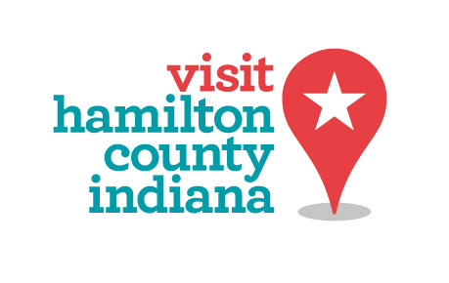

**Hamilton County Tourism, Inc.**

37 E. Main Street, Carmel, IN 46032

The Board of Directors Will Meet:

**Friday, October 6, 2017**

**8:30-10:30 a.m., Board Meeting, HCT Offices, 37 E. Main Street, Carmel**

**Mission Statement: *We message. We move. We make it fun.***

**Core Values: *Communication, Collaboration, Stewardship, Intelligence and Growth***

I. Welcome John Hughey

II. Review of the Minutes of the August Meeting John Hughey

III. Metrics

A. Tax Collections Brenda Myers

B. Lodging Data Brenda Myers

C. Budget Review Brenda Myers

D. Dashboard Updates Tina Rodgers

IV. Old Business

A. Building/LOI Update Karen Radcliff

B. Kincaid House Update Brenda Myers

C. Nickel Plate Heritage Railroad Brenda Myers

D. White River Regional Master Plan Brenda Myers

E. Grand Park Event Center Brenda Myers

V. New Business

A. 2018 Preview HCT Staff

1) Reserves Policy

VI. Department Updates

A. Handout: Major HCT Departmental Initiatives Updates

VII. Adjourn until **November 6, 2017** John Hughey