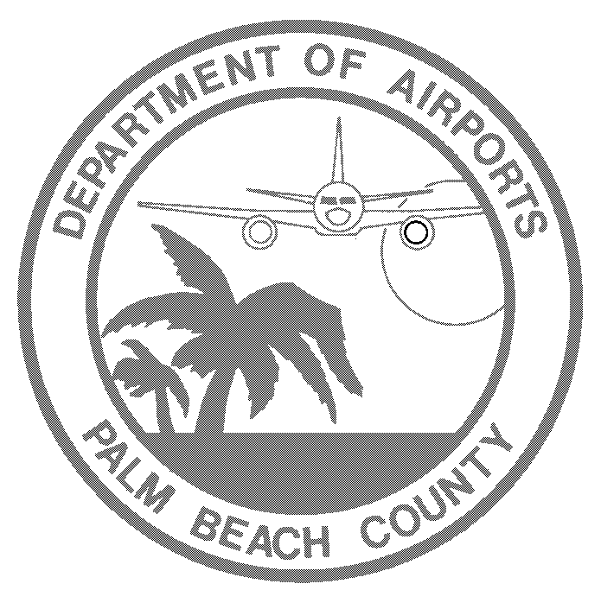
PERMIT # _ DECAL 1 #
DECAL 2 #
Flight Crew Parking Exp Date: ____________________
Fee Paid: $______________

2017 FLIGHT CREW APPLICATION FOR PARKING AT PBIA

ACTIVE FLIGHT CREW ID AND VEHICLE REGISTRATION IS REQUIRED FOR ISSUANCE OF FLIGHT CREW PARKING PERMIT

NAME: LAST, FIRST AIRLINE

EMAIL ADDRESS: CELL PHONE # HOME PHONE #

VEHICLE INFORMATION: STATE MAKE MODEL COLOR

VEHICLE TAG # 1:

VEHCILE TAG # 2:

Flight Crew parking fee is non-refundable, no exceptions.

Please mark the appropriate parking fee you are requesting:

3 Month @ $100 Additional decal $50

6 Months @ $ 175 Lost access card $100

12 Months @ $250

12 Months Plus: Total fee $_______ (($250yr + ($21month * ___months)) (only up to the expiration date on flight crew ID)

Payment options: Credit Cards (Discover, American Express, Visa, or MasterCard) or Money Order/Cashier Check
REQUIREMENTS:
Only Palm Beach International Airport airline leaseholders will be privileged for the flight crew parking.
- You must have a VALID Parking Card and your vehicle must display a VALID parking permit.
- ALL Flight Crew Permits remain the property of The Departments of Airports (Do not discard or destroy).
- No refunds for issued permits. No refunds if you park outside of the Flight Crew Parking Lot in any paying lot.
- Flight Crew Parking Cards SHALL be surrendered upon demand or when employment is terminated.
- If the Flight Crew member elects not to renew for the following year and does not return the parking card, the Lost Access Card fee of $100.00 SHALL be applied.
- The permit is in no way transferable. Permit holders’ parking privileges shall be revoked if permit is given to others for use.
The applicant understands and agrees The Department of Airports and USA Parking assume no liability for loss or damage to the vehicle(s) and contents while in the Flight Crew Parking Lot

Damaged, lost or stolen permits must be immediately reported to USA Parking and/or The Department of Airports.
If your access card does not work contact USA Parking at 561-471-7459 24/7 or press the blue button at the entrance/exit of flight crew parking lot.

With my signature I hereby certify I have read, understand and agree to comply with the above regulations and that the information on this application is correct to the best of my knowledge.

Signature: Date:

