Field Marketing Handbook

This handbook will list out the instructions for how to pick up promo materials, steps for submitting content, and how to complete the poster & flyer challenges to get points for your work.

How to Pick Up Your Materials?
Who to Contact to Do So?

City / Targeted Market -
(Contact Name): (Email here) (Phone Number)

Pick Up Location Address -

Hours of Operation -

Info for Shipping Materials -

What to Do & What Not to Do When Handing Out Hard Promo:
DO...
- Hand flyers to people and take photos or selfies with them.
- Go to high traffic areas and relevant retail locations including...
  - Coffee shops
  - Record stores
  - Bars
  - Colleges campuses
  - Concert / Events / Venues
  - Any places where you find people who would be interested in the event!
***Use your best judgement, and if someone tells you to stop, respect their wishes and move on.

Recommendations:
- Place stack flyers (½ inch thick) on counter. Ask permission from staff/manager
- Put flyer on car (Specifically on door handle.)
- Go to actual shows/events when you hand people flyers
- Pin flyers/posters on cork boards.
- Be friendly!

DON'T…
- Don't litter
- Don't leave multiple flyers on staircases
- Don't take photos of just your hand holding the flyer
- Don't placing flyers next to trash
- Don't invade people’s privacy
- Don't stack or leave flyers at businesses that are irrelevant to the festival.
- Don't make origami
- Don't make a house out of flyers/cards
- Don't stack 500 flyers at one business
- Don't flyer cars when its raining

Hard Promo Submission:
How to Complete Poster & Flyer Challenges

Step 1:
Go to your challenge page and find the poster / flyer challenge. Click into this challenge and read the challenge description.
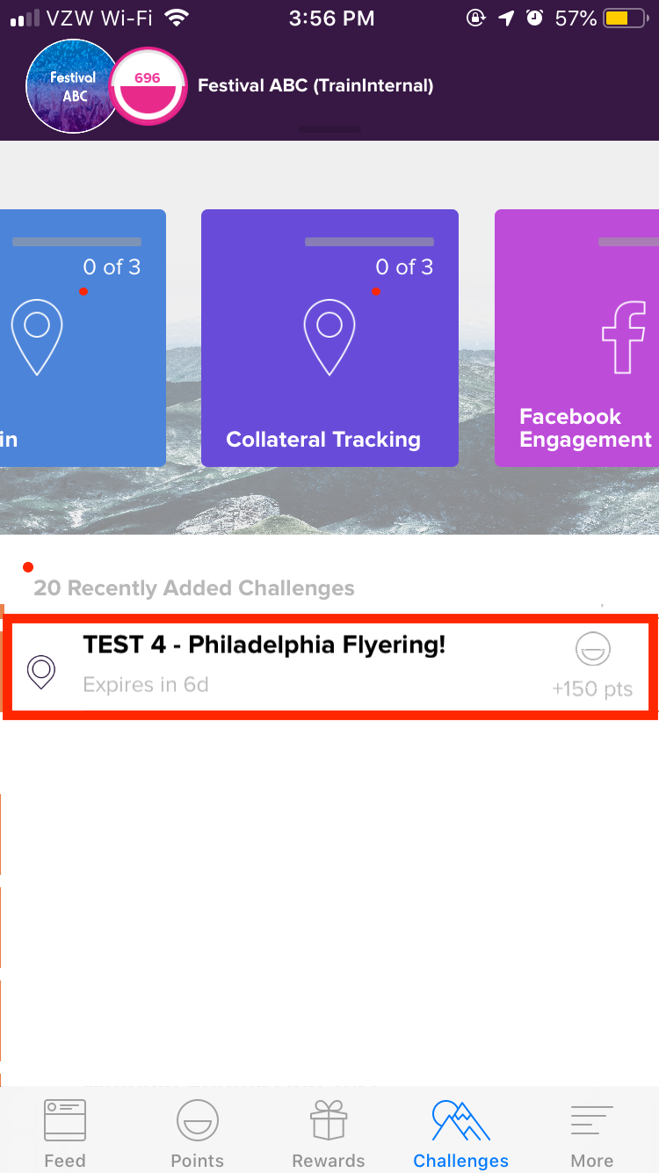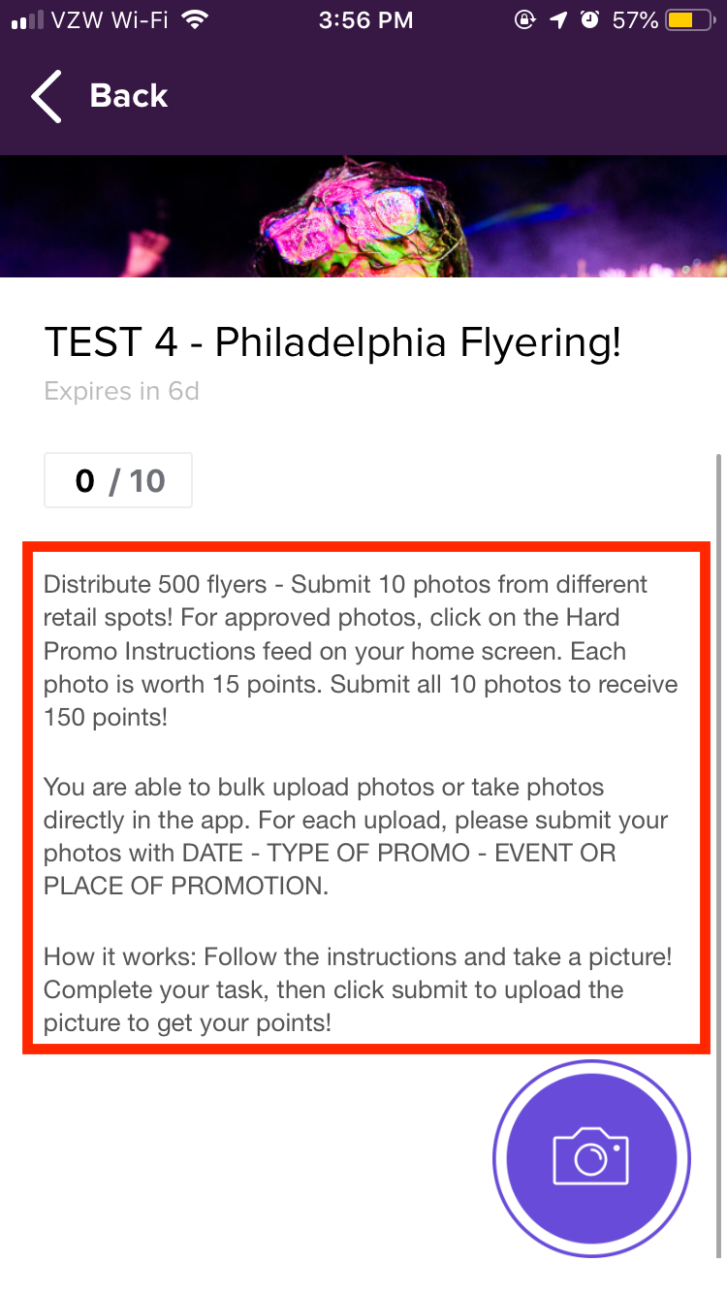

Step 2:
Click on the camera icon at the bottom right-hand corner of the challenge. On the next page, click on the camera icon again. This will prompt you to take a picture from your camera or your photo library. Select the images that you’d like to upload (highlighted in blue), and click “Done”.

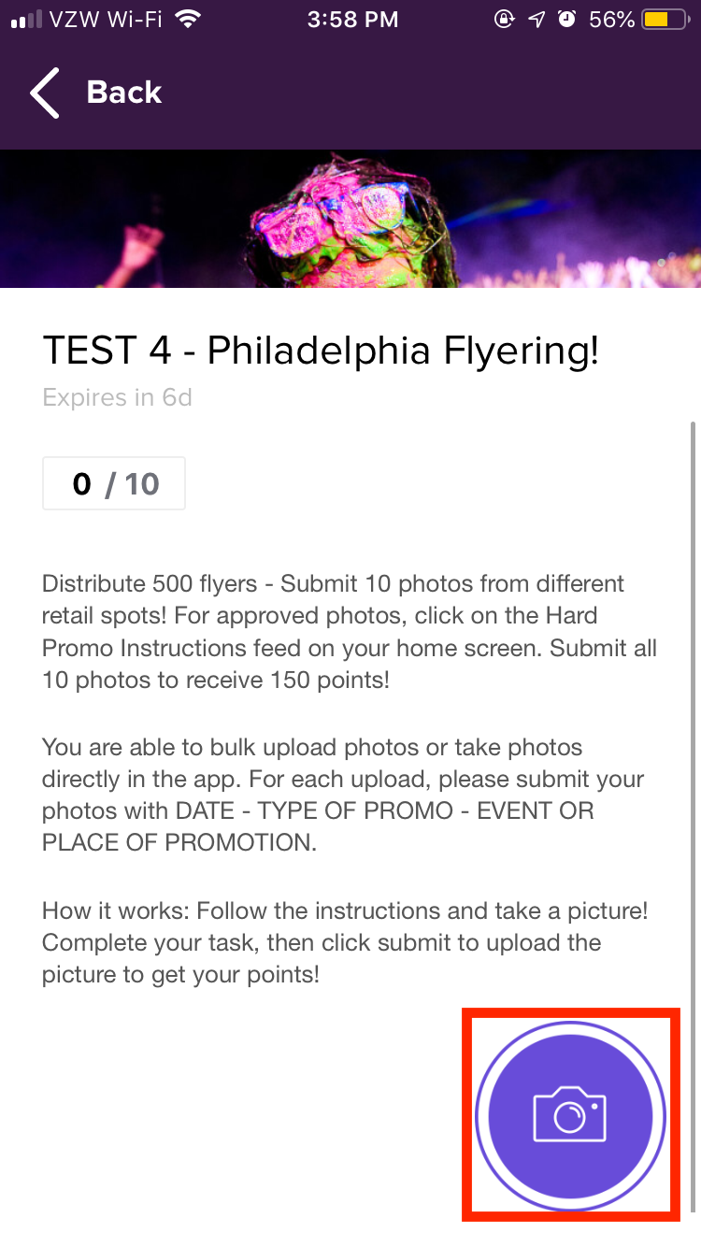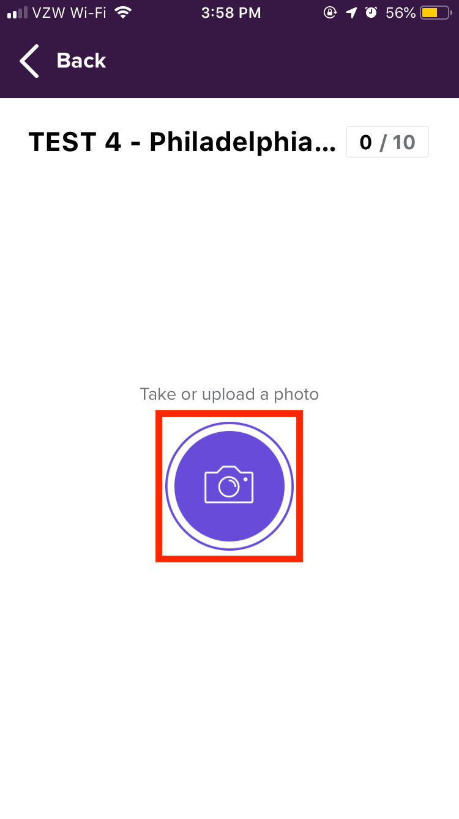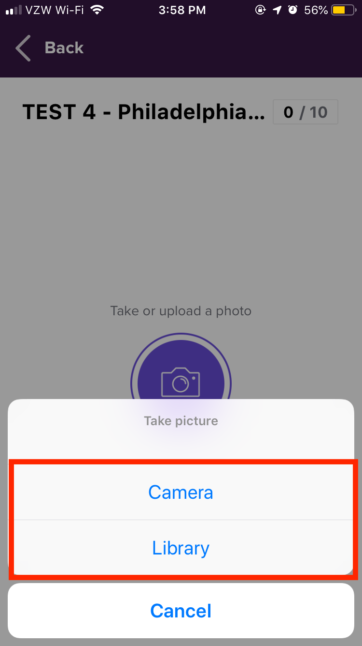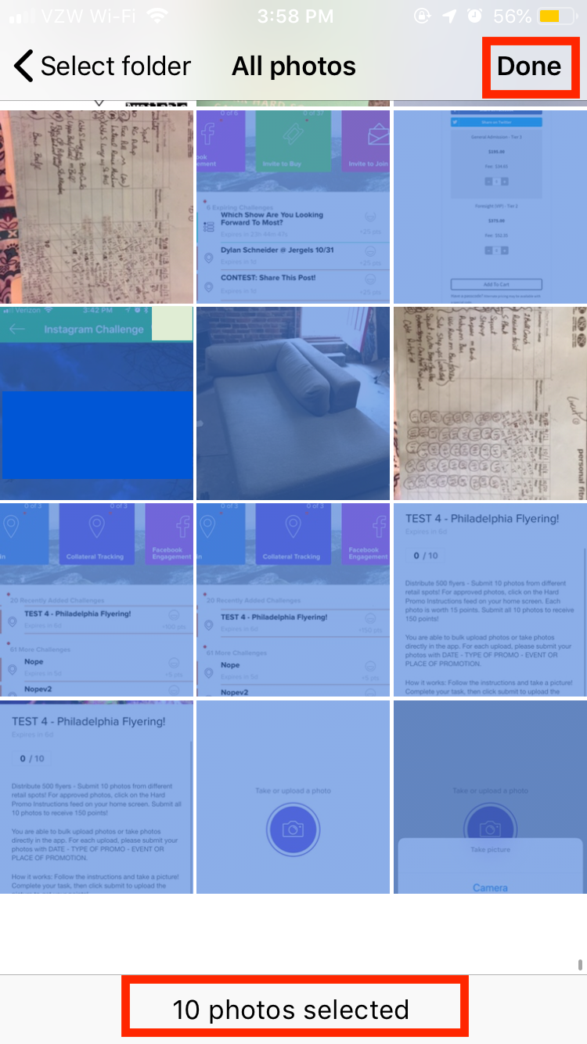

Step 3:
Add the descriptions required to complete this challenge: DATE - TYPE OF PROMO - EVENT OR PLACE OF PROMOTION. If each photo is from a different date or event/location, please attach these images separately and add individual descriptions. Then, make sure you’ve selected the total number of photos required to complete the challenge (in this case, 10 photos). Click on “ATTACH.”
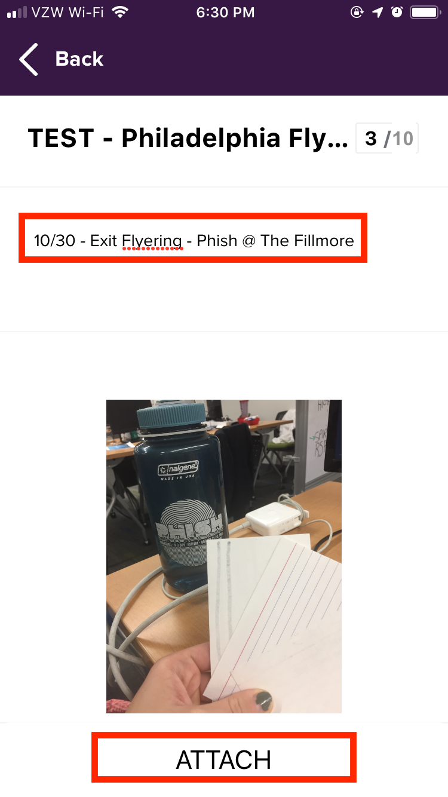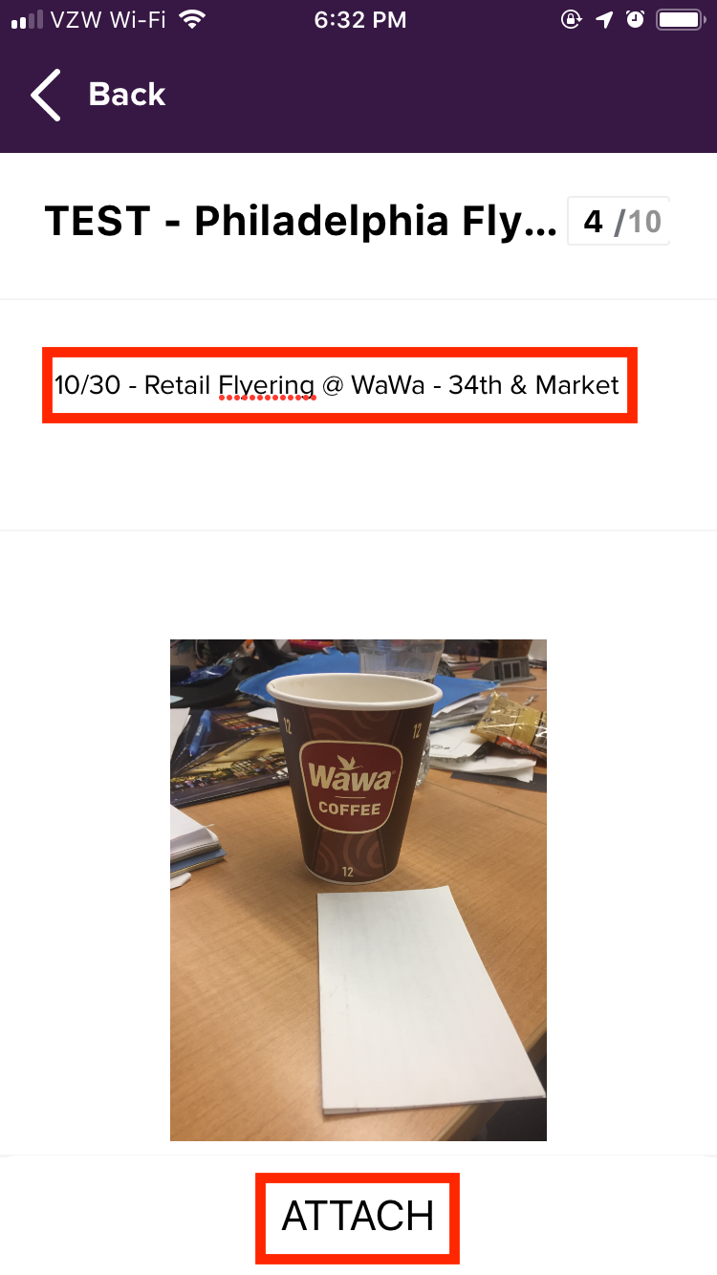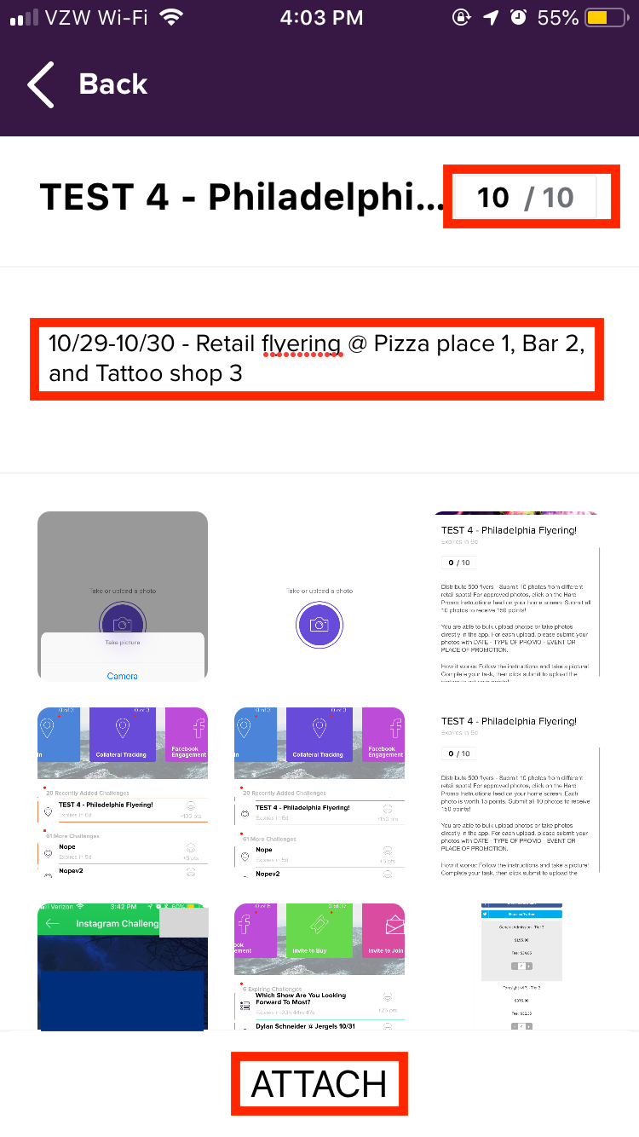

Step 4:
Once all descriptions have been added to each photo and all photos have been uploaded & attached, click on “Submit.” Once you click on “Submit” you can’t go back and edit the photos or their descriptions, so make sure everything is correctly labeled! After the photos are submitted, you will receive a message saying that you’ve completed the challenge!
