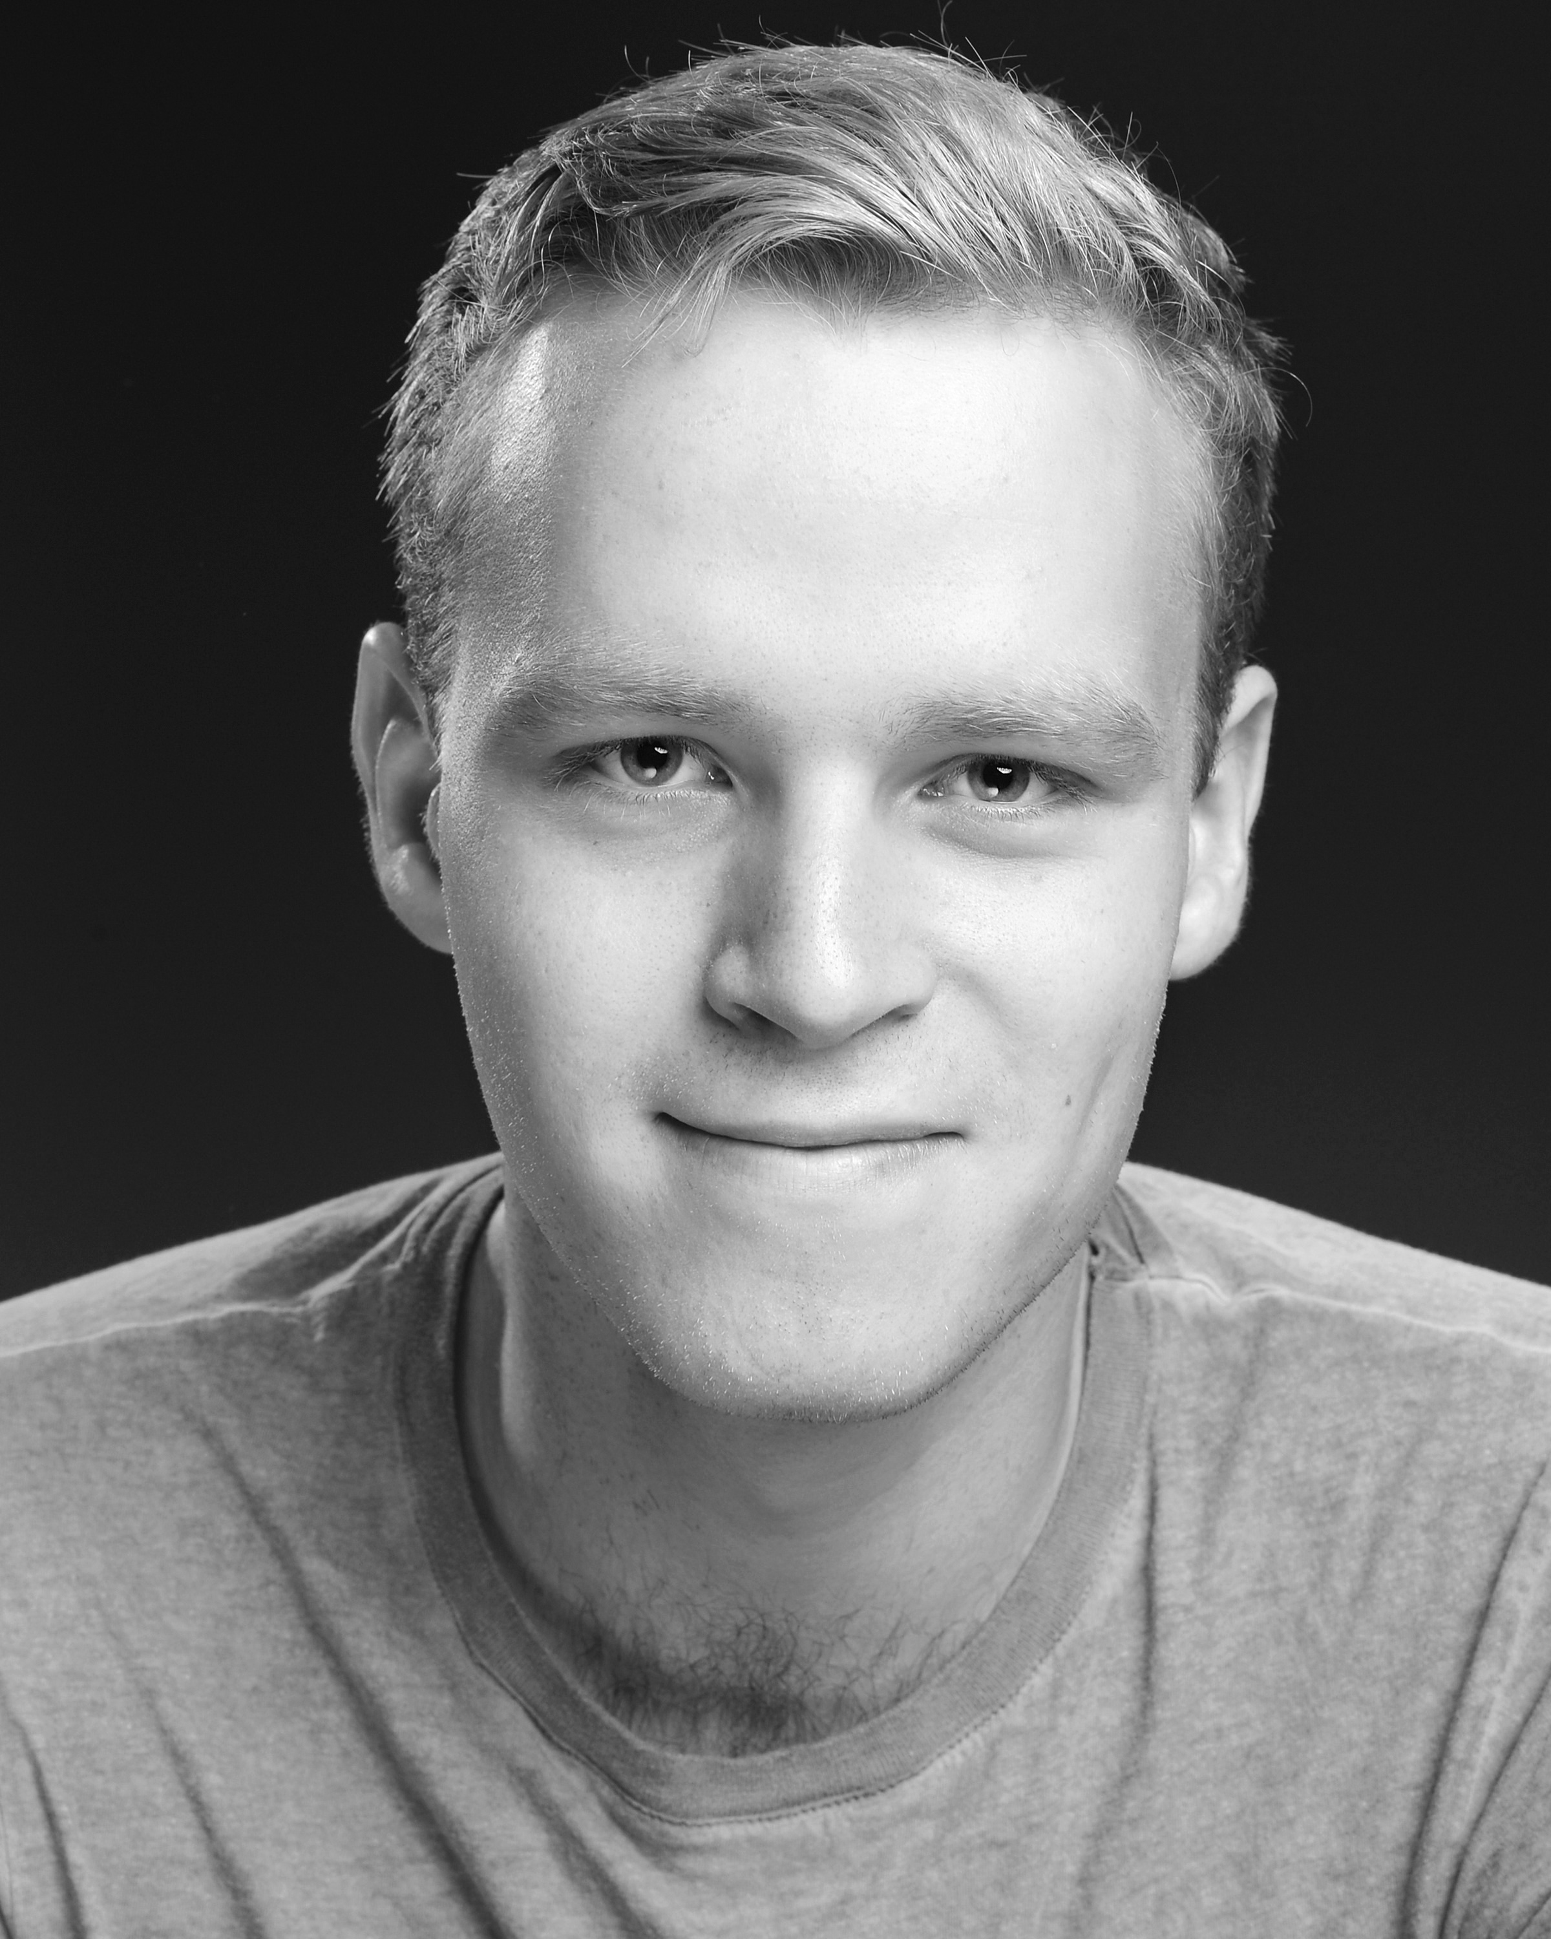

**Contact** **Jacob**: +44745 521 6322

**Contact Spotlight:** C/O 3811-6720-2398

**Equity No:** A00435743

**Email:** jacobmarkies@gmail.com

**Training**

East 15 Acting School, **BA (Hons) Acting**

*Nationality* British

*Height*  6ft

*Hair Colour* Blonde

*Eye Colour* Blue

*Build*  Athletic

© Caroline Webster.

**Accents/Dialects**: RP*(Native) London, general Scottish, general American, good ear for accents.

**Musical Instruments:** Acoustic Guitar* Electric Guitar and Classical Guitar.

**Singing:** Bass, Baritone,Tenor.

**Dance**: Waltz, Foxtrot.

**Professional Roles**

|  |  |  |  |
| --- | --- | --- | --- |
| **Date** | **Production** | **Character** | **Director** |
| 2016 | The Priory  (Tristan Bates) | Karl | Mitchell Glass |
| 2016 | Bull  (Tristan Bates) | Carter | Mitchel Glass |
| 2015 | Peter Pan  (Regents Park) | Soldier/Ensemble | Timothy Sheader and Liam Steel |

|  |  |  |  |
| --- | --- | --- | --- |
| **Date** | **Production** | **Character** | **Director** |
| 2016 | Summer Folk | Zimin/Dudakoff | Mathew Lloyd |
| *2015* | *Macbeth* | Macbeth | Jonathan Humphreys |
| *2015* | *Taming of the Shrew*  *The Cherry Orchard* | Vincentio/Tailor/Peter  Trofimov | Jeremy Mortimer  Phillip Weaver |
| *2014* | *Baden Baden Lesson on Consent* | Ensemble/Chorus | Dan Ayling |
| *2014* | *Summer Brave* | Hal | Phillip Weaver |
| *2014* | *Serving It Up* | Nick | Charlotte Thompson |
| *2014* | *With Their Eyes Verbatim* | Jack | Gerry McAlpine |

**Roles at East 15**

**Other Experience:** Living History, Commedia Dell’Arte, Laban, Eurhythmy,

**Skills:** Full clean driving license, Tennis, Improvisation, Cycling, Swimming. Skiing, Football.

**Interests:** Literature (mostly biographical and auto biographical) Classical Civilisation Sports, Music, Fitness, Cooking.