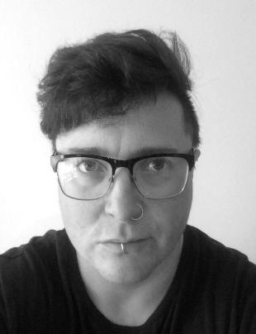**Niall F D S Farnan**

*Training:* University of South Wales *MA Drama and Performance*

Bristol Institute of Performing Arts (BIPA) / University of Gloucestershire

*BA (Hons – 1st) Drama and Performance*

*Height:* 165cm

*Weight:* 196lb

*Hair:* Brown

*Eyes:* Hazel

*Nationality:* British

*Gender:* Trans-Masculine male

*Natural Accent:* West Country/Neutral

*Playing Age:* 30 - 45

*Contact Details:* @Niall_Farnan / NiallFarnan74@gmail.com / 07936156351

**Performance Credits**

|  |  |  |  |
| --- | --- | --- | --- |
| **Year** | **Role/Type** | **Production/Director** | **Company/Venue** |
| 2018 | Writer/Director | ‘Elephants (are the largest land mammals)’.  Self | Atomic Clock Theatre and Performance  University of South Wales |
| 2018 | Performer/Writer/Director | ‘Tight Lines’  Self | Atomic Clock Theatre and Performance  Cardiff Fringe Festival |
| 2017 | Contributor | GPS Embroidery / Walking Performance  Elizabeth Philps/Self | Elizabeth Philps  Touring/Hamilton House, Bristol |
| 2017 | Actor/Performer | ‘The Stanley Miller Project’  Elizabeth Philps/Self | BIPA  The Loft Theatre |
| 2017 | Performer  Artist | ‘Body of Work in Progress’  Self | Bath Arts Fringe Festival/FaB |
| 2017 | Writer/Director | ‘Elephants Are The Largest Land Mammals’  Self | BIPA  Alma Tavern Theatre |
| 2017 | Performer  Artist | ‘Body of Work in Progress’  Self | BIPA |
| 2017 | Director/Joker | ‘Callum’ - Self Image Forum Theatre for young adults.  Self | BIPA  Various School Venues |
| 2016 | Director | ‘Translations’  Self | BIPA  The Olympus Theatre |
| 2016 | Performer  Writer/Director | ‘New York - I Sing The Body Electric’  Co-directed with Sophie Mathieson-Medrano | BIPA  Site Specific |
| 2016 | Actor  Producer/Assistant Director | ‘As You Like It’  Sophie Mathieson-Medrano | Tinned Pizza Theatre  Molloy’s Public House,  Bath |
| 2015 | Actor  Writer/Director | ‘Behinds Closed Doors’  Elizabeth Philps/Self/Nick Young | BIPA  The Olympus Theatre |
| 2015 | Actor | ‘The Day Off’  Silva Semerciyan | BIPA  The Loft Theatre |
| 2015 | Performer | Site Specific Workshop  Self/Group | BIPA  Serbia |
| 2014 | Actor | ‘The Red Button’  Elizabeth Philps/Nick Young | BIPA  The Olympus Theatre |
| 2014 | Contributor | ‘Fifty Miles to My Mother’s House’  Elizabeth Philps | Bristol Ferment  Bristol Old Vic |

**Other Skills and Experience**   
Stand up; Improvisation; Devising; Writing; Foundation Art and Design (Distinction); DBS Checked. Arabic Dance; Archery; Fencing; Some Boxing.