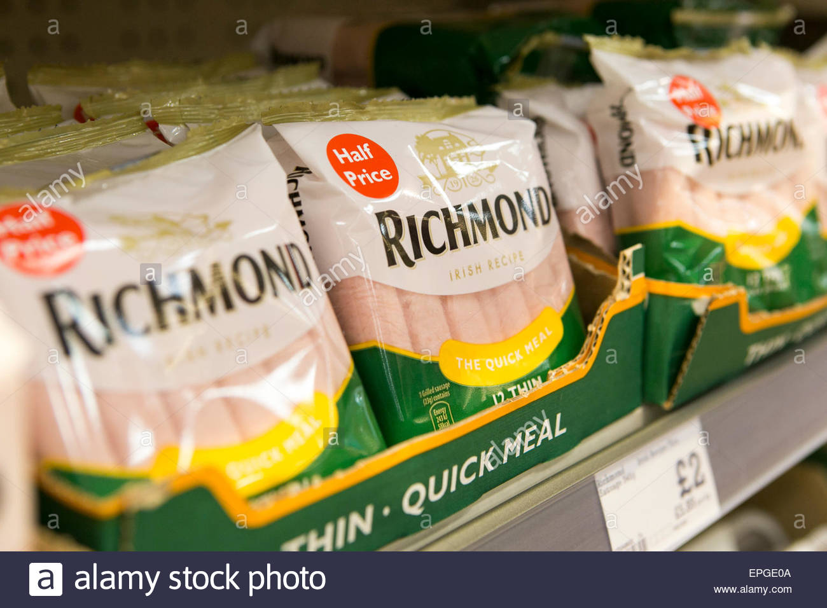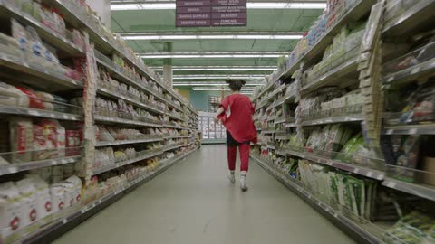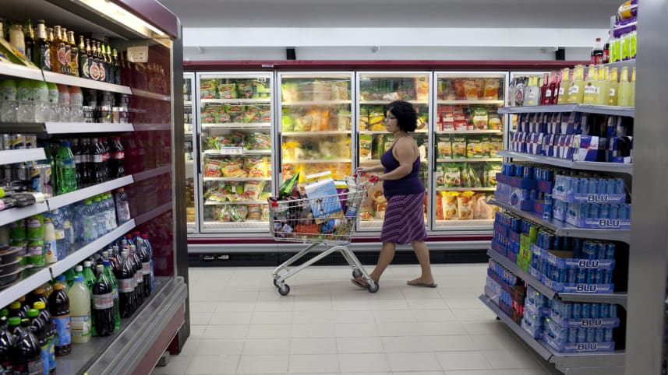

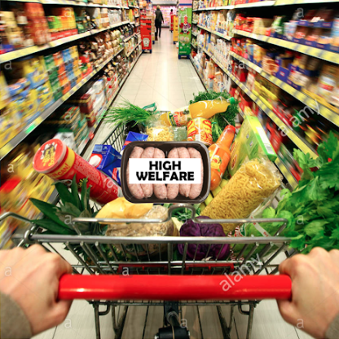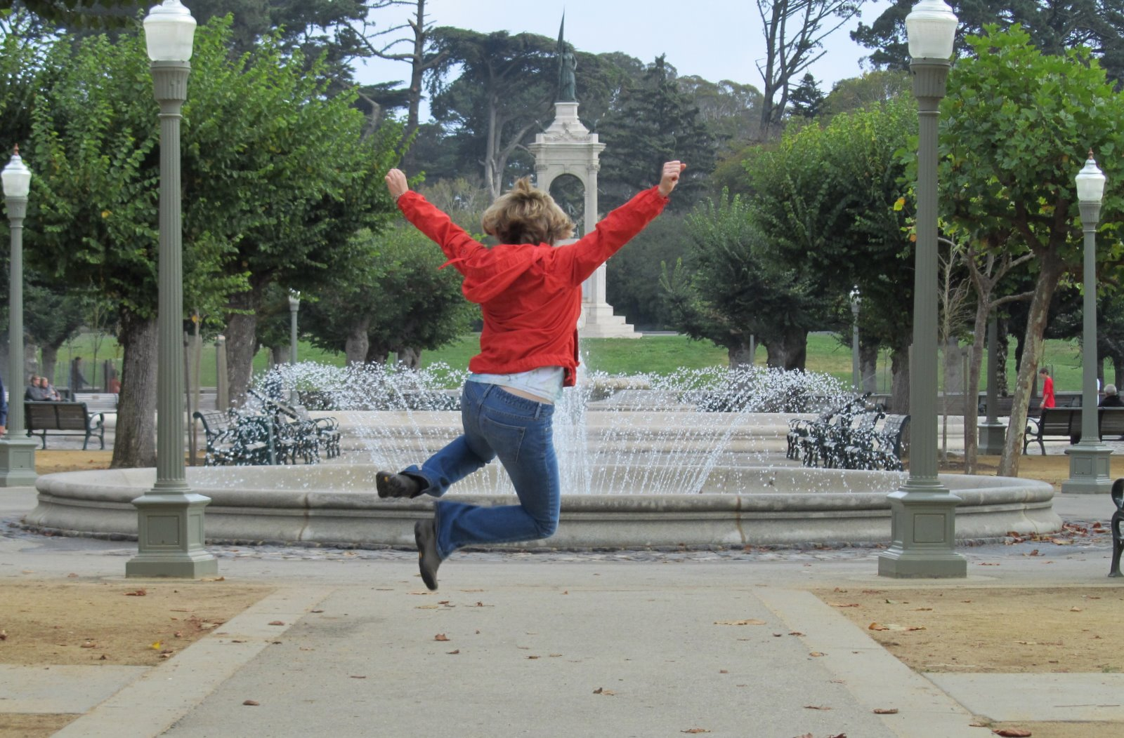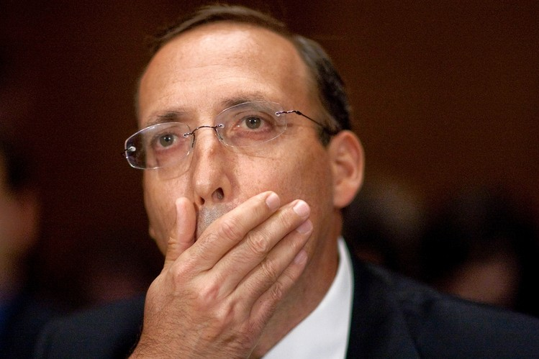

<https://www.youtube.com/watch?v=KnLFCY2vWoI&start_radio=1&list=RDKnLFCY2vWoI>

Song 🡪 The Housemartins – Think For A Minute!

START 0:00 / 1:31

Person walks across the screen past an aisle. Song plays over the supermarket speakers, tinny sounding. Pushing trolley of mostly veg. Looking tired / distracted. Sees that sausages are the last remaining item on the list.

Lyrics - “And nothing I could say could ever make them see the light”

0:09 / 1:40

Comes in to view turning onto the meat aisle and walks towards camera. Picks up both low and high welfare sausages. Cut to face which looks confused faced with this choice.

Lyrics - “Now apathy is happy that, it won without a fight”

0:20 / 1:51

POV low welfare brought closer to the camera, high welfare out of focus so all attention is on the low welfare. Face breaks into a frown, deep in thought. Music transitions from tinny supermarket speakers to full quality in time for the chorus.

Lyrics - “Think for a minute”

0.25 / 1.56

Frown deepens. Zoom in so screen dominated by eyes, eyebrows and forehead. Crunched up paper unfolds opening the thought bubble on their forehead, containing factory farmed footage and consequences of factory farming e.g. slurry spreading and algal blooms inside (also stop motion). Thought bubble all post production.

Lyrics - “stop for a minute. Think for a minute.”

0.35 / 2:05

Zoom out to full face, High welfare pack brought into focus. High welfare thought bubble.

Lyrics - “Stop for a minute”

0.40 / 2.10

Decisively places low welfare back on the shelf and high welfare into the trolley. Walks away from the camera with a sense of victory. Disaster avoided. Relieved / proud expression on their face. Clicks their heels in the air in celebration.

0.50 / 2:20 [End card 1]

Think for a minute. Only buy pork with a high welfare label.

0.54 / 2:24 [End card 2]

For further information on labelling, visit farmsnotfactories.org