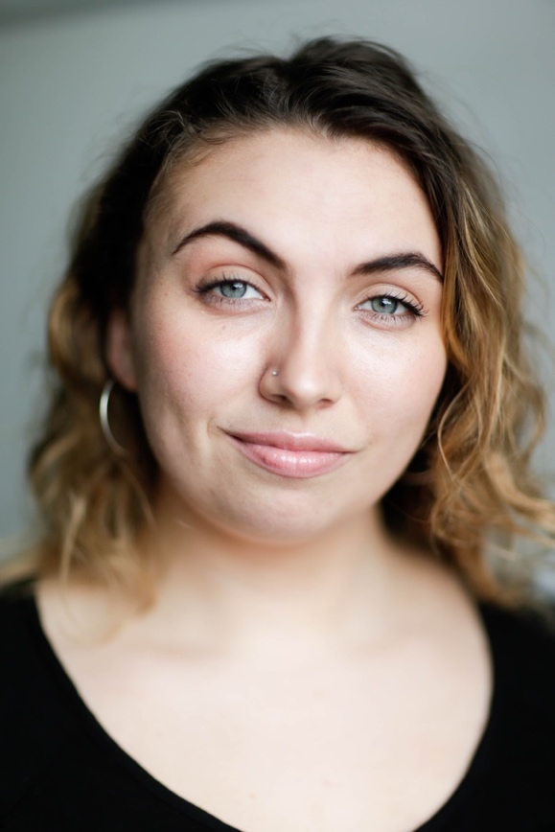Bonnie hay

bonniehay94@gmail.com | 07794813204

Height: 5’9”

Eyes: Green

Hair: Brown

Build: Average

Playing Ages: 18-25

Accents: English RP*, Bristolian, Lancashire, London, American RP ,New York, Texan (* native)

Dance Styles: Ballet, Tap, Contemporary, Modern (all advanced)

|  |  |  |  |
| --- | --- | --- | --- |
| 2010 | MARPLE-THE PALE HORSE | Mummer | ITV |
| 2008 | Casualty | Maria | BBC One |
| 2005 | Big Brother Little Sister | Little Sister | Short Film (Joy of Eight) |

**Non-Professional productions**

**Professional productions**

|  |  |  |  |
| --- | --- | --- | --- |
| 2015 | Want’s Unwhilst Work | Bertha Lerner (principal) | University of Missouri |
| 2015 | Breakfast Club | Jackie | University of Manchester Drama Society |
| 2015 | No Exit | Inez | The Operating Theatre Company |
| 2013 | Church Forced To Put Up Gates After Font (syc) | Cleaner (principal) | Theatre Uncut Manchester |
| 2012 | Pictures at an Exhibition | Ensemble | Bristol Old Vic Young Company |
| 2011 | RUN | Crying Girl | Bristol Old Vic Young Company |
| 2009 | Twelfth Night | Cesario | Shakespeare Schools Festival |

**Training and workshops**

Action and Impulse with Simon Trinder (Royal Exchange)

Bristol Old Vic Young Company (2010 – 2013)

Skills: Singing (Contralto), Devising, Physical theatre, improvisational comedy (MU Improv), Saxophone (Grade 3 jazz), Guitar, Directing, Writing, Silver Arts Award.