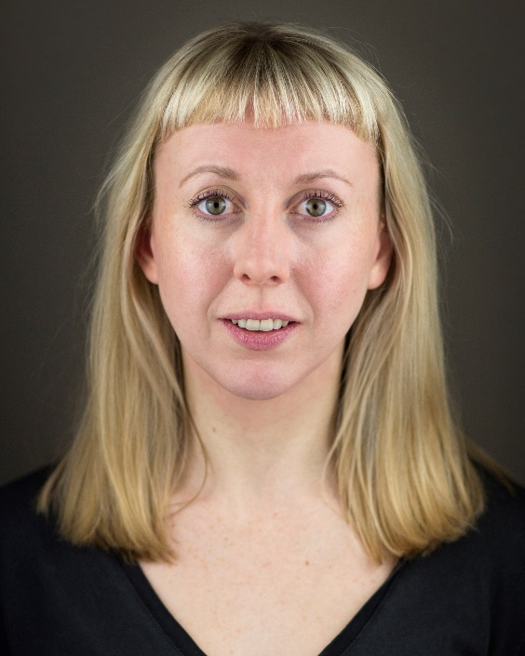**Liz Kelly**

**Flat 2, 69 Coronation Road**

**Southville**

**Bristol**

**BS3 1AT**

**07812341973**

**Lizzy_kelly15@hotmail.com**

**Location:** Bristol (Willing to travel)

**Height:** 5’8”

**Build:** Slim/Size 8

**Playing Age:** 27-35

**Eyes:** Green/Grey

**Hair colour:** Blonde

**Hair length:** Shoulder length

**Theatre**

Twelfth Night (May 2018) – Multi Role – Jealous Lemon Productions, Sam Roker

Knowledge and a Girl (April 2018) – Snow White – Kelvin Players, Sam Grayston

Hungry (March 2018) – Multi Role – Out of Your Mind Festival, Stephanie Kempson

Merely Existing (February 2018) – Becky – Sharp Teeth, Stephanie Kempson

The Beaux Stratagem (March 2017) – Gypsy – Kelvin players, Martin Walsh

Midsummer Night’s Dream (June 2017) – Starveling - Gatecrash Theatre, Anna Friend

**Film**

The Officer, The Boy and The Body (October 2016) – Woman – Screenology Film School, Catherine Cable

**Training**

BAA Showcase Course (2018 – ongoing) – Bristol Acting Academy, Bristol

TRB Theatre School (2018 – ongoing) – Theatre Royal Bath, Bath

Summer Intensive (2016) - Maggie Flanigan Studio, New York

**Additional info/Workshops**

I have completed an unarmed combat for stage and screen workshop with Alter Ego Acting. I am a member of the Unscripted Players at the Bristol Improv Theatre and performed in ‘What a Difference a Friend Makes’ as part of their Big July Show. I am also a member of a longform group called Waiting for Becky and perform with them at the monthly improv night, Parents Basement.