Christian ROwbotham

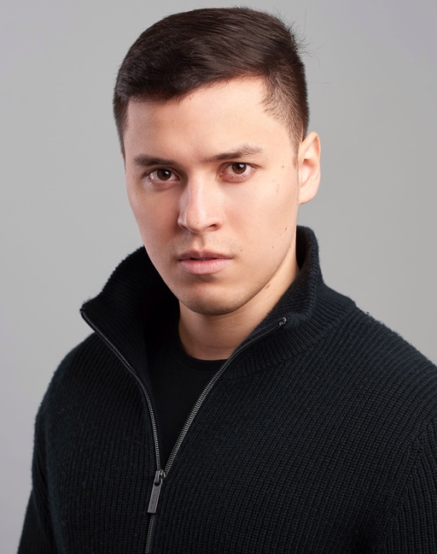

Eyes color: Brown

Hair color: Brown

Height: 1,69m

Address: 5 Bruton Close, Nailsea, North Somerset. BS484YW

Languages: English and Spanish.

Email: [Chris.rowbotham955@gmail.com](mailto:Chris.rowbotham955@gmail.com)

**Acting Experience and Credits:**

2019

* Raven’s Gate (Shortfilm): Kelvin
* “Road” (Kelvin Players production): Curt and Blowpipe.

2018

* Claimed and Shamed (BBC One documentary) : A Fraudster
* Love Song (Bristol acting academy: Showcase) : Harry
* The best man (Shortfilm) : Andy
* "Phoenix Forever" Sci-fi action feature film by Screenology : Billy
* A midsummer night's dream (showcase, Bristol acting academy) : Demetrius
* " Butcombe" advert : Liam
* The ego dance (Shortfilm): Psycho Boyfriend

2017

* Bristol Acting Academy : Showcase Course
* Dealers Choice : Frankie
* Stuff em and kip em safe : Tom

2016

* Pavlov : Mauricio
* Antigonas o detrás del murmullo : Dr. Carlos
* Entiendeme tu a mi : Mario
* Twelfth Night : Malvolio

2015

* CICA: Drama school: BA Professional Acting (Venezuela).
* Mesoneros: Potty.
* Entrada de Artistas (stand-up comedy): Myself.

2014

* Glee: The musical: Will Schuester.

2011

* Pocahontas: Governor Radcliffe.
* Nightmare before Christmas: Dr Finkelstein.

2010

* El País de Caramelo: Toronton and Capitán Miralejos.

2009

* Alice in wonderland : The Caterpillar
* Viaje al centro de la tierra : Ned and old traveler

**Biog:**

Christian first discovered his passion for acting during early childhood. He started his acting career as child actor at the age of fourteen when he first joined a Youth theatre academy founded by Television actor, director and producer “Karl Hoffmann” where Christian had the opportunity to be interviewed at “Venevision” with the rest of the cast for the Musical Show “Alice in Wonderland” and “Journey to the Centre of the earth”. After graduating from CICA Drama School in Venezuela in 2016, Christian was blessed to star in numerous theatre productions and tours around Caracas, with fifteen professional and amateur productions under his belt: “Los Mesoneros” (Theatre Chacaito entertainment), “Glee: The Musical” (Theatre Santa Fe Productions/Tour), “Entrada de Artistas: Stand Up Comedy “ (Theatre Santa Fe Productions), “Pavlov” (CICA: BA Acting Academy Showcase), “Entiendeme tu a mi” ( Santa Fe Micro theatre Festival and winner for Best Santa Fe micro-theatre comedy), “Twelfth Night” ( Skeena Productions), and others. Despite subsequently pursuing a career in Law, Christian kept in touch with acting, and abandoned his university studies in order to pursue an acting career in the United Kingdom. He attended the Bristol Acting Academy for one year under the tutelage of staff from the “Bristol Old Vic Theatre School”. During his time in UK so far, he has performed both modern and classical roles, including Frankie in “Dealer’s Choice”, and Demetrius in “A midsummer night’s dream”. Christian made his first theatre debut in UK for “Stuff em’ an’ kip em safe” as Tom, performed in Gloucestershire, and his first debut Short film “Phoenix Forever” as Billy (A Sci-Fi action film produced by Screenology), and appeared in several short films in UK. Christian is driven to succeed as a working actor and currently he is member of Kelvin player's theatre company. He is hard working and always looking forward to the next challenge.

**References:**

Trino Rojas

Contact number: 04164119089

Carlos Roa

Contact number: +1 (786) 277-7566

Gary Owston

Contact number: +447712 444374

Karl Hoffman

Contact number: 02129793266