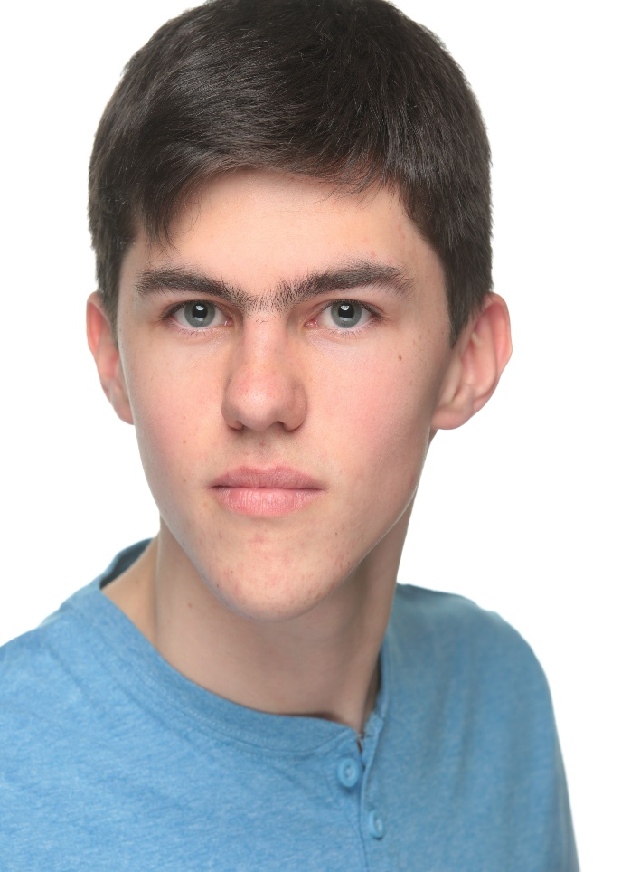DANIEL HARDWELL

ACTOR

***EMAIL:*** [*DANHARDWELL@VIRGINMEDIA.COM*](mailto:DANHARDWELL@VIRGINMEDIA.COM)

***MOBILE:*** *07709 639510*

**Date of Birth:** 28/08/2002

**Height:** 5’7”

**Build:** Slim

**Eyes:** Blue

**Hair:** Dark Brown

**Nationality:** British

**Playing Age:** 13 - 19

**EDUCATION**

2018 – 2020 Boomsatsuma (Bristol) RSL Level 3 Extended Diploma in Creative and

Performing Arts (Acting)

**PREVIOUS WORK**

**Theatre**

**Production Part Venue**

Flesh [unnamed role] Bristol Old Vic – NT Connections

Flesh [unnamed role] Redgrave Theatre – NT Connections

Trouble’s A Brewin’ Mr. Walton Her Majesty’s Theatre (London) - PQA

Annie Jr. Rooster Hannigan Phoenix Theatre – New College (Swindon)

We Will Rock You Henchman 1 Nailsea School

Beauty & the Beast Jr. The Beast Phoenix Theatre – New College (Swindon)

The Lazy Ace (PQA Original) Chip Buddy Her Majesty’s Theatre (London) - PQA

**Film**

**Title Part Production Company**

The Interrogation Game Servant PQA – Available to watch on “PQA TV” on YouTube