**JWBeyond Different Kettle of Fliss**

Jon Wilks Fliss O’Dwyer

48 st Andrews Road <https://www.linkedin.com/in/felicityodwyer/>

Gosport

Hampshire

PO12 1QB

[jwbeyond@hotmail.co.uk](mailto:jwbeyond@hotmail.co.uk)

07816084419

**SEXGREMLINS**

**LOVE** is **WAR**. **WE** search, **THEY** destroy.

# The Show

Serialized dramedy comprised of six episodes with a classic comedy runtime of twenty-three minutes per episode and one forty-eight minute christmas special. Additional online content such as development podcasts and video journals/sketches made while filming.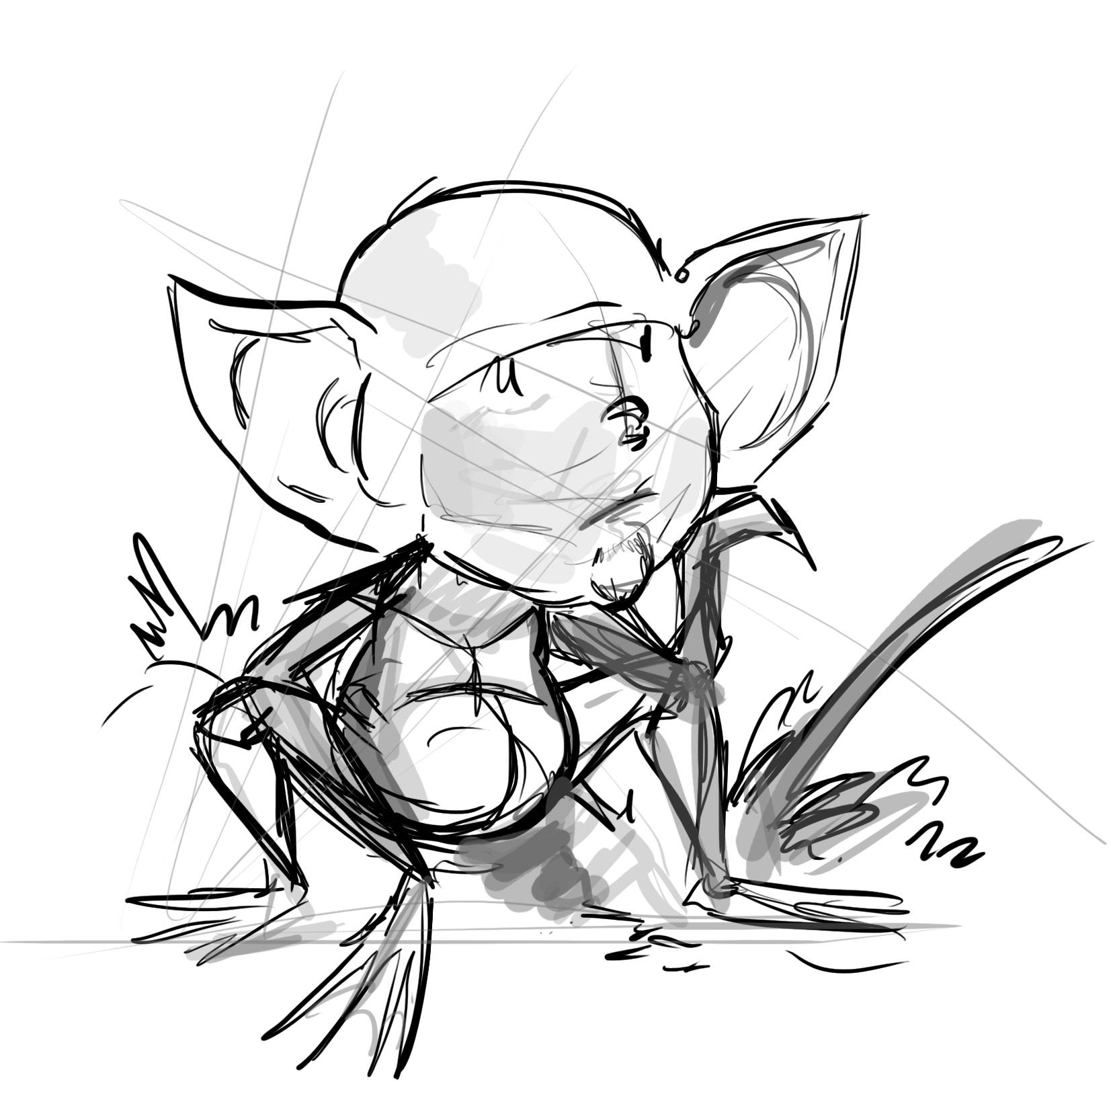

Filmed in live-action with the addition of puppeteered scenes this post-watershed show is aimed at the 25-34 demographic that doesn't rely on nostalgia or “reality” tv. Instead this unique show will focus on the panic of being single and directionless in a world that expects you to have figured all that stuff out by the time you hit 30.

But what if the most important aspect of that future is being sabotaged.

We have ALL had an embarrassing sexual encounter that we have locked away in the dark recesses of our minds.

But it’s ok, it wasn't our fault. It was…

**SEXGREMLINS**

# Synopsis

What would happen if the cast of the **IT Crowd** had total control over the love lives of **Romeo and Juliet**? Welcome to the world of Sex Gremlins, a world just like our own but with the addition of little creatures that will do anything to mess up one of our oldest and most popular pastimes.

We begin on the streets of **Bristol** when we meet **Dean** (a thirty year old guy that has given up on being happy and sleepwalks through life) and Joanna an attractive twenty seven year old woman who is equally lonely but can't help but be positive. These two hit it off and go on a date but unbeknownst to them they have three **SEX GREMLINS** accompanying them.

The world is being ruined by humans and Gremlins have taken it upon themselves to stop human couples overpopulating the world any further. Gremlins can’t be seen or heard by humans which makes their work so much easier. The leader of this group is **Oly**, an experienced yet grumpy Gremlin that is training his replacement to sabotage Dean’s sex life, a young gremlin lad named **Arfor**. We also meet **Foof,** a female “know-it-all, Hermione type” who is Joanna's gremlin. With all three Gremlin’s combined effort they successfully sabotage the couple’s relationship from going any further, namely four black eyes and two bruised egos.

The morning after Dean and Joanna meet with their respective friends and with some coercion the couple both decide to start dating other people. This gives the gremlins more opportunities to sabotage these dates with increasingly bizarre outcomes. But will Dean and Joanna’s first encounter really be the end of their relationship?

Not only do our couples have terrible luck during sex but it also turns out that the people in their everyday lives are just as troublesome.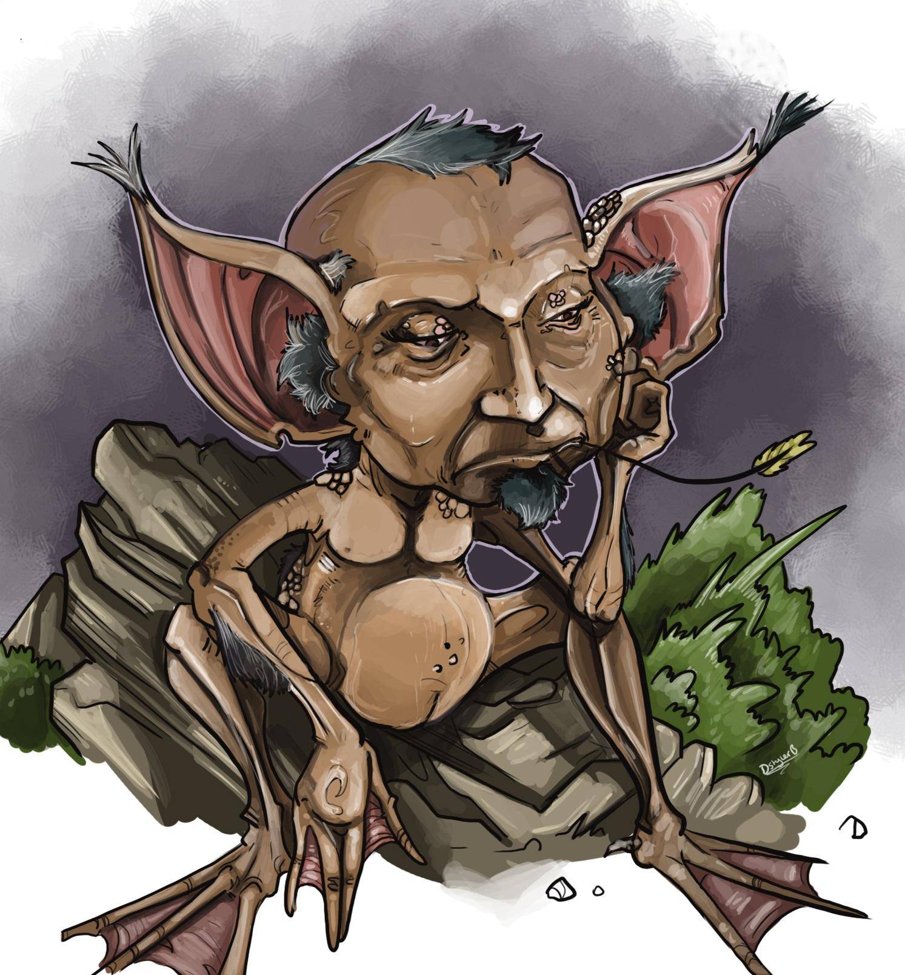

Here are just a couple of them:

* **Wednesday:** An energetic, pushy cam-girl with bright hair and a mysterious eyepatch.
* **Angelo:** A confident, selfish, casanova want-to-be.
* **Helen:** Oversexed office worker that misses her single life.
* **Izzy:** A “multi-gender” sex therapist.
* **Bob:** A psychotic CAT out for revenge.

As the show progresses we will meet many more characters, go on more dates, have more embarrassing sexual encounters, mysteries to solve, a death or two, All finally climaxing within the weird world of Bristol’s Fetish community.

**Show Bible, Set-up, Scripts, and Concept Art are all available upon request.**

**Concept Art** featured by Daniel Styler-Bradley.

Early **proof of concept**: <https://youtu.be/_MQkyB3-cs0>

Sex Gremlins are small warped human/frog-like creatures hidden from our everyday world.

For the filming we plan to have the actors wearing a small puppet body against a green screen so the actor has full range of facial movement to give the gremlin as much life as possible.

# 

# Planned Additional Media.

**YouTube** is an incredible resource for entertainment and advertising. Although the show itself would not be suitable for YouTube we could easily make trailers, sketches and dev diarys using unused resources from filming the Tv show.

A **web page** could be easily be set up with character bios, galleries, advertisements and even special character centered activities. For example one character enjoys mixing odd foods together so we could make an online recipe book for meals seen in the show.

**Podcasting** has exploded in popularity recently so a podcast could be made while the show is being created. Weekly updates of the shows progression, Interviews with staff from all aspects of the shows production will give a unique insight to the process of creating a show in the UK.

The Gremlins themselves are perfect for **Merchandising**. Official images or simple re-designs could be added to all kinds of stationary, trinkets and collectable statues.

# Long-term Plans

**Series 2.** The first series is based around our main characters Dean and Joanna but with their story nicely wrapped up I intent to end their story there. Often when romantic shows span multiple series they force a new challenge to the relationship which often ruins the journey of the first which is why i do not intend to continues that story. However other characters stories from series 1 can continue without disrupting the original. I would also like other writers with a passion for the Sex Gremlin universe to create new love stories with a fresh perspective. With this in mind I would also like other series to be set in different cities around the UK celebrating the varied cultures and landscapes the UK has to offer.

**Overseas markets**

The show was designed from the very beginning with overseas markets in mind. The idea of disappointing sex is something people from all countries can relate to. America in particular is known for remaking UK shows for American audiences but very rarely succeeding. The first series of Sex Gremlins will leave room for many of the characters to be able to leave the UK and continue their adventures in new shows. While these remakes of the show can easily use plot points from the original series they will also have the opportunity to fit the show to their own countries views on sex and relationships. But with the inclusion of UK characters it is also a continuation (Technically a spin-off) which will be uniquely popular with UK audiences.

**SEX GREMLINS is an extremely unique story that has all of the ingredients for a blockbusting TV show and is also open to worldwide universe building. With the right people on board this could easily be the lightning in a bottle that you are looking for!**

Thank you for your time and we look forward to working with you ;)

Created and Written by **Jon Wilks** 2018