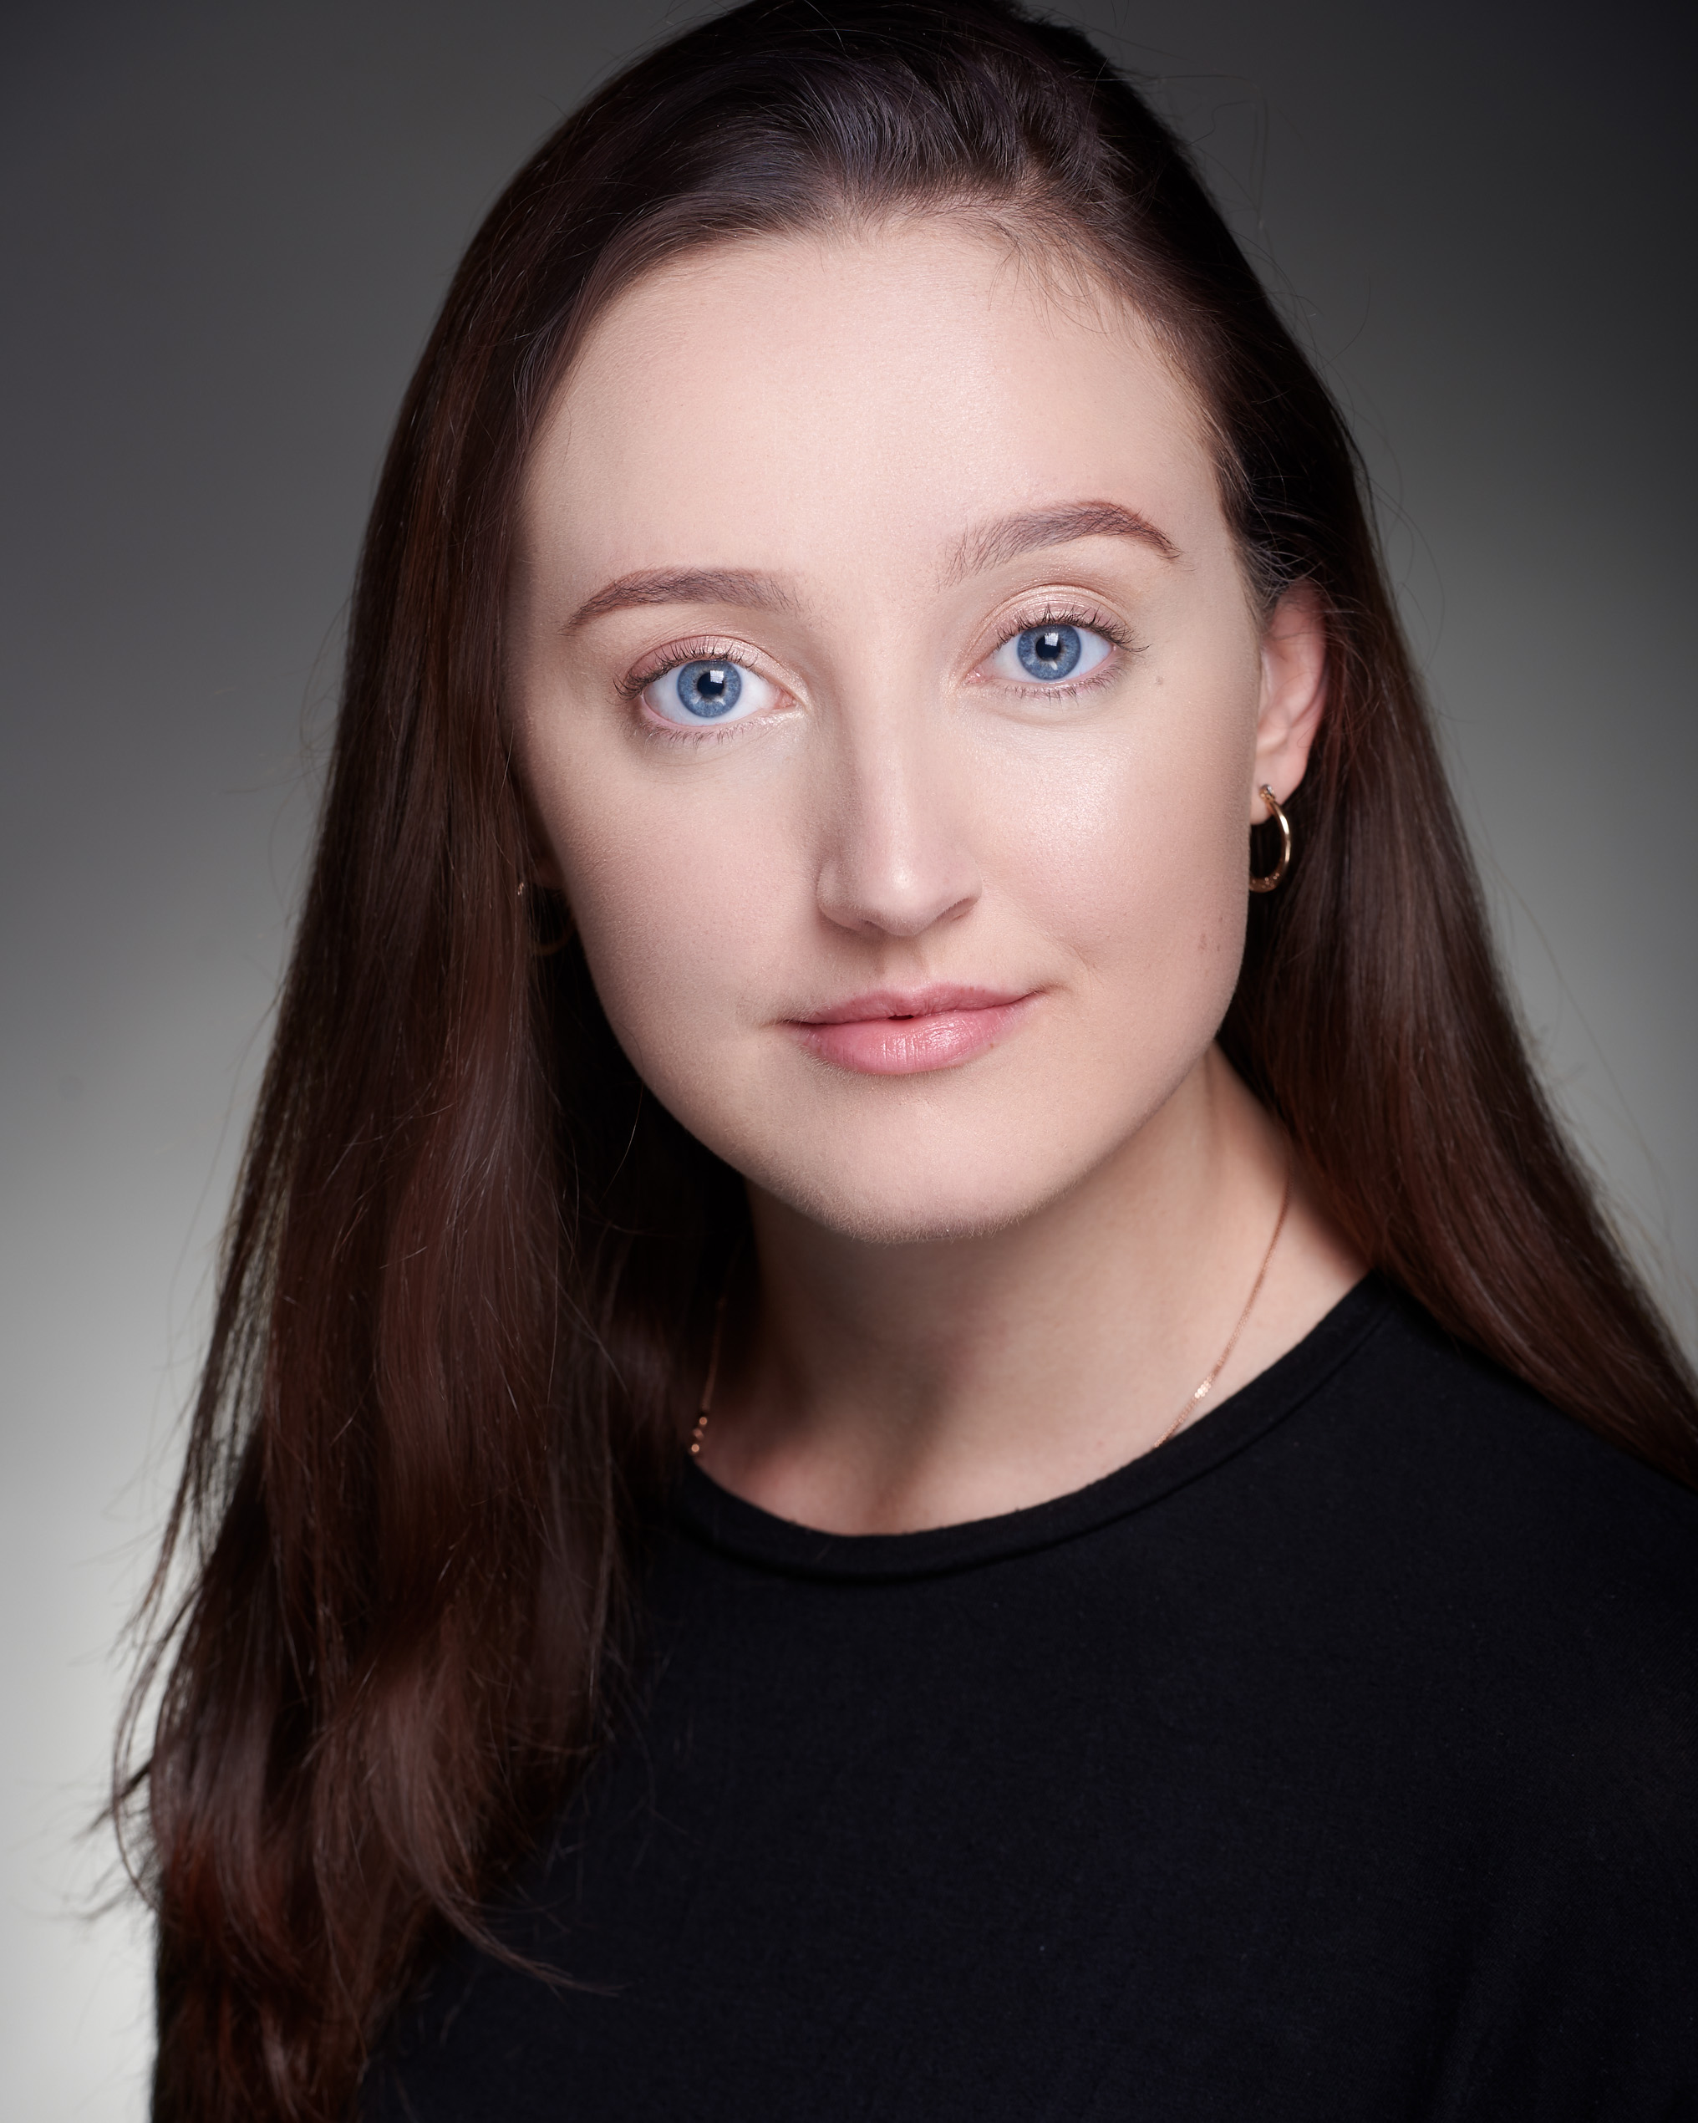**Elizabeth Taaffe**

**Location:** Bath/Birmingham

**Height:** 5ft 9

**Build:** Slim

**Dress:** 10

**Hair:** Medium, Brown

**Eyes:** Blue

**Playing age:** 17-24

**Training:** Bath Spa University

(BA Hons Acting)

**Phone:** 07979125425

**Email:** [lizzie-taaffe@hotmail.co.uk](mailto:elizabeth.taaffe16@bathspa.ac.uk)

|  |  |  |  |
| --- | --- | --- | --- |
| **Film** | **Role** | **Company** | **Director** |
| Kobudai (Short) - 2019 | Melvina | Bath Spa Productions | India Casson |

|  |  |  |  |
| --- | --- | --- | --- |
| **Theatre** | **Role** | **Company** | **Director** |
| I’ll take it from here - 2019 | Eve | Bath Spa Productions | Abigail Dow / Brandon Power |
| Cell Block What The **** - 2019 | Inmate 3 | Bath Spa Productions | Elizabeth Taaffe |
| Britain’s got fashion ‘Rehearsed reading’ - 2019 | Gillian | Bath Spa Productions | Kerry Irvine |
| Doctor Faustus – 2018 | Wrath/Cardinal | Bath Spa Productions | Ricky Dukes |
| IMDb script to screen awards - 2018 | Jane (Winner) / Narrator | IMDb | Mark Langley |
| Twelfth Night - 2018 | Viola | Bath Spa Productions | Roger Apfelbaum |
| The Hired Man - 2016 | Farmer/Miner | Lichfield Garrick | Tim Ford |

**Skills:**

**Accents:** RP, Standard American, Irish, Somerset, Birmingham

**Sports:** Swimming, Running, Bowling, Badminton

**Singing:** Mezzo – Soprano

**Stage Combat:** Armed (Rapier/Dagger) and Unarmed combat

**Theatre:** Comedy, children’s theatre, mask work, Feldenkrais method, physical theatre, animal work, musical theatre

**Other:** Barista, waitress