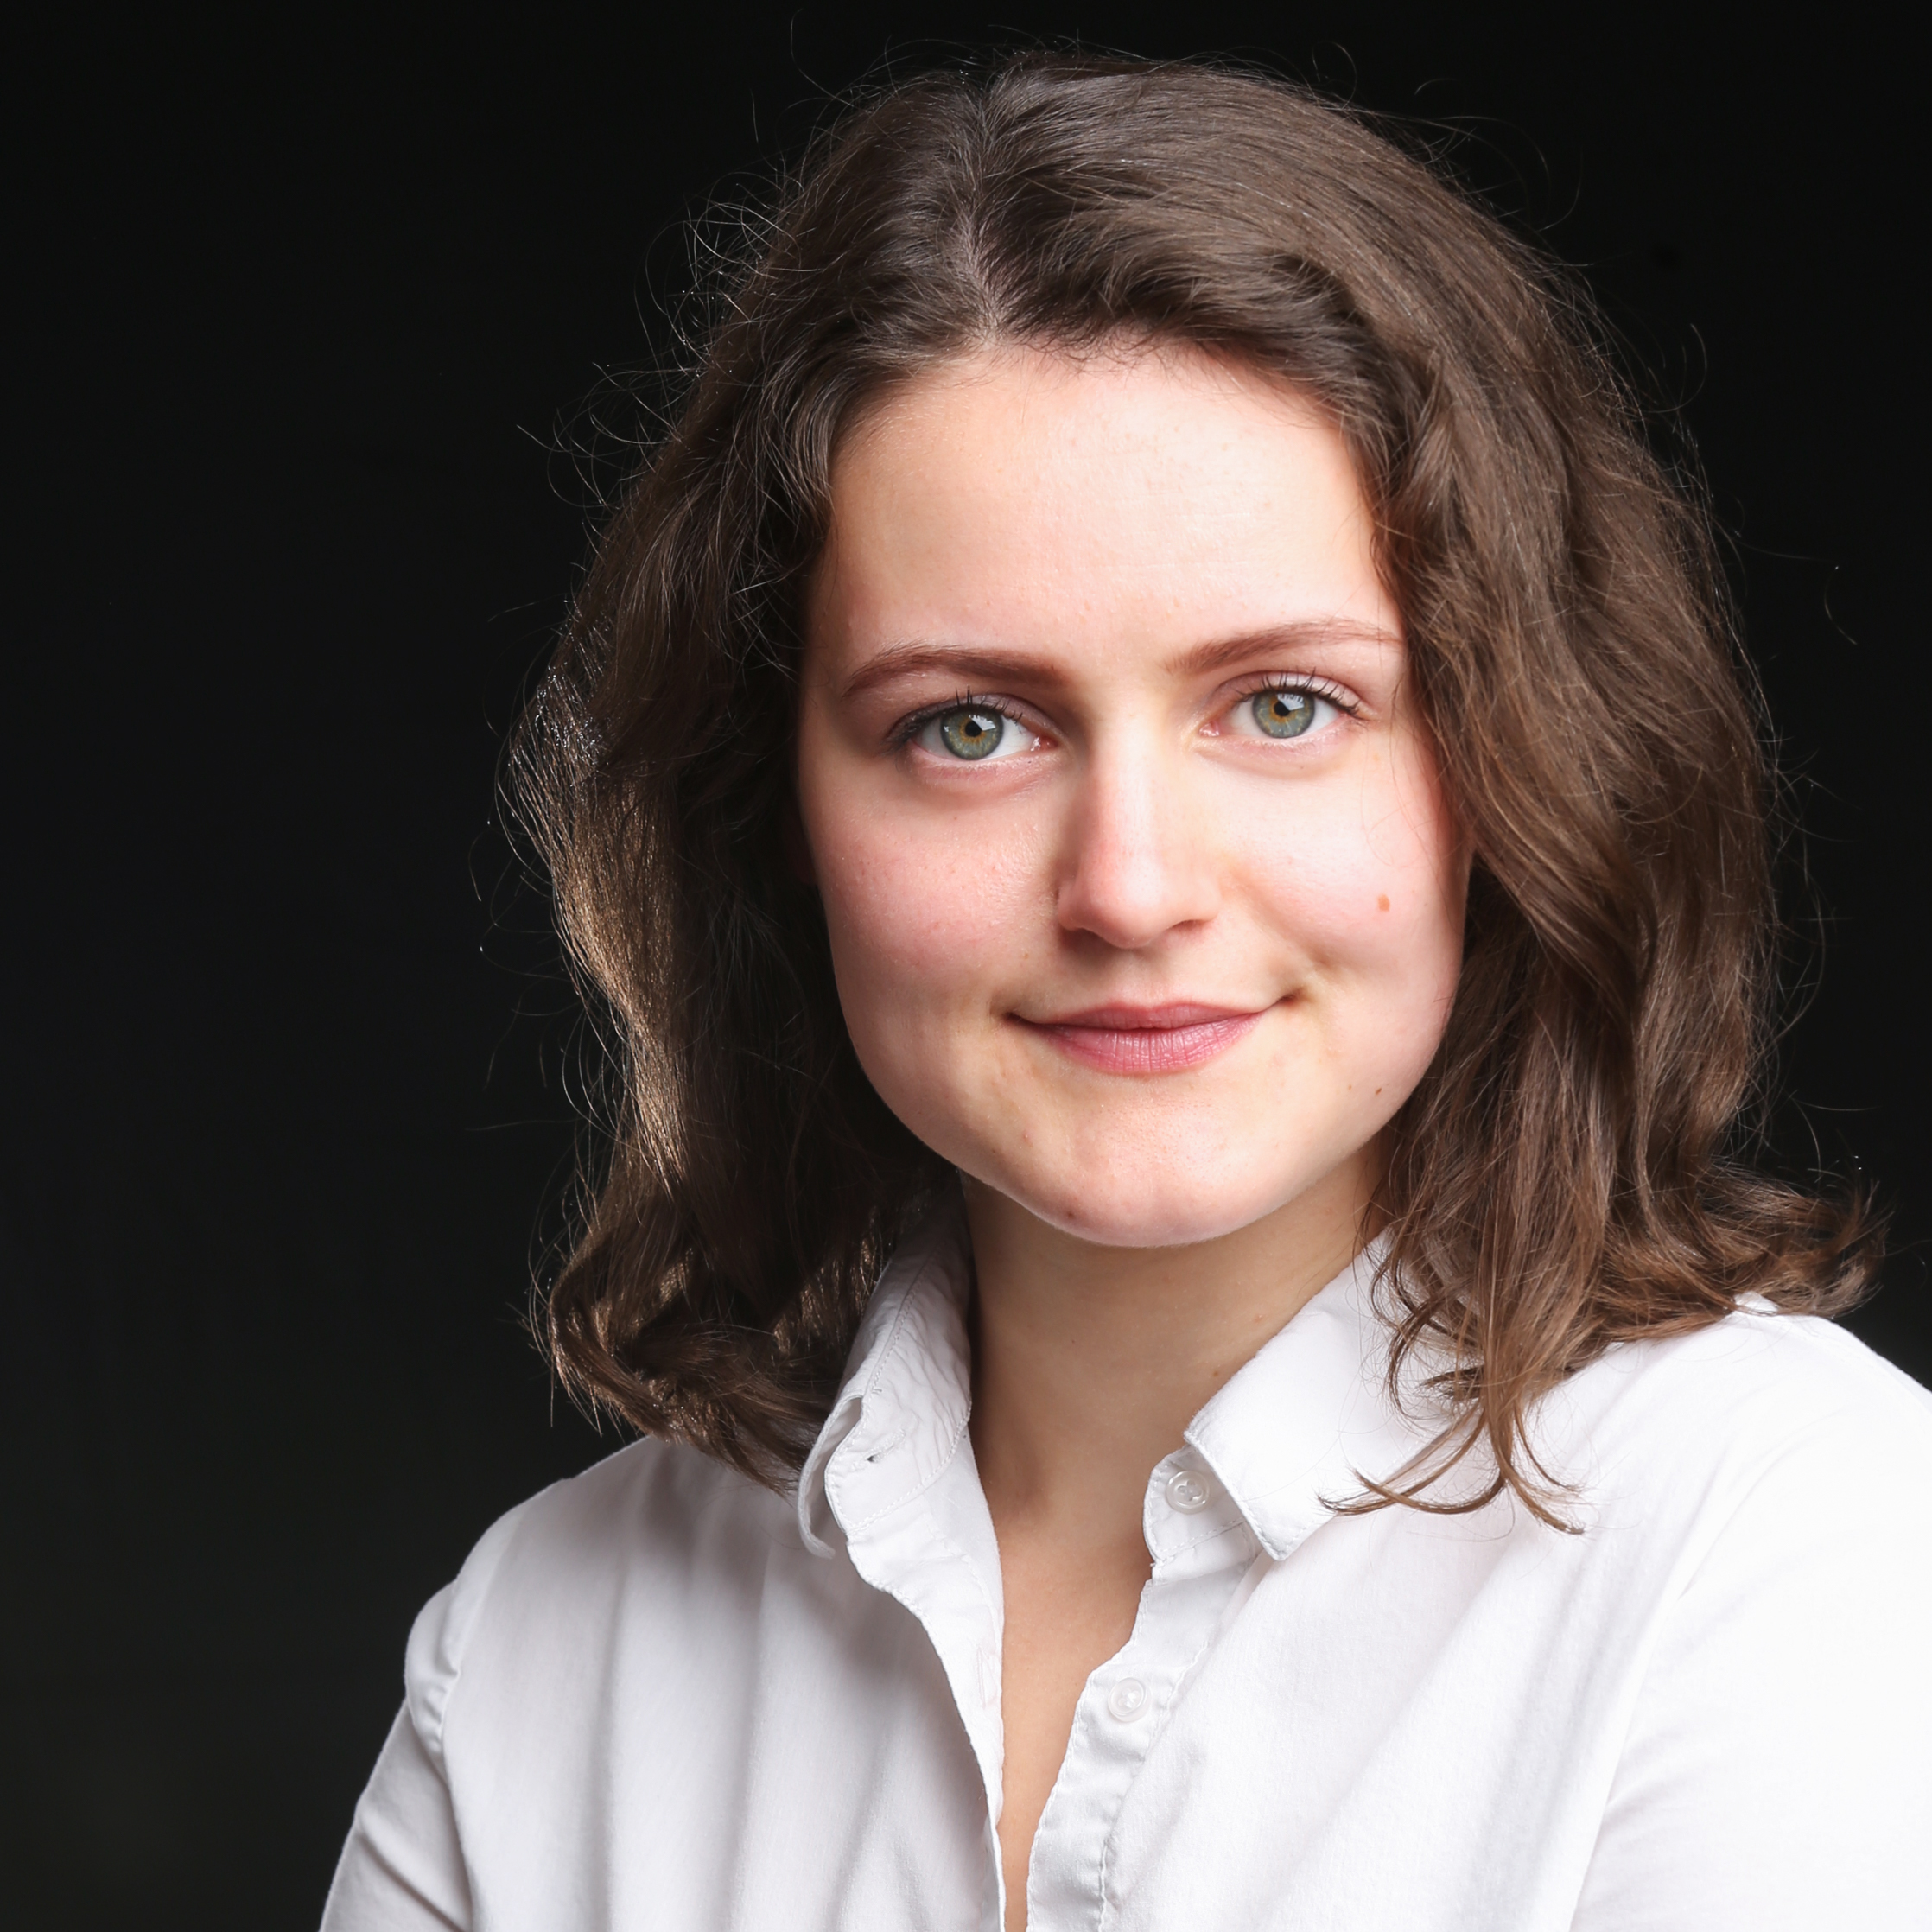Tiffany Rhodes

Email: tiffany.rhodesofficial@outlook.com

Mandy:https://actors.mandy.com/uk/actor/profile/tiffany-rhodes

Mobile: 07706 416265

Height: 5ft 3 (160cm)

Eyes: Green/Blue

Hair: Brown

Playing Age: 15-25

**Stage Credits:**

|  |  |  |  |  |  |
| --- | --- | --- | --- | --- | --- |
| Year | Type | | Role | Production/Director | Company/Venue |
| 2018 | Film | | Maurice/  Anna/David | A Girls Guide To The Entertainment Industry | FF Productions |
| 2018 | Stage | | Patience | Orphan by Russell Eccleston/ Gabby Finnegan | Black Dog Productions/The Mission Theatre |
| 2017 | Stage | | Eva Schloss | And Then They Came For Me by James Still/June Trask | Moondog/ The Mission Theatre |
| 2017 | Stage | | Elsie | Films about Ghosts by Russell Eccleston/Russell Eccleston | Black Dog Productions/Burdalls Yard |
| 2016 | Stage | | Anne/Actor | Time Slides by Crysse Morrison/Crysse Morrison | Nevertheless Fringe Theatre/Cornerhouse Frome |
| 2016 | Stage |  | Emma | Shed Man by Kevin Jones/ Liam-James Maddin | The James Company/The Lion and Unicorn |
| 2016-2017 | Stage | | Nancy | Howl by Russell Eccleston/ Russell Eccleston | Black Dog Productions/ Burdall’s Yard, The Lion and Unicorn, The Nest |
| 2016 | Stage | | William Shakespeare | Where There’s A Will by Stewart Melton/ Ian Nicholson | Onset/The Egg |
| 2015-2016 | Stage | | Valerie Babbage | Tongue Tied/  Jonathon Bisby | Freshly Squeezed/ Burdall’s Yard, Lion and Unicorn, St Keyna School |

**Training/Workshops:**

|  |  |  |  |
| --- | --- | --- | --- |
| Year | Course Name | | Place of Training |
| 2013 - 2016 | BA Acting |  | Bath Spa University |
| 2015 | Trestle workshop: Devising | | Bath Spa University |
| 2015-2016 | Intermediate Stage Combat Level 2 (BADC)  Advanced Stage Combat Level 3 | | Bath Spa University |
| 2015 | Acting for Camera Workshop | | Bath Spa University |
| 2013 | Improvisation/How to Become an Actor | | Central School of Speech and Drama |

**Accent:** Southern England, Received Pronunciation UK English, General American, Somerset

**Skills/Other:** Clean UK Driving License, Confident Swimmer, Singing – Mezzo Soprano