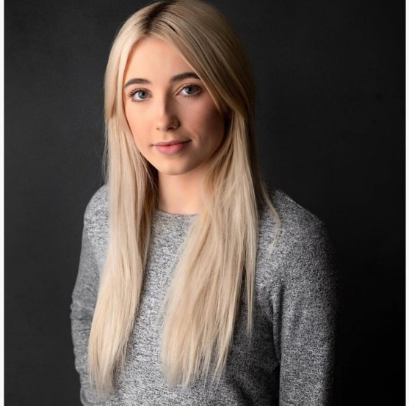

**REFERENCES**

Available on request.

**ACCENTS**

**Received Pronunciation Standard American**

**Somerset Californian**

**West Country**

**WORK EXPERIENCE**

**October 2018** – **Swiis Foster Care Ltd - Bristol**

Corporate advertisement used both on social media and the company website. Promotional video.

**2010 – 2016** **Various Clothing Brands**

I have modelled for independent clothing brands

**June 2015** - **Pinewood Studios, London**

Work experience on a Warner Brothers film

**ROLES**

2018 Lead role in ‘Infinite’ a short film short listed in the Exeter Phoenix Film Festival

2019 Walk-on/Supporting artiste

**MEASUREMENTS**

Height: 5' 4

Bust: 31.50

Under Bust: 25.5

Bra (Back): 30

Bra (Cup): D

**DOB**  23-12-1995

**ADDRESS**  115 Greenvale Drive Timsbury Bath BA2 0NR

**MOBILE** 07960 909375

**EMAIL** paigefarnham95@hotmail.co.uk

**TRAINING**

May – June 2018 Actors Bootcamp – The Acting Corps (North Hollywood - Los Angeles)

This course was based mainly on the Meisner technique, which helped me develop a more natural and instinctive style of acting.

**SKILLS & INTERESTS**

* Free weights
* Script writing
* Interior design
* Fashion and ‘upcycling’

Waist: 24.5

Hip (Top): 33

Hip (Lower): 36

Shoe Size: 4

**PROFILE**

I am a hardworking, driven and professional person. I have a strong work ethic and aim to excel in everything I do. Since a young age, I have had a passion for acting and I am committed to my goal of becoming a professional actor.

I have a full, clean drivers licence and am flexible to travel globally if required.

I have a variety of different experience and am now looking for new representation and to take on new roles and develop my skills and experience as an actor.

PAIGE FARNHAM-BYWATER