**Billie-Joe Ingrams**

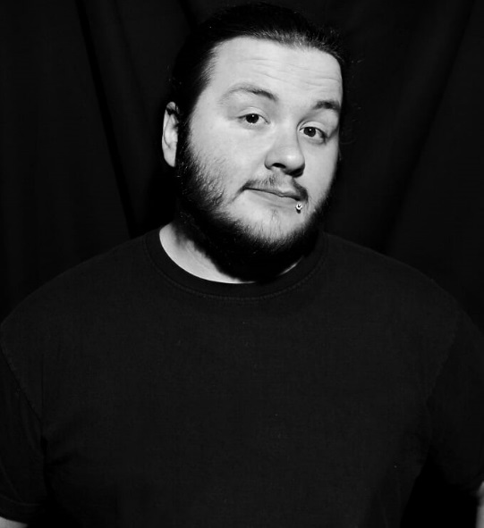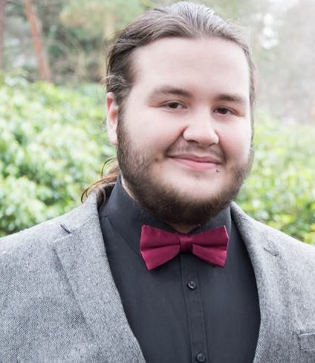**Contact:** 07808 072672

**Height:** 5’8ft **Weight:** 108KG **Build:** Filled out

**Natural hair Colour**: Brown (Currently) Black

**D.O.B:** 15/5/1997 Playing Age: 19-30

**Ethnicity**: White British **Eye:** Brown

**Singing range: B4 F3**

**Accents:**  South-East London, Cockney London,

Scottish, Australian, Russian, Basic American, Southern American

**Previous Performances/Appearances (P) – Professional Credit**

**Name Role Writer/Director Producer**

**(P) Dark Net Gary/David/Donny D Gavin Maxwell NEXUS ENSEMBLE**

**(P) Once upon a Mime Mime Kerry Reeves Kingston Uni**

**(P)A Day Of Fun Host A Billion Mice Theatre Theatre Utopia**

**(P)The Key Problem Ethan (Boy) Chloe Caldwell Andrea Curso**

**(P)Romeo & Juliet Lord Capulet, Friar L Leanne Bentley NEXUS ENSEMBLE**

**(P)Stuck In Time Trevinius Billie Ingrams(Self) Shed-Perton Studio**

**(P) The Dish Sebastian Matt Connor MrMattimation**

**Derailed Justin Imprint Theatre Bath Spa Uni**

**Pronoun SMT Gavin Maxwell NESCOT USR**

**Monologue Slam Nick Gavin Maxwell NESCOT USR**

**Training & Skills**

**1: BA(Hons) Awarded at: Bath Spa University, HND Performing Arts; Awarded at: Nescot College, Lvl 3 BTEC Performing Arts: DDM; Awarded at: Nescot College, 7 GCSE’s: A-C grades; Awarded at: Addington High.**

**2: Work Shops complete with: Charlotte Josephine, Late night gimp fight, Action to the word, Fourth Monkey.**

**3: Skills – Graphics Design, Steel Drums, African Drums.**

**4: Stage combat with forge initiative: Pass grade.**