Mariel Karu  
Trainee Hair and Makeup Artist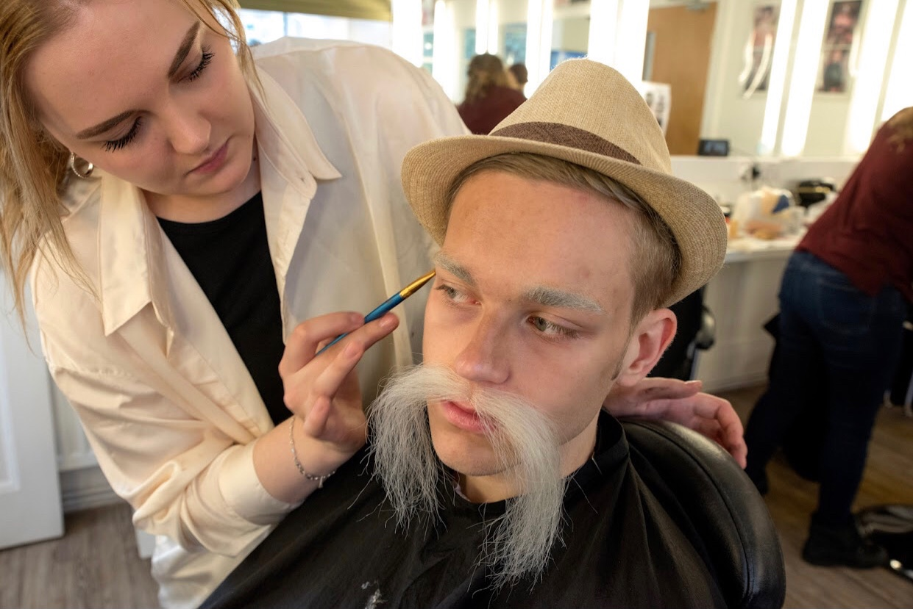

Bristol based, UK, Willing to travel anywhere

**+44 7305059705**

[**Mariel.karu@yahoo.com**](mailto:Mariel.karu@yahoo.com)

[**Www.instagram.com/marielkarumakeup**](http://www.instagram.com/marielkarumakeup)

**I am a hardworking and reliable professional. Able to communicate on many levels due to many years of experience in hospitality. I work great under pressure and I am very organised and work efficiently.**

# Key Skills

**Makeup artist:** bridal makeup, high definition makeup, airbrush and skin camouflage, continuity makeup, facial postiche, application of facial hair, male grooming, skin preparation, laying on hair, period/vintage/fashion makeup, special effects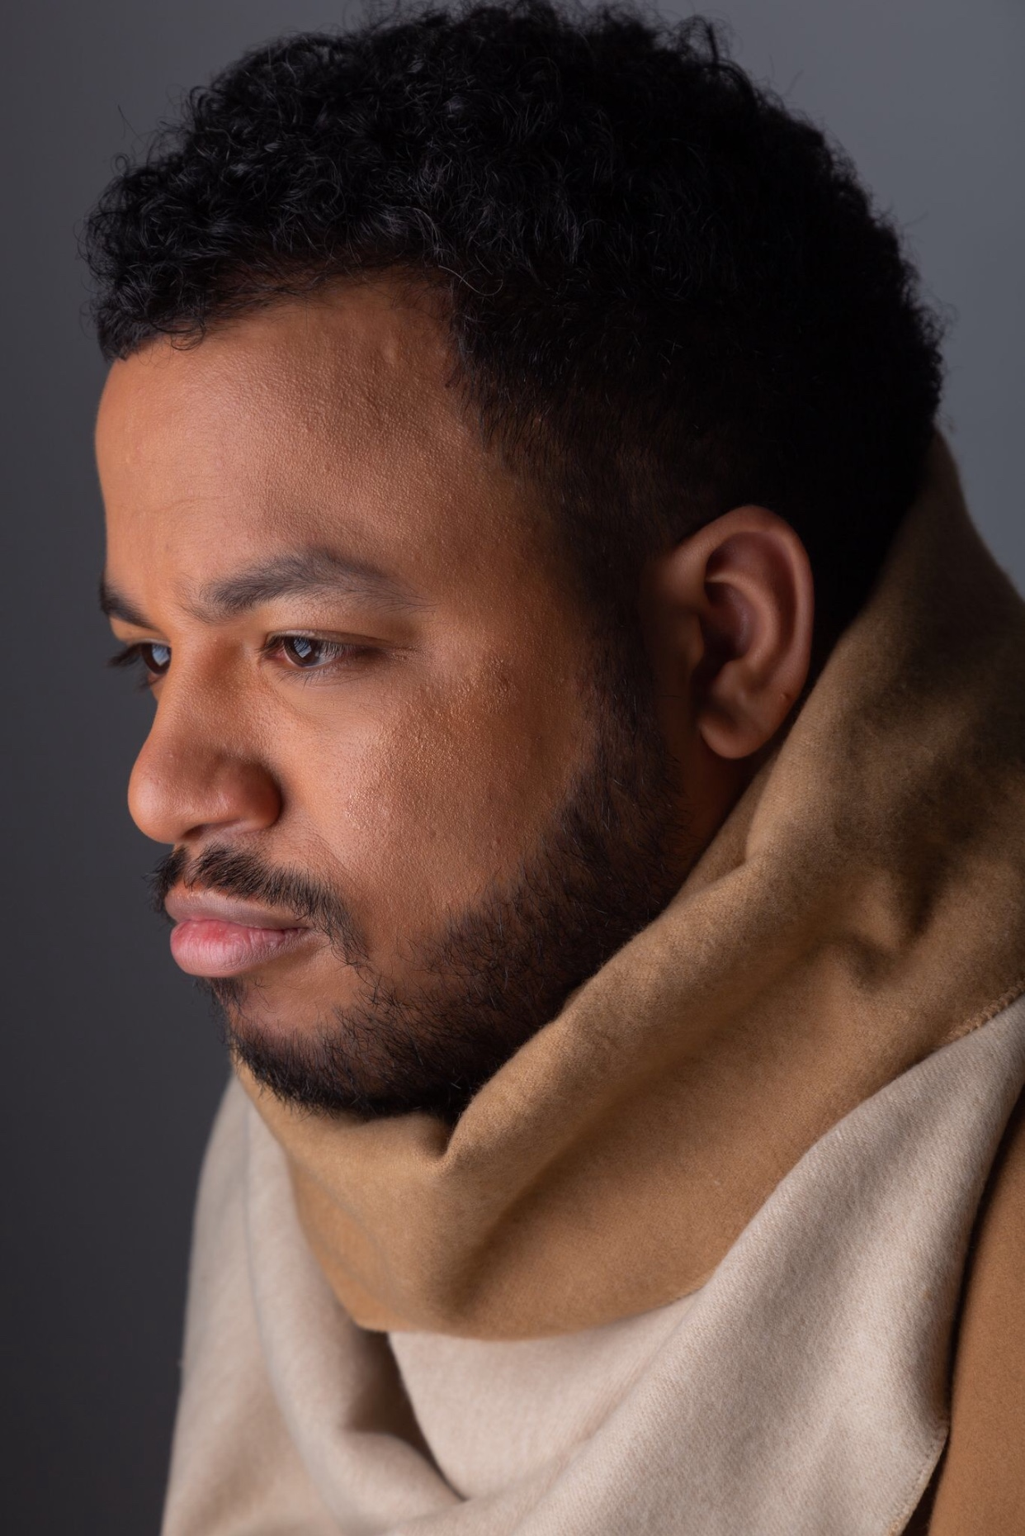

**Hair stylist:** wig application,knotting, weaving, hair cutting for continuity , wig blocking, vintage and period hairstyles, setting hair, wrapping hair, applying bald cap

**Beauty therapy:** prepping the skin, eyelash application both strip and individual, eyelash and eyebrow tinting

# Experience

Bellisa X Clothing Spring/Summer 2020 collection- makeup designer Gozra Lozano- February 2020

Working with photographer Guy Traynor for various photoshoots- modules include: bridal hair and makeup, facial postiche, vintage hair and makeup, historical hair and makeup

Day Trainee at Bristol Hippodrome for Chitty Chitty Bang Bang - September 2018

Mercure Holland House Hotel Receptionist - June 2018- December 2019

# Education

## 13 January 2020- present

### Peter Swords King Television and Film Hair and Makeup Artist course- Bath Academy of Media Makeup

6 July 2016( date of qualification)

### City of Bristol College- Level 2 Makeup

High school in Estonia 2012-2014 -**32.High School Tallinn**